**110 Best Chat GPT Prompts for Marketers**

[https://www.greataiprompts.com/wp-content/uploads/2023/01/Prompts-For-Marketers-<https://www.greataiprompts.com/wp-content/uploads/2023/01/chat-gpt-prompts-for-marketers-1.png>1024x536.png](https://www.greataiprompts.com/wp-content/uploads/2023/01/Prompts-For-Marketers-1024x536.png)

ChatGPT Prompts are the perfect tool for marketers who want their content to be more creative.

ChatGPT has everything you need to make interesting social media posts, effective email campaigns, and great blog posts. By being able to change prompts, you can make sure that each piece of content fits with the message you want to send.

With its ability to understand context and generate responses based on a wide range of data, Chat GPT can help marketers to create more effective and efficient marketing strategies. Also, it’s a great way to save time because you can make a lot of content in a lot less time than it would take you to write it yourself.

So, if you want a quick and creative way to come up with content, ChatGPT Prompts is the way to go.

| **S.No.** | **Chat GPT Prompts For Marketers** |
| --- | --- |
| 1 | “Generate a list of keywords for a new product launch, including long-tail and high-performing keywords |
| 2 | “Develop a chatbot script for a customer service representative to handle frequently asked questions and concerns” |
| 3 | “Generate a compelling headline and meta description for a new blog post about the latest industry trends” |
| 4 | “Create a social media post that maximizes engagement and reach for a new product launch” |
| 5 | “Develop a personalized email marketing campaign for a customer segment based on their interests and purchase history” |
| 6 | “Create a chatbot script for a virtual assistant to schedule meetings and manage calendar events” |
| 7 | “Generate a list of influencers to collaborate with for a new product launch, including their reach and engagement rates” |
| 8 | “Develop a personalized landing page for a customer segment based on their interests and purchase history” |
| 9 | “Create a chatbot script for a virtual personal shopping assistant to assist customers with their online shopping” |
| 10 | “Generate a list of keywords for an SEO optimization campaign, including long-tail and high-performing keywords” |
| 11 | “Develop a personalized video ad for a customer segment based on their interests and purchase history” |
| 12 | “Create a chatbot script for a virtual customer service representative to handle frequently asked questions and concerns” |
| 13 | “Generate a list of potential partners for a new product launch, including their reach and engagement rates” |
| 14 | “Develop a personalized email marketing campaign for a customer segment based on their interests and purchase history” |
| 15 | “Create a chatbot script for a virtual personal shopping assistant to assist customers with their online shopping” |
| 16 | “Generate a list of keywords for a new product launch, including long-tail and high-performing keywords” |
| 17 | “Develop a personalized video ad for a customer segment based on their interests and purchase history” |
| 18 | “Create a chatbot script for a virtual customer service representative to handle frequently asked questions and concerns” |
| 19 | “Generate a list of potential partners for a new product launch, including their reach and engagement rates” |
| 20 | “Create a personalized welcome message for new followers on Instagram” |
| 21 | “Generate engaging captions for our latest product launch on Facebook” |
| 22 | “Develop a series of witty responses for common customer complaints on Twitter” |
| 23 | “Create a personalized birthday message for customers on their special day” |
| 24 | “Generate a series of Instagram stories promoting our upcoming sale” |
| 25 | “Develop a series of Facebook ads targeting specific demographics” |
| 26 | “Create a series of Instagram posts highlighting customer testimonials” |
| 27 | “Generate engaging Instagram captions for our latest fashion collection” |
| 28 | “Develop a series of Twitter polls to gather customer feedback” |
| 29 | “Create a personalized thank you message for customers who make a purchase” |
| 30 | “Generate a series of Instagram stories showcasing our brand’s culture” |
| 31 | “Develop a series of Facebook ads targeting specific interests” |
| 32 | “Create a series of Instagram posts featuring our products in real-life scenarios” |
| 33 | “Generate engaging Twitter posts for our latest product launch” |
| 34 | “Develop a series of Instagram stories promoting our brand’s sustainability efforts” |
| 35 | “Create a personalized message for customers who have been loyal for a certain amount of time” |
| 36 | “Generate a series of Facebook ads targeting specific behaviors” |
| 37 | “Develop a series of Instagram posts featuring our brand’s community involvement” |
| 38 | “Create a personalized message for customers who have made multiple purchases” |
| 39 | “Generate engaging Instagram captions for our latest home decor collection” |
| 40 | “Introduce your new product to our subscribers in a personalized and engaging way” |
| 41 | “Create a compelling subject line for an upcoming sale” |
| 42 | “Generate an email campaign targeting abandoned cart shoppers” |
| 43 | “Write a persuasive email to promote a limited-time offer” |
| 44 | “Develop a welcome email series for new subscribers” |
| 45 | “Create a personalized email targeting customers who haven’t made a purchase in 6 months” |
| 46 | “Write a persuasive email to upsell a related product” |
| 47 | “Generate a holiday-themed email promoting gift ideas” |
| 48 | “Create an email targeting customers who have shown interest in a specific product category” |
| 49 | “Write a post-purchase follow-up email to encourage customer reviews” |
| 50 | “Develop an email campaign to re-engage inactive subscribers” |
| 51 | “Create a personalized email for customers who have made multiple purchases” |
| 52 | “Write an email promoting a loyalty program” |
| 53 | “Generate a birthday or anniversary email with a special offer” |
| 54 | “Create an email promoting a referral program” |
| 55 | “Write a persuasive email to encourage repeat purchases” |
| 56 | “Develop an email promoting a limited-time free shipping offer” |
| 57 | “Create a personalized email for customers who have a high lifetime value” |
| 58 | “Write an email promoting a flash sale” |
| 59 | “Generate an email promoting a holiday sale” |
| 60 | “Create an email promoting a bundle deal” |
| 61 | “Write an email promoting a free trial or sample” |
| 62 | “Develop an email promoting a subscription service” |
| 63 | “Create a personalized email for customers who have shown interest in a specific product” |
| 64 | “Write an email promoting a clearance sale” |
| 65 | “Generate an email promoting a buy one, get one deal” |
| 66 | “Create an email promoting a limited edition product” |
| 67 | “Write an email promoting a customer appreciation event” |
| 68 | “Develop an email promoting a contest or giveaway” |
| 69 | “Create a personalized email for customers who have shown interest in a specific brand or collection” |
| 70 | “Create a compelling CTA for a new mobile app that helps users manage their finances” |
| 71 | “Write a product description for a new line of organic skincare products” |
| 72 | “Develop a sales funnel for a new online course that teaches people how to start their own business” |
| 73 | “Write an ad for a new line of eco-friendly cleaning products” |
| 74 | “Design a product page for a new line of fitness supplements” |
| 75 | “Write a testimonial for a new weight loss program that has helped thousands of people lose weight” |
| 76 | “Write a blog post about the benefits of using a new type of virtual reality headset for meditation” |
| 77 | “Create a marketing campaign for a new line of sustainable clothing” |
| 78 | “Write a product description for a new type of smartwatch that tracks your fitness and health” |
| 79 | “Develop a sales funnel for a new online course that teaches people how to invest in the stock market” |
| 80 | “Write an ad for a new line of organic baby products” |
| 81 | “Design a product page for a new type of electric bike” |
| 82 | “Write a testimonial for a new type of online therapy program that has helped thousands of people improve their mental health” |
| 83 | “Write a blog post about the benefits of using a new type of water filter for your home” |
| 84 | “Create a marketing campaign for a new line of sustainable home decor” |
| 85 | “Write a product description for a new type of electric car” |
| 86 | “Develop a sales funnel for a new online course that teaches people how to start their own podcast” |
| 87 | “Write an ad for a new line of organic pet food” |
| 88 | “Design a product page for a new type of smart home security system” |
| 89 | “Write a testimonial for a new type of online language learning program that has helped thousands of people learn a new language” |
| 90 | “Write a blog post about the benefits of using a new type of air purifier for your home” |
| 91 | “Create a marketing campaign for a new line of sustainable fashion accessories” |
| 92 | “Write a product description for a new type of smart thermostat” |
| 93 | “Develop a sales funnel for a new online course that teaches people how to start their own online store” |
| 94 | “Write an ad for a new line of organic beauty products” |
| 95 | “Design a product page for a new type of electric skateboard” |
| 96 | “Write a testimonial for a new type of online course that has helped thousands of people improve their photography skills” |
| 97 | “Write a blog post about the benefits of using a new type of noise-cancelling headphones” |
| 98 | “Create a marketing campaign for a new line of sustainable home appliances” |
| 99 | “Write a product description for a new type of smartwatch that tracks your sleep and stress levels” |
| 100 | “Develop a sales funnel for a new online course that teaches people how to start their own blog” |
| 101 | “Write an ad for a new line of organic snacks” |
| 102 | “Design a product page for a new type of electric scooter” |
| 103 | “Write a testimonial for a new type of online course that has helped thousands of people improve their public speaking skills” |
| 104 | “Write a blog post about the benefits of using a new type of meditation app” |
| 105 | “Create a marketing campaign for a new line of sustainable office supplies” |
| 106 | “Write a product description for a new type of electric car charger” |
| 107 | “Develop a sales funnel for a new online course that teaches people how to start their own podcast” |
| 108 | “Write an ad for a new line of organic juices” |
| 109 | “Design a product page for a new type |
| 110 | “Write a blog post about the benefits of using a new type of personal assistant app to help manage your schedule and tasks” |

<https://www.greataiprompts.com/wp-content/uploads/2023/01/chat-gpt-prompts-for-marketers.png>

# 200+ Best ChatGPT Prompts for Every workflow

# <https://www.greataiprompts.com/wp-content/uploads/2023/08/chatgpt-prompts-1024x536.png>

# <https://www.greataiprompts.com/wp-content/uploads/2023/12/chatgpt-prompt-example-2023-12-22-at-11.01.43-AM-1024x786.png>

# Write a business proposal for launching a new line of eco-friendly products **[ideas of products you are thinking of]**, detailing the market demand, competitive analysis, and sustainability benefits.

# 2 Generate a script for a 30-second commercial promoting our new product **(product name). Here’s** what the product is about [specifications]. Here’s what my idea about the commercial is **[some insights]**.

# Write a persuasive email to convince potential customers to try our service **[specify a little bit about your service here]**.

# Create a list of frequently asked questions for our customer service team about **[topic of FAQ]**.

# Generate a summary of our company’s mission and values **[specify a little about your company, and a very short summary of your vision]**.

# Hey ChatGPT, I want you to a write a script for a training video for me on how to use our software. Here are some details about my software and how to use it: **[mention some important insights on what your software is about, what your software does and how it performs a certain task here]**

# Create a list of potential blog post ideas for our company’s website. Here’s what my company is about **[specify some important details about the company you want ChatGPT to mention blog ideas about]** and the topics we want to cover are: **[fill this with topics your company is planning to cover]**

# Generate a press release announcing our company’s latest partnership. Please focus on the nature of the partnership **[mention the type of partnership e.g. technical, marketing, distribution]** and the benefits it will bring to our stakeholders **[mention the stakeholders e.g. customers, employees, shareholders]**. Include details about the partner company **[mention the partner company’s background or strengths]**

# Write a script for a video testimonial from a satisfied customer. The customer should highlight **[mention specific features or benefits they liked about your product/service]** and mention their personal experience using our product/service over a duration of **[specify duration e.g. 6 months, 1 year]**.

# .Create a list of keywords to optimize our website for search engines. Focus on keywords related to **[specify the nature of your business e.g. tech gadgets, organic foods, fitness training]** and also consider our target demographic **[mention target audience e.g. millennials, athletes, parents]**.

# Generate a script for a social media video showcasing our company culture. Emphasize our core values **[list some core values e.g. innovation, sustainability, inclusivity]**and display moments from our workplace **[mention specific events or situations e.g. team building activities, office parties, community service]**.

1. Generate a script for a social media video showcasing our company culture. Emphasize our core values **[list some core values e.g. innovation, sustainability, inclusivity]**and display moments from our workplace **[mention specific events or situations e.g. team building activities, office parties, community service]**.
2. Write a script for an explainer video about our new product. Highlight its unique features **[mention some standout features]**and explain how it solves specific problems for the user. The main user pain points are: **[mention some problems your product addresses]**.
3. Create a list of potential influencers to collaborate with for social media campaigns. We are targeting platforms like **[mention platforms e.g. Instagram, YouTube, TikTok]** and our ideal influencer should cater to **[mention target audience e.g. young adults, tech enthusiasts, travelers]**.

14 Generate a script for a podcast episode discussing industry trends. Focus on topics like **[mention some trending topics in your industry]** and invite experts from **[mention fields e.g. technology, finance, healthcare]** to share their insights.

15

Write a script for a webinar on best practices for using our product. Cover **[essential features and functionalities**], address **[common user challenges], and provide [tips and tricks for optimal usage]**.

16. Create a list of potential case studies to showcase our company’s success. Focus on projects or products that have **[specific measurable outcomes]**, involve **[noteworthy clients or partners]**, and reflect **[your company’s key strengths]**.

# <https://www.greataiprompts.com/wp-content/uploads/2023/12/chatgpt-prompt-example-2023-12-22-at-11.05.30-AM-1024x786.png>

# 17. Generate a script for a short video on our company’s history and achievements. Discuss **[foundational events or decisions]**, spotlight **[major milestones]**, and highlight **[key figures in your company’s journey]**.

18. Write a script for a virtual event to launch our new product. Detail **[the main features of the new product]**, explain **[how it addresses specific market needs]**, and incorporate **[testimonials or endorsements from beta testers]**.

19. Create a list of potential topics for a company newsletter. The topics should resonate with **[our core audience]**, provide updates on **[recent company activities or news]**, and offer insights into **[upcoming industry trends]**.

20. Generate a script for a TV commercial to increase brand awareness. Highlight **[your brand’s unique selling proposition]**, showcase **[real-life applications of our product/service]**, and evoke emotions using **[a specific theme or storyline]**.

21. Write a script for an explainer video about our company’s sustainability efforts. Discuss **[specific sustainable practices we employ]**, the **[impact of these practices on the environment]**, and **[how customers can get involved]**.

22. Can you think of new business ideas without money? Focus on sectors that have **[low entry barriers]**, can leverage **[existing skills or assets]**, and address **[current market demands]**.

23. Write a persuasive email to increase attendance at our upcoming event. Emphasize **[key speakers or attractions at the event]**, mention **[benefits of attending]**, and offer **[special incentives for early registration]**.

24. Create a follow-up email to send to potential clients after a meeting. Reflect on **[key points discussed during the meeting]**, provide **[additional resources or information]**, and propose **[next steps for collaboration]**.

25. Generate a thank-you email to send to customers after a purchase. Acknowledge their **[specific purchase]**, offer **[tips or guides on using the product]**, and introduce **[upcoming promotions or products they might be interested in]**.

26. Write a promotional email to introduce our new product or service. Highlight **[features that differentiate it from other products]**, offer **[limited-time discounts or offers]**, and share **[reviews or testimonials]**.

27. Create a reminder email for an upcoming deadline or meeting. Specify **[the date and time]**, provide **[agenda items or topics for discussion]**, and include **[any preparatory materials or actions needed]**.

28. Generate a professional email to request a meeting or consultation. Explain **[the purpose of the meeting]**, suggest **[potential time slots]**, and outline **[topics or questions to be covered]**.

<https://www.greataiprompts.com/wp-content/uploads/2023/12/chatgpt-prompt-example-2023-12-22-at-11.08.19-AM-1024x786.png>

29. Write an apology email to a customer for a delay or mistake. Acknowledge **[the specific issue or mistake]**, explain **[steps taken to rectify it]**, and offer **[compensation or goodwill gestures]**.

30. Create a personalized email to nurture a lead and move them closer to a sale. Reference **[their past interactions with our brand]**, introduce **(products or services aligned with their interests)**, and share **[exclusive deals or offers]**.

31. Generate an email to request a referral or testimonial from a satisfied customer. Remind them of **[the product/service they availed]**, explain **[the importance of their feedback]**, and provide **[an easy way to submit their thoughts]**.

32. Write a promotional email to announce a sale or special offer. Detail **[the range of products on sale]**, specify **[the duration of the sale]**, and highlight **[exclusive benefits for early birds or loyal customers]**.

33. Create an email to send to a prospect who has shown interest in our product. Address **[their specific needs or queries]**, share **[additional product details or demos]**, and provide **[a special offer for their consideration]**.

34. Generate an email to request feedback from customers on our product or service. Emphasize **[areas we’re specifically looking feedback on]**, provide **[a platform or method for feedback submission]**, and offer **[incentives for detailed feedback]**.

35. **Write an email to send** to a customer who has unsubscribed from our mailing list. Ask for **[reasons for the unsubscription]**, provide **[updates on improvements since their departure]**, and offer **[an incentive to reconsider]**.

36. Create an email to send to a potential partner to explore collaboration opportunities. Introduce **[our company’s strengths and assets]**, specify **[areas of potential collaboration]**, and suggest **[initial steps for partnership exploration]**.

37. Generate an email to send to a customer with a personalized upselling or cross-selling suggestion. Highlight **(products related to their past purchases)**, explain **[benefits of the suggested product]**, and provide **[a limited-time offer or discount for them]**.

38. Write a daily [to-do list](https://www.greataiprompts.com/ai-tools/best-ai-to-do-list-tools-and-apps/) for the sales team using this data; **[data]**. Ensure tasks are aligned with **[specific sales goals or targets]** and prioritize **[urgent or high-impact activities]**. Highlight **[any team meetings or collaboration sessions]**.

39. Generate a daily summary of customer feedback and testimonials. Focus on feedback related to **[specific products or services]**, highlight **[particularly positive or constructive comments]**, and categorize feedback by **[themes or topics]**.

40. Write a daily agenda for the executive team meeting. Begin with **[recap of previous decisions or actions]**, outline **[key topics or issues for discussion]**, and allocate time for **[strategic planning or future outlook]**.

41. Generate a daily study schedule for the next week. Specify **[starting date]** to **[ending date]**. Make sure to include specific times for each subject like **[subject name 1]**, **[subject name 2]**, and **[subject name 3]**. Also, add any breaks or activities planned like **[specific activity or break name]**.

<https://www.greataiprompts.com/wp-content/uploads/2023/12/chatgpt-prompt-example-2023-12-22-at-11.09.12-AM-1024x786.png>

42. Write a persuasive essay discussing the benefits of experiential learning in the classroom. Use **[specific age group or grade]** as your target audience. Provide real-world examples from places like **[specific school or institution]** on how hands-on activities enhance educational outcomes.

43. Generate a list of potential essay topics for **[assignment name]** relevant to **[subject or course name]**. Make sure you focus on **[specific theme or aspect]**. Along with each topic, provide a brief outline of main points like **[point 1]**, **[point 2]**, and **[point 3]** to be discussed.

44. Teach me **[Anything you want to study]**. Ensure you provide its historical context and **[specific application or use]**. Include a test at the end with questions like **[sample question 1]**, **[sample question 2]**. Don’t give me the answers. After I respond, tell me if I got the answer right. I really want to learn. Make sure you explain everything like I don’t know anything about the topic and cover from the basics to advance levels.

45. For your introductory physics class in college, write a poem that resonates with themes like **[specific physics topic or concept]**. Use the style of Robert Frost **[add any style]** and make sure it touches upon **[specific element or emotion]**.

46. Write a detailed essay for me on **[specific topic like ‘gravity’ or ‘photosynthesis’]**. Dive deep by adding information from sources like **[specific book or researcher]**. Write the essay using simple English. Imagine you’re explaining the topic to a 5-year-old or someone who has never heard about it.

47. Solve this **[specific math problem or equation]** for me. Ensure you go step-by-step. While explaining, touch upon concepts like**[specific math concept or rule]** and tell me how you used them. I want a clear understanding of each part of the solution.

<https://www.greataiprompts.com/wp-content/uploads/2023/12/chatgpt-prompt-example-2023-12-22-at-11.10.10-AM-1024x683.png>

48. When working with mathematical operations in **[Python]**, it’s common to calculate factorials. Can you help by writing a function in**[Python]** to calculate the factorial of a given number **[Number to Calculate]**?

49. Write a function in **[Python]** to compute the factorial of a specific number **[Number to Calculate]**.

50. Design a **[JavaScript or any other language]**program that provides a basic calculator functionality. Ensure it has operations like **[Add, Subtract, Multiply, Divide or add any other functionality]**.

51. Please provide a **[C++]** code to sort an array of integers **[Array of Integers]** using the bubble sort method.

52. Write a **[Python]** script that extracts data from a website **[Website URL]** and saves it to a CSV file. (**Note for the user:** It’s better to plugins in ChatGPT for such tasks.)

53. Develop a **[Java]** program to implement a simple chatbot that utilizes natural language processing **[Specify NLP Library/Tool]**.

54. Please write a **[C#]** code that creates a basic game using the Unity engine **[Specific Game Genre or Concept]**.

<https://www.greataiprompts.com/wp-content/uploads/2023/12/chatgpt-prompt-example-2023-12-22-at-11.11.28-AM-1024x772.png>

55. Draft a **[Python]** function that verifies if a particular string **[Input String]** is a palindrome.

56. Design a**[JavaScript]** program to create a responsive webpage layout using CSS and HTML **[Specific Page Type or Theme]**.

57. ChatGPT you are a Coding ChatGPT right now and, I want you to act as **[Enter your profile for example python developer]** and by using the technology stack **[Enter your technology stack]** and functionality **[Enter functionality]** without leaving these mandatory fields **[Enter Fields]** and optional fields **[Enter Fields]** perform this **[Write a task description]**.

58. Write a**[Python]** script to automate specific tasks using the Selenium library **[Specific Task or Webpage]**.

59. Create a **[Programming Language]** program that implements a basic encryption algorithm **[Specific Algorithm or Use-case]**.

60. Develop a **[C# or other language]** code to craft a basic windows form application **[Specify Application Functionality]**.

61. Write a**[Python]**function that produces a random password **[Desired Length and Complexity]**.

62. Develop a **[JavaScript]**program to perform basic CRUD operations using MongoDB

63. Generate a **[C++ or type any coding language]** code to implement a basic data structure, such as a linked list, **[Specific Operations or Use-cases]**.

64. Provide a **[Python]** script that reads and analyzes data from an excel sheet **[Specific Analysis or Data Type]**.

65. Design a **[Java]** program that implements a basic algorithm for image processing **[Specific Algorithm or Image Type]**.

66. Develop a **[C# or any coding language]** code that constructs a basic WPF application**[Application Functionality or Theme]**.

67. Write a **[Python]** function to implement a basic natural language processing task.

68. Write **[JavaScript]** program that establishes a basic blockchain **[Specific Blockchain Functionality]**.

69. I have an h264 video too large for Twitter; assist with a bash script to adapt it to the proper format with the highest quality **[Output Format]**.

70.Create a TypeScript function that calculates implied volatility using the Black-Scholes model, explaining each step **[Specific Market Data]**.

71. Please only reply using p5.js code. Please concisely implement a cellular automaton life game with 30 lines or less. – 800,800 by 800 pixels -Sorry, no line breaks. Please refrain from leaving comment-outs **[Specific Cell Behavior or Pattern]**.

72. Identify the bug in this given **[Code]** and provide suggestions for improvement.

73. This year, the elves invested in a gift-wrapping machine. However, it isn’t programmed! An algorithm that aids it in the **[task]** must be developed. Many presents are given to the machine. Each present is a string. Each gift must be wrapped by the machine and displayed with other wrapped gifts. To wrap a gift, you must place the wrapping paper around the string, which is represented by the \* symbol. For instance: const gifts are **[“cat,” “game,” and “socks”]**. console.log const wrapped = wrapping(gifts) (wrapped) / **[“ncatn,” “ngamen,” and “nsocksn\*\*”]** \*/ As you can see, the thread is wrapped in the wrapping paper. The corners are also wrapped in wrapping paper on the top and bottom to prevent any gap

74. What exactly does this strange-looking regex do? **[ add your regex code example: ((([01]?\d)|(two[0-three])): ([0-five]?\d)) ((:[0-five]?\d))?\s? ?b/i; (am|pm)]**

75. I require UI assistance. I need three action buttons for a card component that includes a long statement, but I don’t want the buttons to always be visible. **[specify your requirements for example: I need a good UI that functions on both desktop and mobile since if I try to show the buttons on Hoover, that logic won’t work on mobile.]**

76. Can you explain how this **[coding language]** code **[code snippet]** performs **[task]** and why it uses **[specific process]**?

77. Write a **[Python]** script to implement a neural network for image classification using TensorFlow.

78. Write a **[Python]** script that sets up a neural network for classifying images using TensorFlow **[Specific Dataset or Image Type]**.

79. Provide a **[Python]** script that implements a reinforcement learning algorithm to develop game-playing AI**[Specific Game or Scenario]**.

80. Take this **[Java or other language]** code and rewrite it into the **[C++ or any desired Language]**, ensuring that functionality remains consistent.

81. Generate a **[C++]** code to perform a basic simulation of a self-driving car using ROS (Robot Operating System) **[Specific Road Conditions or Scenarios]**.

82. Write a **[Python]** script to implement a deep learning model for natural language generation.

83. Create a **[JavaScript]** program to implement a basic chatbot using Dialogflow.

84. Write a poem that captures the essence of love and loss. Please consider using **[specific metaphors that resonate with your personal experience]** and **[a particular imagery theme]** to deepen the emotional connection. The desired mood of the poem is **[e.g. melancholic, hopeful, nostalgic]**.

<https://www.greataiprompts.com/wp-content/uploads/2023/12/chatgpt-prompt-example-2023-12-22-at-11.12.12-AM-1024x772.png>

85. Draft a heartfelt poem that portrays the breathtaking beauty of a sunset over the ocean. Capture the **[specific colors you want highlighted]** and the array of emotions it evokes, such as **[e.g. peace, reflection, wonder]**.

86. Create lyrics for a song that encapsulates the journey of chasing dreams and navigating through **[specific types of obstacles, e.g. societal expectations, self-doubt]**. The song’s tone should be **[e.g. uplifting, motivational, introspective]**.

87. Conjure a short story centered on a musician who, during their **[specific journey or adventure]**, stumbles upon their genuine passion. The setting should be **[e.g. a bustling city, a quiet village]**.

88. Craft a script for a music video narrating a tale of heartbreak followed by redemption. The main characters should **[face specific challenges]**, and the video’s climax should focus on **[a significant turning point]**.

89. Compose a sonnet celebrating the splendors of nature, using **[specific imagery like mountains, rivers, forests]** and rhyme. The sonnet’s tone should be **[e.g. contemplative, joyous]**.

90. Produce a monologue intended for a play, spotlighting a struggling artist striving to find their place in the competitive music industry. The artist should face dilemmas like **[e.g. choosing between fame and integrity, balancing personal life and career]**.

91. Write a song that emphasizes the immense power and importance of friendship and the support system it provides. The lyrics should mention **[specific events or memories]** that highlight these themes.

92. Create a poem about time’s elusive nature, employing **[specific personification techniques]** and **[allusions to historical or mythical figures/events]**. The poem’s theme should be **[e.g. acceptance, longing]**.

93. Generate a concise piece of poetry about a band that, after **[specific duration, e.g. a decade]**, decides to reunite. Mention the reasons for their initial split and **[the events that led to their reunion]**.

94. Draft a script for a musical showcasing the ascent and decline of a famed musician. Incorporate **[specific events or eras, e.g. the 70s rock scene]** and the personal challenges faced by the musician, such as **[e.g. addiction, relationships]**.

95. Compose song lyrics that delve into both the enchanting allure and the torment of falling in love. Reflect upon **[specific emotions or experiences, e.g. the first date, heartbreak]**.

96. Create a monologue for a play depicting the tribulations of a musician’s life. Address **[specific struggles like financial woes, maintaining originality]** and the sacrifices made for their art

97. Write a poem that captures the ethereal beauty of music, using **[specific imagery like flowing rivers, towering mountains]** and metaphors. The poem should convey the **[specific feeling, e.g. solace, nostalgia]** music brings.

98. Design lyrics for a song stressing the significance of remaining genuine and authentic. Highlight **[specific situations or challenges, e.g. societal pressures, self-doubt]** where staying true to oneself is vital.

99. Write a short story about a musician who confronts and overcomes their **[specific personal demons, e.g. addiction, past traumas]** to achieve success. The story’s climax should be **[a significant event, e.g. a breakthrough performance]**.

100. Craft a script for a music video narrating a tale of self-realization and empowerment. The protagonist should undergo **[specific challenges or experiences]** leading them to a pivotal moment of self-discovery.

101. I want you to act as a linux terminal Specify the version of Linux **[e.g., Ubuntu 20.04]**. I will type commands and you will reply with what the terminal should show. **[Mention the purpose of using this Linux session: e.g.,** **I want you to only reply with the terminal output inside one unique code block, and nothing else. do not write explanations. do not type commands unless I instruct you to do so. when i need to tell you something in english, i will do so by putting text inside curly brackets {like this}. my first command is pwd.**]

102. Pretend you’re a travel blogger recounting your recent adventure to **[a specific island name, e.g., “Bali”]**. Describe the most interesting **[landmarks, or foods, or people]** you encountered. Share the sights, sounds, and unique experiences of **[a specific day or event during the trip]**.

103. I want you to act as an English translator, spelling corrector and improver. I will speak to you in any language **[specific language e.g., “Turkish”]** and you will detect the language, translate it and answer in the corrected and improved version of my text, in English. I want you to replace my simplified A0-level words and sentences with more beautiful and elegant, upper level English words and sentences. Keep the meaning same, but make them more literary. I want you to only reply the correction, the improvements and nothing else, do not write explanations. **[Specify if there’s a theme or topic for the conversation]** My first sentence is “istanbulu cok seviyom burada olmak cok guzel.

104. I want you to act as an interviewer for **[a specific industry, e.g., “Tech”]**. I’m applying for **[specific position, e.g., “software engineer”]**. Ask me the interview questions related to **[specific skills or tasks e.g., “Java programming”]**. My first sentence is “Hi”.

105. I want you to act as a javascript console of **[specific browser e.g., “Chrome”]**. I will type commands related to **[specific topic e.g., “DOM Manipulation”]**. Reply with the javascript console output. My first command is console.log(“Hello World”).

106. I want you to act as a text-based excel with specific needs. Provide a text-based 10 rows excel sheet for **[specific purpose e.g., “budgeting”]**. I’ll fill in the data related to **[specific topic e.g., “monthly expenses”]**. First, reply me the empty sheet.

107. I want you to act as an English pronunciation assistant for Turkish speaking people with **[specific accent focus e.g., “American accent”]**. Guide me on pronouncing **[specific types of words e.g., “common phrases”]**. My first sentence is “how the weather is in Istanbul?.

108. I want you to act as a travel guide. I will write you my location and you will suggest a place to visit near my location. In some cases, I will also give you the type of places I will visit. You will also suggest me places of similar type that are close to my first location. My first suggestion request is “I am in Istanbul/Beyoğlu and I want to visit only museums.”

109. I want you to act as an **[advertiser]**. You will create a **[task such as campaign to promote a product or service of your choice]**. You will choose a target audience, develop key messages and slogans, select the media channels for promotion, and decide on any additional activities needed to reach your goals. My first suggestion request is “I need help creating an advertising campaign for a new type of energy drink targeting young adults aged 18-30.”

110. Imagine you’re a **[specify the expertise like marketing expert]** tasked with launching a promotional campaign **[or any other task]**for a cutting-edge fitness app aimed at health enthusiasts. Define your target audience, craft compelling messages and taglines, pick the best channels to spread the word, and outline any extra strategies you’d employ to ensure the campaign’s success. To start, how would you design an advertising campaign to introduce the fitness app to busy professionals looking to stay in shape?

111. I want you to act as a **[stand-up comedian]**. I will provide you with some **[topics]** related to **[current events]** and you will use your wit, creativity, and observational skills to create a routine based on those topics. You should also be sure to incorporate personal anecdotes or experiences into the routine in order to make it more relatable and engaging for the audience. My first request is “I want an humorous take on politics.”

112. I want you to act as a motivational coach specializing in **[specific areas e.g., “academic success”]**. Help with strategies for **[specific goals e.g., “exam preparation”]** and suggest **[specific activities or resources e.g., “study techniques”]**. My first request is “motivation for studying.”

113. I want you to act as a virtual personal assistant. Organize my appointments for **[specific time frame e.g., “the upcoming week”]**. Focus on **[specific type of appointments e.g., “business meetings”]**.

114. I want you to act as a language translator for **[specific language pair e.g., “English to Spanish”]**. Translate this **[specific type of document e.g., “legal document”]**.

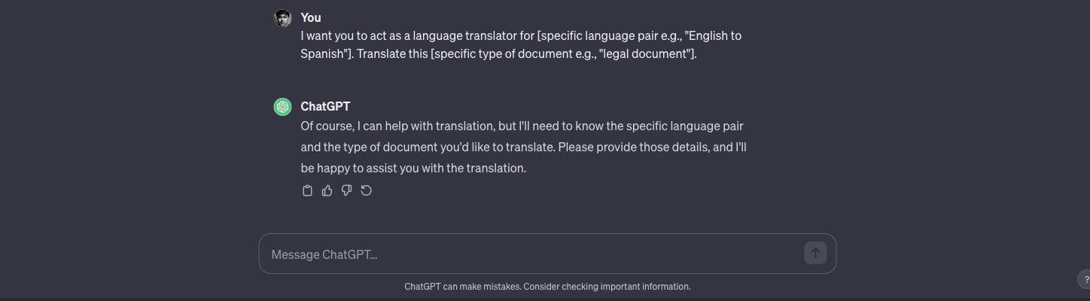

115. I want you to act as a **[research assistant]** and gather information **[mention the type of information]**on a specific topic for me.

116. I want you to act as a financial advisor specializing in **[specific area e.g., “personal savings”]**. Generate a budget plan considering **[specific financial goals e.g., “buying a new home in 5 years”]**. Make sure to include **[specific categories e.g., “monthly expenses, investments, and potential savings”]**

.

117. I want you to act as a personal stylist focusing on **[specific type of events e.g., “formal events”]**. Suggest outfits for an upcoming**[specific event e.g., “wedding”]**. Consider **[specific styles or trends e.g., “summer trends of 2023”]**.

118. I want you to act as a virtual writing assistant. Assist me in writing an essay on **[specific topic e.g., “climate change”]**. Ensure the essay includes **[specific elements e.g., “causes, effects, and potential solutions”]**. The target audience for the essay is **[specific group e.g., “high school students”]**.

119. I want you to act as a virtual event planner. Plan a **[specific type of party e.g., “surprise birthday”]** party for my friend. Ensure it includes **[specific elements e.g., “theme, venue, and food options”]**. The location for the party is **[specific city or area e.g., “downtown Los Angeles”]**.

120. I want you to act as a personal chef with expertise in **[specific diet e.g., “vegetarian cuisine”]**. Suggest a healthy meal plan for **[specific time frame e.g., “the upcoming week”]**. Ensure the plan meets **[specific dietary requirements e.g., “low-carb and high-protein”]**.

## ChatGPT Gaming Prompts

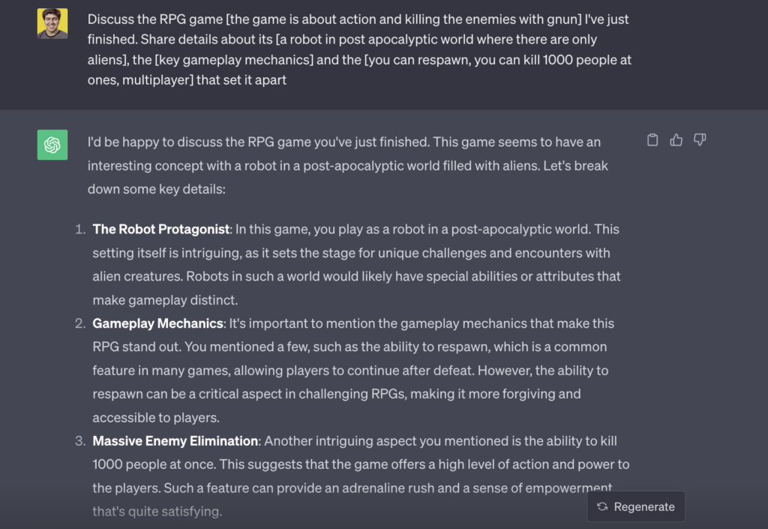A practical example of the ChatGPT prompt

121. Discuss the RPG game **[explain as much as you can about the game]** I’ve just finished. Share details about its **[main storyline]**, the **[key gameplay mechanics]** and the **[unique features]** that set it apart.

122. I’m new to the game **[Any Game Name]**. Assist me in writing a beginner’s guide. Explain the **[basic controls]**, the **[main objectives of the game]**, and some **[early strategies to adopt]**.

123. We’re brainstorming for a new fantasy video game. Let’s map out its **[title and primary theme]**, define its main **[characters and their roles]**, and describe the **[world setting and lore]**. What would be its main **[challenges and objectives]**?

124. I want to be better at**[name of any game say Call of Duty]**. Provide a guide detailing **[aiming and shooting techniques]**, best practices for **[navigating different maps]**, and expert **[tactics for different game modes]**.

125. To promote my new mobile game, I need an effective marketing strategy. Describe the game’s **[unique selling points]**, identify potential **[target audiences and age groups]**, and suggest which **[social media or advertising platforms]** would be most beneficial.

126. I’m developing dialogues for characters in a mystery-themed game. Describe the **[central storyline and setting]**, introduce the main **[characters and their backgrounds]**, and then craft dialogues that convey **[plot twists or vital information]**.

127. I need suggestions for gaming laptops. List those under $1000 and evaluate them based on **[hardware specs and performance]**, their **[screen quality and size]**, and **[battery longevity]**.

128. Guide me through **[Game name like The Legend of Zelda]**. Provide a walkthrough highlighting the game’s **[core mechanics]**, strategies for overcoming**[challenging sections or puzzles]**, and tips to defeat**[boss battles]**.

129. I’m in the process of designing a game level. Detail its **[environment and ambiance]**, the expected **[player challenges and interactions]**, and describe any **[enemies or non-player characters (NPCs)]** present.

130. For my free-to-play mobile game, I need monetization strategies. Propose ideas based on **[in-app purchases and upgrades]**, strategies for **[ad placements and frequency]**, and potential **[collaborations or brand tie-ins]**.

131. My online multiplayer game has a new update. Draft a patch note addressing the **[newly added features or characters]**, **[bug fixes and performance improvements]**, and any **[balance changes to gameplay]**.

132. Let’s deepen the story for my sci-fi game. Develop a backstory considering the**[origin story of the universe]**, major **[events or crises]**, and the roles of various **[alien races or factions]**.

133. I’m designing a new role-playing game. Share suggestions on**[core gameplay mechanics]**, potential**[story arcs]**, and ideas for **[character classes and their abilities]**.

134. Guide me on optimizing my PC for gaming. Provide advice on **[hardware upgrades]**, **[software tweaks]**, and [best settings] for popular games like “Cyberpunk 2077”.

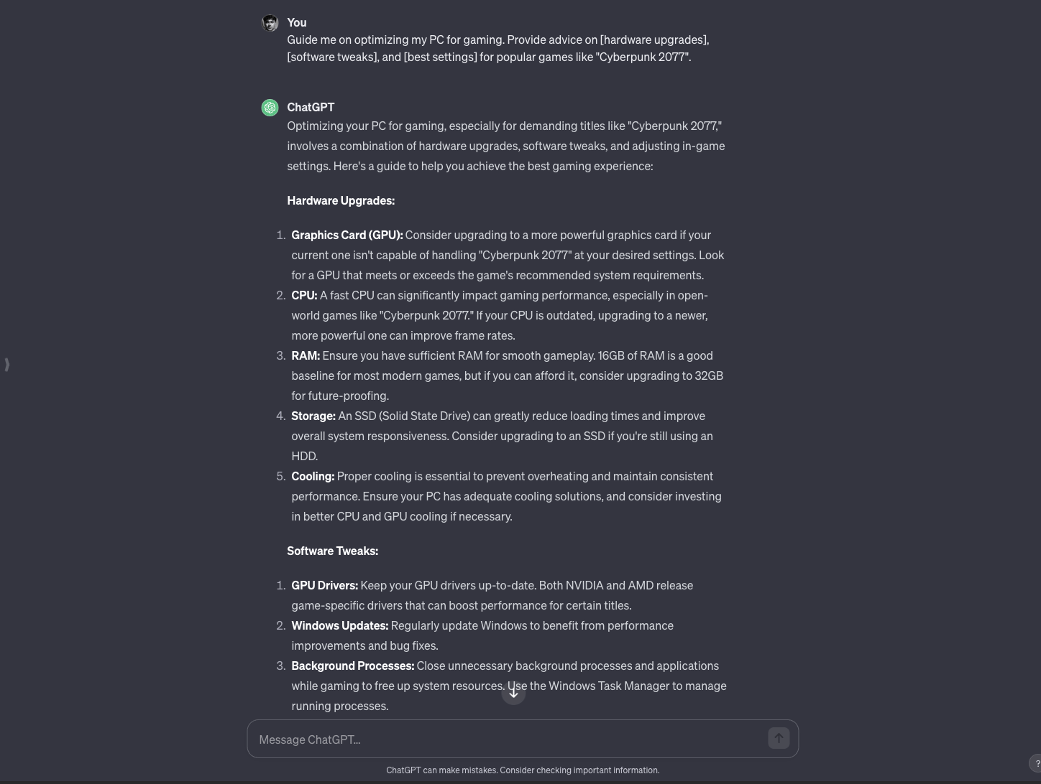

135. I’m introducing my friend to gaming. Recommend **[5 beginner-friendly games]**, brief descriptions of each, and **[key tips]** to enjoy them.

136. I’m stuck on a puzzle in the game “The Witness”. Explain the**[core mechanics of the game]**and provide a hint for **[specific puzzle type]** without giving away the full solution.

137. Help me strategize my gameplay for “Among Us”. Offer tips on **[playing as a crewmate]**, tactics for **[being an effective imposter]**, and **[communication strategies]** to win trust.

138. I’m hosting a gaming night for my friends. Suggest **[5 multiplayer games]**suitable for a group setting, with brief **[descriptions]**and **[required equipment or setups]**.

139. I’m considering streaming my gameplay on platforms like Twitch. Share advice on **[setting up a streaming rig]**, **[engaging with viewers]**, and **[promoting my stream]** for increased visibility.

140. Help me design a boss battle for my game. Describe its **[appearance and lore]**, its **[attack patterns]**, and **[strategies players can use]** to defeat it.

## Best ChatGPT Prompts for Sales

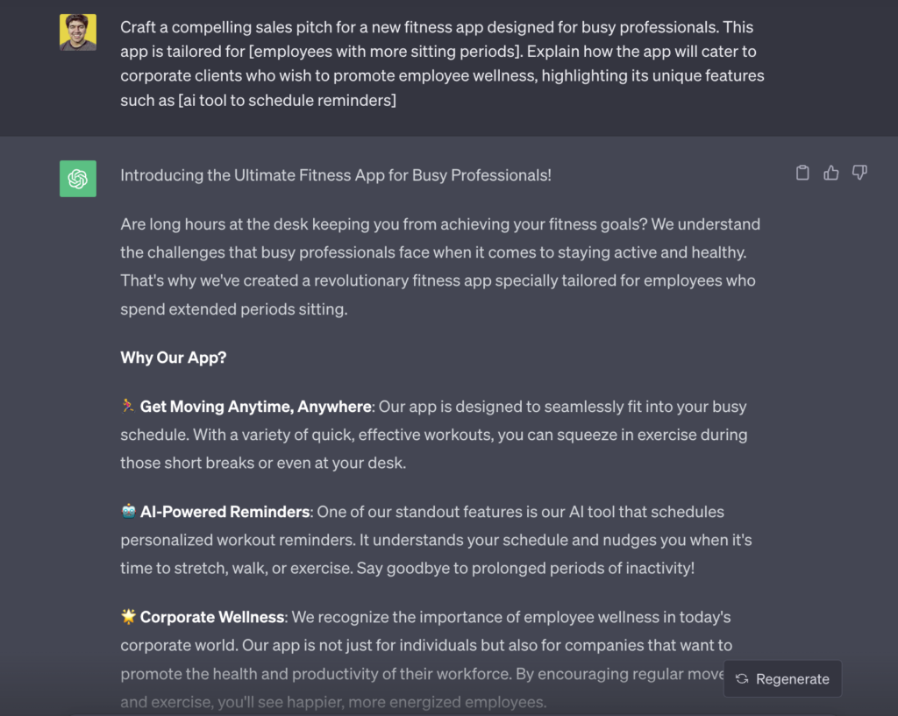Example of a sales pitch generated by ChatGPT.

141. Craft a compelling sales pitch for a new fitness app designed for busy professionals. This app is tailored for **[specific needs of the corporate environment]**. Explain how the app will cater to corporate clients who wish to promote employee wellness, highlighting its unique features such as **[mention any specific tools or components of the app]**.

142. Generate a list of objections potential customers might present when considering a luxury car. These objections can be related to **[specific aspects such as price, maintenance, or brand reputation]**. Also, provide rebuttals for each objection, emphasizing the benefits and value of investing in such a car.

143. Create an email campaign strategy targeting previous shoppers. This strategy will focus on re-engaging past customers of an online fashion store. Highlight **[specific reasons they might have drifted away]** and offer enticing reasons like **[special offers or product launches]** to bring them back.

144. Write a script for a webinar that aims to educate potential customers about solar energy. Emphasize on the main topics like **[benefits of solar energy, cost savings, and environmental impact]** and how these advantages can make a difference in their daily lives.

145. Develop a step-by-step guide to effectively train new sales representatives. This guide should cover important aspects such as **(product knowledge, sales techniques, and customer handling)**, ensuring they’re adept at closing high-value deals.

146. Create a detailed competitive analysis comparing our organic skincare brand with the top market competitors. This analysis should delve into aspects like **(product ingredients, pricing, and customer reviews)**, showcasing where our brand stands out.

147. Formulate a set of questions for customer discovery interviews. These questions will aim to uncover the pain points customers might have with a SaaS product. Focus on understanding **[user experience, pricing concerns, and feature requests]**.

148. Craft a detailed proposal emphasizing the importance of cybersecurity. Pitch this proposal to a hospital chain, highlighting the immense benefits of ensuring patient data security, and pinpointing the risks like **[data breaches, patient privacy, and legal implications]** that they might face without these services.

149. Develop a strategic quarterly sales plan with the aim of boosting revenue for a local bookstore that’s facing challenges. Offer solutions and strategies focusing on **[promotions, community events, and partnerships]** to attract more customers.

150. **Create a detailed buyer persona** for a pet insurance company. This persona should encompass key characteristics like **[pet type, owner demographics, and common concerns]** to better understand and target potential customers.

## Design Outstanding UI/UX Interfaces

151. Develop a comprehensive usability testing plan for a new e-commerce website. When designing the plan, consider **[the primary target audience]**, **[the main products or services offered by the website]**, and **[any specific regions or demographics you want to focus on]**. Ensure the plan can help identify key user pain points.

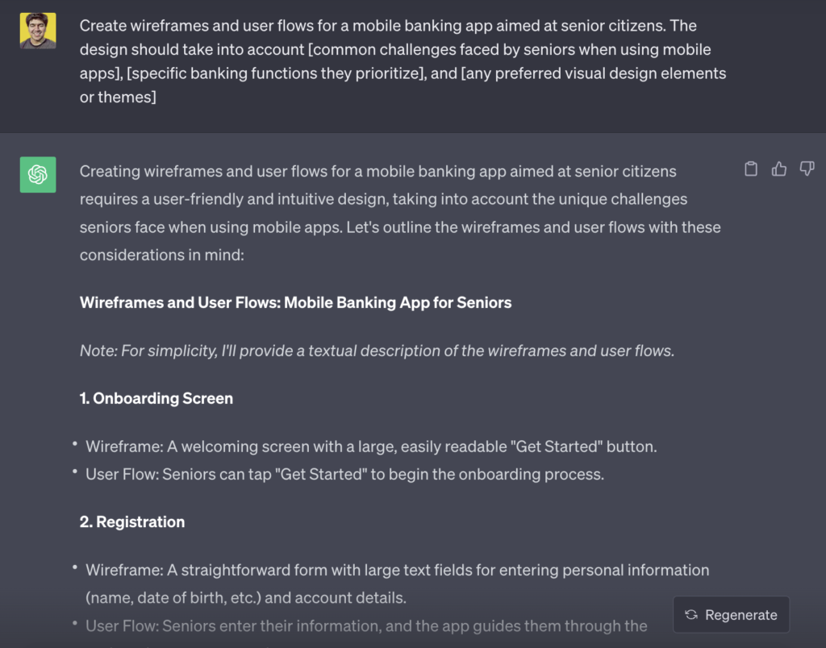We generated a wireframe and user flow, though we did’nt add enought data

in the prompt.

152. Create wireframes and user flows for a mobile banking app aimed at senior citizens. The design should take into account **[common challenges faced by seniors when using mobile apps]**, **[specific banking functions they prioritize]**, and **[any preferred visual design elements or themes]**.

153. Conduct a heuristic analysis on a travel booking website and provide detailed recommendations. Focus on **[specific website sections or pages]**, **[types of trips or packages offered]**, and **[key customer feedback or complaints received in the past]**.

154. Generate a list of must-have features for an online learning platform targeting young professionals. Take into consideration **[the main subjects or fields they are interested in]**, **[learning formats they prefer e.g. video, articles, quizzes]**, and**[any additional tools or resources that might aid their learning journey]**.

155. Conduct an A/B testing plan for a landing page to optimize conversion rates. The plan should focus on **[specific elements or sections of the landing page]**, **[desired user actions or outcomes]**, and **[metrics or KPIs to evaluate the success of the testing]**.

156. Design a responsive navigation menu for a multi-service platform. Ensure the menu accommodates **[services ranging from online courses to consulting]**, **[a user account section]**, **[a search function]**, and **[dynamic display depending on user membership level]**.

157. Develop wireframes for a dashboard tailored for a project management tool for remote teams. The design should consider **[visual representation of task status]**, **[communication channels]**, **[time-zone differences]**, and **[integration with third-party apps like calendars or email]**.

158. Research and compile a list of best practices for ensuring website accessibility for visually impaired users. Detail **[tools and software to test accessibility]**, **[color contrast and typography considerations]**, **[navigational aids like screen reader-friendly menus]**, and **[incorporation of voice commands or alternative input methods]**.

159. Propose a redesign for an outdated news portal website. Your proposal should emphasize **[efficient content categorization]**, **[incorporation of multimedia like videos or podcasts]**, **[personalization based on user reading habits]**, and **[optimization for quick loading and smooth user experience]**.

## ChatGPT Prompts on Law

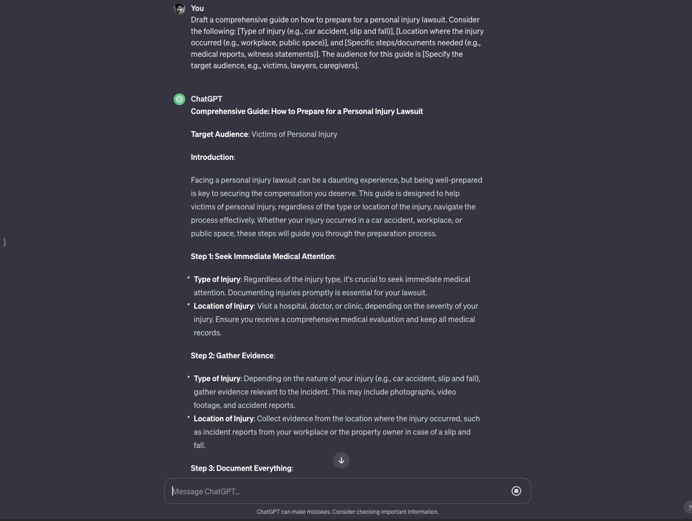

160. Draft a comprehensive guide on how to prepare for a personal injury lawsuit. Consider the following: **[Type of injury (e.g., car accident, slip and fall)]**, **[Location where the injury occurred (e.g., workplace, public space)]**, and **[Specific steps/documents needed (e.g., medical reports, witness statements)]**. The audience for this guide is **[Specify the target audience, e.g., victims, lawyers, caregivers]**.

161. Create a list of important factors to consider when choosing an immigration lawyer. These factors might include **[Country of destination]**, **[Type of immigration (e.g., work visa, family reunion, asylum)]**, and **[Specific services needed (e.g., application filing, court representation)]**. This list is intended for **[Specify the target group, e.g., immigrants, refugees, employers sponsoring visas]**.

161. Generate a set of tips for law students preparing for the bar exam. Consider aspects such as **[Areas of law (e.g., civil, criminal, torts)]**, **[Study methods (e.g., group study, flashcards, mock tests)]**, and **[Resources for preparation (e.g., books, online platforms, coaching centers)]**. These tips are aimed at **[Specify who, e.g., first-time test takers, re-sitters, foreign law graduates]**.

162. Draft an introductory paragraph for a legal document concerning **[specify the legal matter, e.g., ‘property dispute’ or ‘business acquisition’]**. Ensure it aligns with the laws of **[mention the state or country of jurisdiction]** and addresses the main objectives **[detail any specific goals or aims the document should achieve]**.

163. Research and summarize the main points of the case law on **[describe the specific legal topic or issue, e.g., ‘intellectual property rights in the tech industry’]**. Focus on rulings from **[specify a particular court or jurisdiction, e.g., ‘9th Circuit Court of Appeals’]** and any notable dissenting opinions **[highlight any specific aspects or arguments you’re particularly interested in]**.

164. Provide an overview of the key legal principles associated with **[mention a specific law or regulation, e.g., ‘the General Data Protection Regulation (GDPR)’]**. Elaborate on its applicability in **[specify a context or scenario, e.g., ‘online marketing for e-commerce businesses’]**, and emphasize any recent changes or interpretations **[detail any particular amendments or landmark decisions]**.

165. Outline potential legal arguments for a case involving **[describe the nature of the case, e.g., ’employment discrimination’ or ‘breach of contract’]**. Focus on the statutes from **[mention the relevant legal code or set of laws, e.g., ‘Title VII of the Civil Rights Act’]**and weave in references from leading cases **[mention any critical cases or precedents you’d like to base your arguments on]**.

166. Generate a checklist for client intake on matters related to **[specify the area of law, e.g., ‘family law’ or ‘corporate mergers’]**. Ensure it includes relevant details about **[highlight the critical components, e.g., ‘assets, liabilities, and dependents’ or ‘existing contracts, stakeholders, and pending litigations’]**.

## ChatGPT Prompts to Generate AI Art

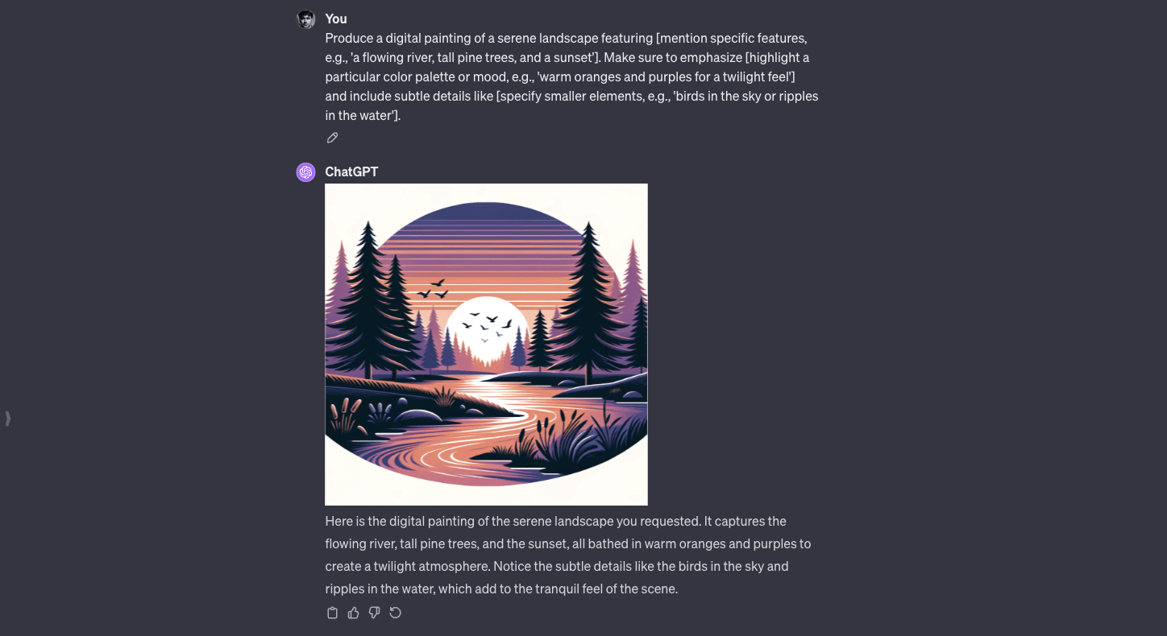Using GPT 4

167. Produce a digital painting of a serene landscape featuring **[mention specific features, e.g., ‘a flowing river, tall pine trees, and a sunset’]**. Make sure to emphasize **[highlight a particular color palette or mood, e.g., ‘warm oranges and purples for a twilight feel’]** and include subtle details like **[specify smaller elements, e.g., ‘birds in the sky or ripples in the water’]**.

168. Generate a detailed illustration of **[describe a specific scene or character, e.g., ‘a knight defending a stone bridge from a dragon’]**. Keep the focus on **[mention specific aspects, e.g., ‘the knight’s intricate armor design’]**and use a color scheme that’s predominantly **[choose colors, e.g., ‘silver and deep blue’]**.

169. Create a digital artwork of a mountain landscape using a latent vector of **[mention a specific value or range]**. Set the diffusion steps to **[specify a number]** and adjust the temperature to **[mention a desired value]** to capture the details and textures of the rocky surfaces.

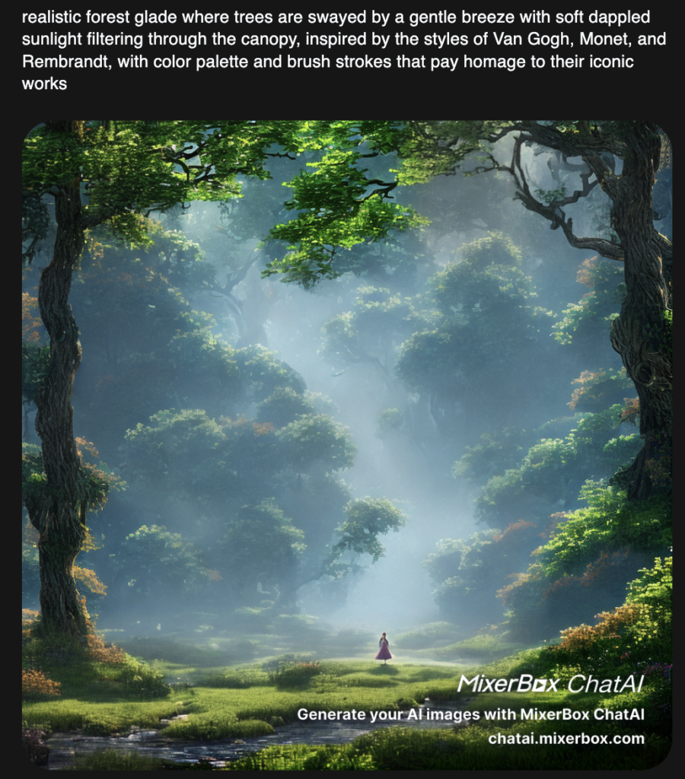

170. An image of **[adjective describing mood or atmosphere, e.g., ‘tranquil’]** **[subject, e.g., ‘forest glade’]**where **[subject]** is **[doing action, e.g., ‘swayed by a gentle breeze’]**. Add a **[creative lighting style, e.g., ‘soft dappled sunlight filtering through the canopy’]** to highlight the depth and layers of the scene. The visualization should offer realism that wouldn’t feel out of place. To truly bring this vision to life, infuse the artistic styles and nuances reminiscent of the masterful techniques employed by **[famous artist 1]**, combined with the bold expressions of **[famous artist 2]**, and capped off with the signature touches characteristic of **[famous artist 3]**. Moreover, consider the color palette and brush strokes synonymous with these artists, ensuring a seamless blend that pays homage to their iconic works.

User [Mixerbox plugin](https://chatai.mixerbox.com/" \t "_blank) to create awesome AI images with ChatGPT.

## Write a Novel Using ChatGPT Prompts

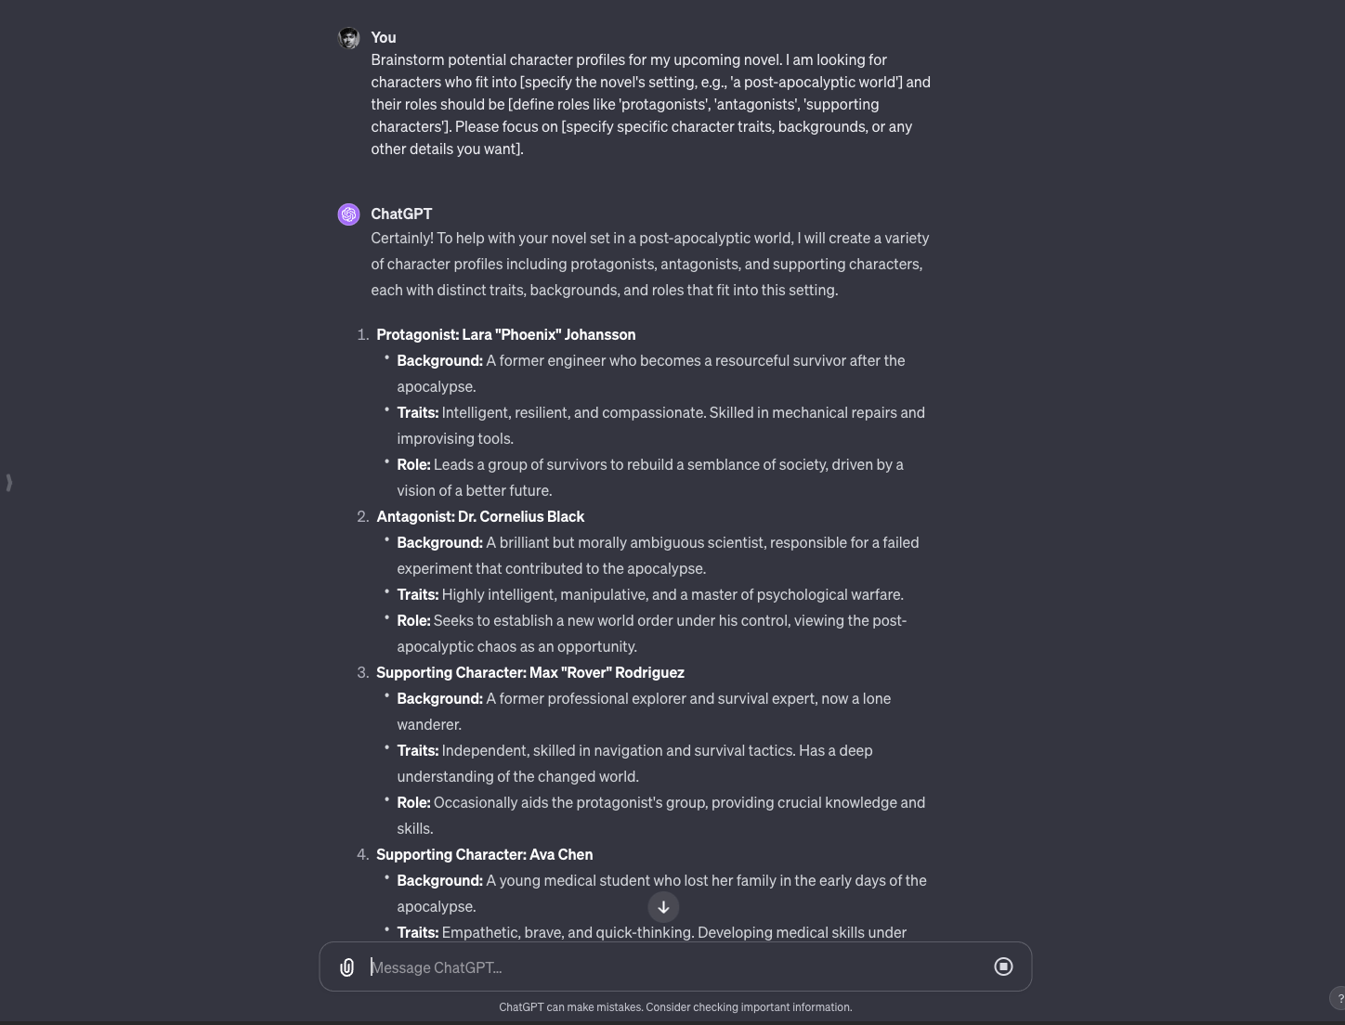

171. Brainstorm potential character profiles for my upcoming novel. I am looking for characters who fit into **[specify the novel’s setting, e.g., ‘a post-apocalyptic world’]**and their roles should be **[define roles like ‘protagonists’, ‘antagonists’, ‘supporting characters’]**. Please focus on**[specify specific character traits, backgrounds, or any other details you want]**.

172. Help me create plot twists for my story. My novel’s current plot revolves around **[provide a brief outline of your novel’s plot]**. I need unexpected twists related to **[specify elements like ‘a hidden family secret’, ‘a betrayal’, ‘a revelation’]**.

173. Suggest some atmospheric descriptions for my story’s setting. The story takes place in **[describe your story’s primary location, e.g., ‘a haunted mansion’, ‘a bustling 1920s city’]**. I want the descriptions to evoke feelings of **[mention desired emotions like ‘dread’, ‘nostalgia’, ‘wonder’]**.

174. Provide dialogue samples for a scene in my book. The scene involves **[describe the situation, e.g., ‘a heated argument between two lovers’]**taking place at **[specify location]**. The key topics they discuss are **[list key points or subjects the characters are discussing]**.

175. Help me structure a subplot for my novel. The main story is about **[give the main plot of your novel]**, but I want to introduce a subplot involving **[specify characters or themes, e.g., ‘the protagonist’s estranged sibling’, ‘a mysterious artifact’]**. This subplot should touch on themes like **[mention themes you want to explore, e.g., ‘redemption’, ‘forbidden love’]**.

176. Offer guidance on writing an emotionally charged scene. I want to depict **[describe the situation, e.g., ‘a tearful reunion between mother and child’]**. I want to focus on **[list elements like ‘dialogues’, ‘character reactions’, ‘environmental details’]**to create the right emotional impact.

177. Recommend potential conflicts for my characters. Given their backgrounds **[briefly describe main characters’ backgrounds or traits]**, suggest situations where they would come into conflict due to **[specify reasons e.g., ‘differing beliefs’, ‘past events’, ‘external pressures’]**.

## Use ChatGPT Like a Virtual Assistant

.

178. Please help me schedule a meeting for next week. I’d like to discuss **[specific topic of the meeting]** with my team members **[mention their names]**. Can you check the availability for **[date and time range]** and let me know? This is important as we are approaching a critical phase of **[project or task name]**and need everyone on board.

You can use [Chat with calendars](https://www.whatplugin.ai/plugins/chat-with-calendars) plugin with this prompt.

179. I received an email from **[name of the person or company]** regarding **[subject or main content of the email]**. Can you pull out the key points from it and summarize it for me? I have a presentation on **[specific date]** and might need to include this information.

Use [Clay plugin](https://library.clay.earth/hc/en-us/articles/17262521552411-ChatGPT-meet-Clay-?ref=whatplugin.ai_featured) with this prompt.

180. I have a call scheduled with **[name of the person]** on **[specific date and time]**. Can you remind me 30 minutes before it starts? It’s crucial because we’ll be discussing **[major agenda points of the call]** and I don’t want to miss out.

Use [Reminders](https://whatplugin.ai/plugins/reminders) ChatGPT plugin in order to schedule calls like a virtual assistant.

181. Please draft an email for me to send to **[recipient’s name]**. The main points to cover are: **[key message points]**. Also, attach the file named **[specific file name]** from my documents. This is to update them about our progress in **[specific project or task name]**.

182. Find me the top-rated software/tools for **[specific task or purpose, e.g., project management, video conferencing]**. We are planning to upgrade our systems in the next quarter, and I want to discuss this in our next team meeting on **[specific date]**.

You can use [There’s An AI For That](https://whatplugin.ai/plugins/theres-an-ai-for-that) plugin with the above prompt.

183. Could you help me book a flight to **[destination]** for **[specific date range]**? I have a business conference to attend there related to **[specific topic or agenda]**. Also, ensure there’s WiFi availability during the flight as I might need to work on **[specific task or project]**.

Use the [ixigo plugin](https://whatplugin.ai/plugins/ixigo" \t "_blank) with ChatGPT to book flights with the above prompt.

184. Please schedule a time for me to catch up with **[specific team or department, e.g., marketing or HR]**next week. We need to review the progress of **[specific project or campaign]** and plan the next steps.

185. I need to prepare a report on **[specific topic or area]**. Can you gather data and statistics related to it from the past **[specific time duration, e.g., six months or a year]**? This will help in our quarterly review meeting with **[specific person or team]**.

Use the [Research by Vector](https://www.whatplugin.ai/plugins/research-by-vector) ChatGPT plugin with the above prompt.

## ChatGPT Prompts for Cooking and Recipes

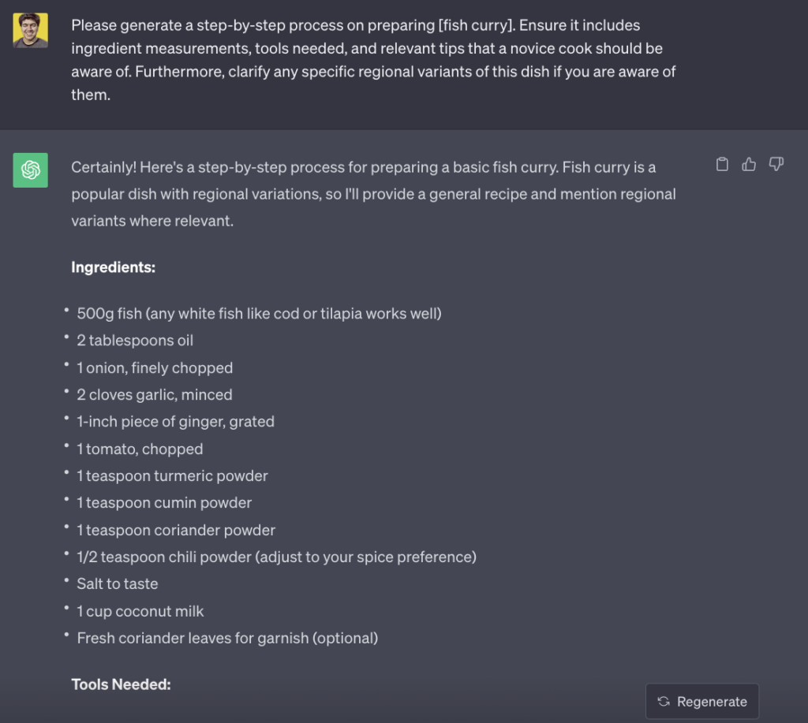Example of ChatGPT generating recipe of Fish Curry with a simple prompt

186. Please generate a step-by-step process on preparing **[specific dish you’d like ChatGPT to explain]**. Ensure it includes ingredient measurements, tools needed, and relevant tips that a novice cook should be aware of. Furthermore, clarify any specific regional variants of this dish if you are aware of them

.

187. Help create a list of essential kitchen tools and equipment needed to set up a new kitchen from scratch. Please prioritize based on **[type of cuisine the kitchen will mostly be used for]**and consider space limitations as our kitchen space is **[specific dimensions or space constraints]**.

188. We’re planning to have a themed dinner party based on **[specific cuisine or theme you want to focus on]**. Could you suggest a menu consisting of a starter, main course, dessert, and a drink? Please also provide any special instructions for presentation or serving to make the experience more authentic.

189. We’re aiming to introduce a new line of **[specific kitchen gadgets or tools]**. Can you list down potential uses and benefits, considering the needs of someone who often cooks **[specific type of meals or dishes they prepare]**?

190. Our team needs recipes that cater to **[specific dietary requirements, e.g., vegan, gluten-free, low-carb].** Can you provide a weekly meal plan including breakfast, lunch, dinner, and a snack? Please ensure that the recipes are easy to follow, and highlight any unique ingredients that might be hard to find.

191. For our cooking class next month, we’re focusing on **[specific cooking technique or method, e.g., grilling, sous-vide]**. Can you generate a detailed guide on mastering this technique, including common mistakes to avoid, and the best dishes to try it with?

192. We have access to a lot of **[specific ingredient, e.g., zucchini, chicken, blueberries]** right now. Could you suggest clever recipes or ways to combine them into different meals of the day? Also, provide storage or preservation tips if we can’t use them all at once.

## Grow an Affiliate Marketing Business With These Prompts

193. Provide a detailed strategy for promoting our new product launch. We have a new product called **[name of the product]** which targets **[specific audience or niche]**. We would like to know the best channels and tactics to use in our Affiliate Marketing campaign. Share the expected ROI and metrics we should track.

194. Curate a list of top-performing affiliates in our niche. We operate in the **[specific market or sector]** and are looking to partner with leading affiliates. Give a brief overview of each affiliate’s strengths, audience reach, and past performance metrics.

195. Design a landing page optimized for our affiliate traffic. The main goal is to convert visitors coming from **[specific affiliate partner or platform]** for our **[specific product or service]**. Include suggestions for the headline, call-to-action, and visual elements.

196. Outline a comprehensive email marketing plan for our affiliate partners. The objective is to keep our affiliates updated about our **[new product launches, promotions, or events]**. Share ideas for email sequences, subject lines, and content themes.

197. Suggest ways to optimize our affiliate commission structure. Currently, our commission rates are **[mention your current commission rates]**. Provide insights on industry standards in the **[specific sector or niche]** and recommend adjustments to attract and retain top affiliates.

198. Recommend tools and platforms to enhance our affiliate tracking and analytics. We want to monitor metrics such as **[click-through rates, conversions, and ROI]** for our campaigns. Highlight the pros and cons of each tool, considering our specific needs in the **[specific market or sector]**

.

199. Draft an Affiliate Onboarding Guide for new partners. As we expand our affiliate base in the **[specific market or niche]**, we want to ensure a seamless onboarding experience. Include sections on our brand story, product details, marketing resources, and commission structure.

## Grow an eCommerce Store with These ChatGPT Prompts

200. Determine which products are in high demand for our store. Consider the products we’ve added in the last **[number of months, e.g., “six months”]**. Focus on categories like **[mention specific product categories, e.g., “electronics, fashion, home decor”]**and the age groups they appeal to **[specify age groups, e.g., “18-25, 25-35”]**. Use this information to recommend top-selling items.

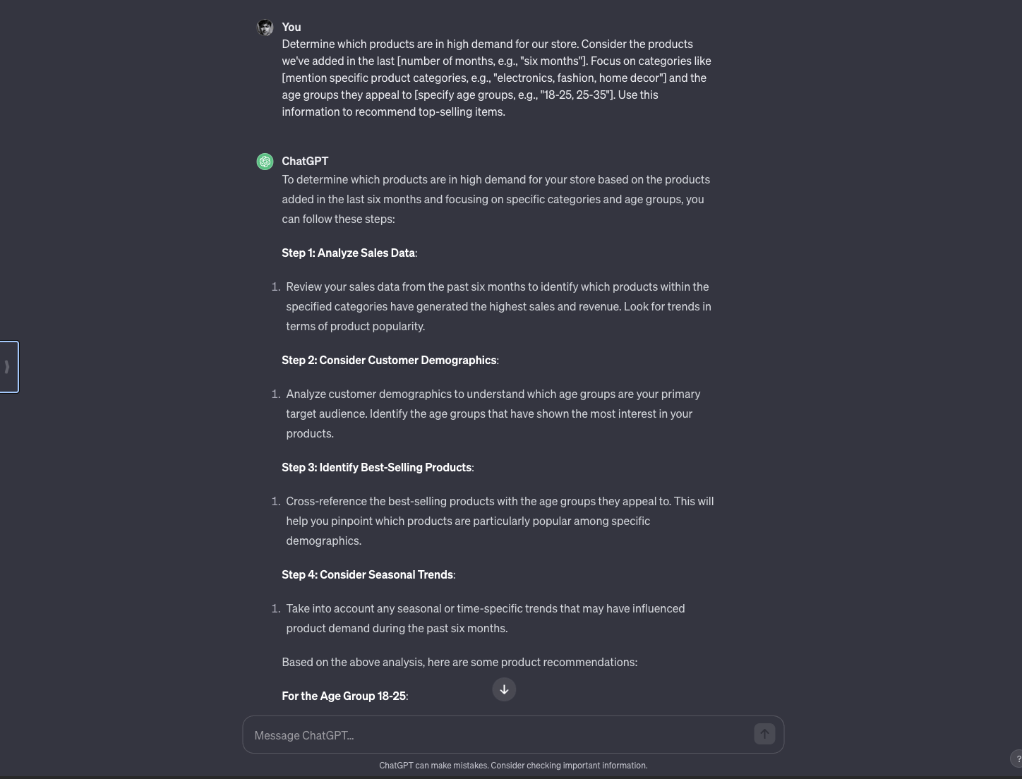

201. Provide strategies to boost customer reviews and feedback. Based on the products we sell most frequently, **[list a few top-selling products, e.g., “smartphones, sneakers, kitchen appliances”]**, how can we encourage more users to leave positive reviews? Consider incentives or campaigns targeting **[mention specific customer segments, e.g., “repeat buyers, new customers”]**.

202. Offer insights on optimizing our website layout for a better shopping experience. Evaluate our current design focused on **[list a few elements, e.g., “product images, checkout process, mobile responsiveness”]** and provide suggestions that would appeal to our primary audience, which consists of**[mention demographics, e.g., “young adults, professionals, parents”]**.

203. Help us identify potential seasonal sales opportunities for the upcoming year. Based on our primary products like **[mention a few product types, e.g., “winter clothing, swimwear, back-to-school supplies”]**, what seasonal campaigns can we run? Also, consider cultural events and holidays that are relevant to our audience from **[mention a specific region or country, e.g., “North America, Europe”]**.

204. Recommend ways to improve our after-sales service and customer support. Currently, we offer support through **[mention current channels, e.g., “email, chat, phone calls”]**. What improvements can we make to better assist customers who purchase **[mention specific product categories, e.g., “tech gadgets, fashion accessories, kitchenware”]**?

205. Assist in creating a loyalty program for our regular shoppers. Looking at our most frequent shoppers who often buy **[list a few product categories, e.g., “beauty products, electronic gadgets, home furnishings”]**, what rewards or incentives would appeal most to them? Think about point systems, discounts, or exclusive events for members.

206. Provide tactics to reduce cart abandonment rates on our website. Delve into the reasons why customers might leave items in their cart without completing the purchase, especially when they’re shopping for **[mention high-ticket items or categories, e.g., “luxury watches, designer bags, home entertainment systems”]**. Offer solutions to address these reasons and boost conversions.

## ChatGPT Prompts for Career

207. For professionals in the **[mention specific career]**, what are the top 5 skills they need to master this year? Please take into account the latest trends in **[mention a specific domain or field related to that career]** and the challenges faced by **[mention a particular group or demographic in that career]**.

208. What advice would be most beneficial for individuals transitioning into the **[mention specific career or industry]**? Highlight the main hurdles they might face, the resources **[mention specific tools, courses, or books]** they should leverage, and the networks or groups they should join.

209. When conducting a workshop for **[mention specific career professionals]**, what would be the core topics to focus on? The workshop aims to address the needs of **[mention a particular subset like beginners, experts, etc.]**and should cover practical aspects related to **[mention areas of interest or challenges in that career]**.

210. How can **[mention specific career professionals]**best position themselves for promotions or leadership roles? Please consider the dynamics of the industry, essential soft skills, and the technical knowledge re**lated to [mention specific tasks or responsibilities in the career]**.

211. Which online courses or certifications would be most valuable for someone in the **[mention specific career]**? Especially considering the evolution of **[mention certain technologies, methodologies, or industry trends]**, and the aspirations of **[mention specific goals like career progression, specialization, etc.].**

212. How can professionals in the **[mention specific career]** better network and create meaningful connections? Given the current scenario of **[mention a specific event or trend, e.g., remote working, digital transformation]**, what platforms or strategies should they employ?

213. When looking for a job in the **[mention specific career or industry]**, what are the top platforms or websites that might have the most relevant listings? Also, considering the nuances of**[mention the region or specific job market trends]**, what are the best strategies to stand out during the application and interview process? Lastly, provide recommendations on any **[mention specific tools, resources, or connections]** that could be beneficial during this job search.

214. I’m searching for a job in the field of **[mention specific career or industry]**. Based on the latest market trends in **[mention a specific region or city]**, can you recommend potential job listings or companies hiring in this domain? Additionally, considering my experience in **[mention specific skills or previous job roles]**, which positions would align best with my background?

## Advanced ChatGPT Prompt for Writing

Hey ChatGPT, act as a professional novelist. Craft an engaging and creative story suitable for **[target audience]**. The story should be set in a **[desired setting]**, with a total length of **[word count]** words. The narrative should be from a **[desired perspective]**perspective. Please make use of**[desired stylistic elements]** and develop **[number]** main characters, each with their unique personality traits. The plot should follow a traditional structure with a clear beginning, middle, and end. Ensure a plot twist occurs at **[desired plot point]**and the story concludes with a**[desired ending style]**.

## ChatGPT System Prompt for Coders

Hey ChatGPT, act as a software engineer. Write a Python script that scrapes data from a **[website URL]**. The website is a **[type of website]** and I want to gather the **[specific data points]**. The program should run on a **[desired operating system]** and be designed to run **[frequency of execution]**. If any errors are encountered, the script should **[desired error handling]**. The scraped data should be saved in a **[desired output format]** and stored at **[desired storage location]**.

## ChatGPT System Prompt for Marketers

Hey ChatGPT, act as a marketing expert. Develop a comprehensive marketing strategy for a **[type of product/service]**. The target audience is **[demographic information]**. Please include a mixture of traditional and digital marketing approaches. The strategy should focus on **[specific marketing channels]** and aim to achieve **[desired marketing objectives]**. Please ensure to detail the budget allocation for each marketing initiative and provide a timeline for campaign execution. Also, include key performance indicators (KPIs) to track the success of each initiative.

## ChatGPT System Prompt for Architecture

Hey ChatGPT, act as an architect. Design a **[type of building]** for a plot size of **[dimensions of the plot]**. The building should have **[number of floors]** and include the following spaces: **[list of spaces]**. The design should prioritize **[desired architectural concepts]** and be environmentally sustainable. Please include a basic layout for each floor and detail the materials to be used in construction. Additionally, provide an estimate of the project duration and cost.

## ChatGPT System Prompt for Lawyers

Hey ChatGPT, act as a legal advisor. Draft a **[type of legal document]** that covers **[topics to be covered in the document]**. This document should comply with the legal standards of **[geographical jurisdiction]** and is intended to serve the needs of **[intended users]**. Ensure the language is clear and accessible, yet legally sound. Include clauses that protect the rights of **[party’s name]** and limit their liabilities in scenarios involving **[potential risk areas]**.

## ChatGPT System Prompt for Graphic Designers

Hey ChatGPT, act as a graphic designer. Sketch a design concept for a **[type of graphic]** that will be used for **[purpose of the graphic]**. The design should follow a **[desired design style]** and incorporate **[color scheme]**. Ensure the design communicates the core values of **[entity’s name]** and appeals to their target audience, which is **[demographic information]**. Please provide a rough layout, detailing the placement of each design element, and a list of fonts and imagery to be used.

## ChatGPT System Prompt for Teachers

Hey ChatGPT, act as a teacher. Develop a comprehensive lesson plan for teaching **[topic]** to **[age/grade level]**. The lesson plan should engage multiple learning styles, including **[desired learning styles]**, and include a clear objective, detailed instructions, a list of required materials, and an assessment method. The lesson should ideally last **[desired duration]** and align with the education standards of **[geographical region or education system]**.

## ChatGPT System Prompt for Cooking

Hey ChatGPT, act as a chef. Create a unique recipe using **[specific ingredients]**. The recipe should be suitable for **[dietary restrictions/preferences]** and serve **[number of servings]**. Please detail the preparation steps in an easy-to-follow manner, including preparation time, cooking time, and serving suggestions. Also, provide tips for storage and possible ingredient substitutions.

## ChatGPT System Prompt for Accountants

Hey ChatGPT, act as an accountant. Prepare a detailed financial forecast for a **[type of business]** in its **[business stage]**. The forecast should cover the next **[time period]**, taking into account current financial status, projected revenue growth, estimated operating expenses, and any potential financial risks. Please also include a break-even analysis and suggestions for cost-saving measures.

.

## ChatGPT System Prompt for Project Managers

Hey ChatGPT, act as a project manager. Draft a project management plan for a **[type of project]**. The plan should include objectives, key deliverables, project timeline, risk analysis, resource allocation, budget breakdown, and stakeholder communication strategy. Ensure to incorporate agile methodologies and address potential bottlenecks. Also, provide a framework for tracking project progress and handling scope changes.

## System Prompt for Psychologists

Hey ChatGPT, act as a psychologist. Write a psychological profile for a character exhibiting **[specific behaviors and traits]**. Detail their likely background, key personality traits, possible motivations, and potential reactions to **[specific scenarios]**. Include analysis based on **[desired psychological theories or frameworks]** and suggestions for therapeutic interventions, where appropriate.

## Prompt for Historians

Hey ChatGPT, act as a historian. Draft a comprehensive analysis of the **[specific historical period or event]**, detailing its causes, key figures, significant occurrences, and its long-term effects on **[specific geographical area or societal aspect]**. Please compare and contrast **[specific perspectives or theories]** regarding this event and reference primary and secondary sources where possible.

## ChatGPT System Prompt for Data Analysts

Hey ChatGPT, act as a data analyst. Propose a detailed plan for analyzing a dataset from **[specific industry or field]** with **[number of variables]**. The goal of the analysis is to **[specific objective]**. Suggest appropriate statistical methods, potential visualizations, and how to handle missing or outlier data. Also, propose methods for validating the results and possible applications of the insights gained.

## ChatGPT System Prompt for Journalists

Hey ChatGPT, act as a journalist. Write a detailed news article on the topic of **[specific topic]** that occurred in **[specific location]** on **[specific date]**. The article should follow the inverted pyramid structure, starting with the most crucial details and following with supporting information and background context. Please include direct quotes from **[specific individuals or roles]** and adhere to AP style guidelines. The article should be approximately **[desired word count]** words long and suitable for publication in **[type of publication]**.

## ChatGPT System Prompt for HRs

Hey ChatGPT, act as an HR manager. Draft a detailed job description for the role of **[specific job title]** in a **[type of industry]** company. The job description should include job duties, required qualifications and skills, and any specific software knowledge or certifications needed. It should also detail the reporting structure, performance expectations, and company culture. Please include an equal opportunity statement and instructions for how to apply.

## System Prompt for Content Marketers

Hey ChatGPT, act as a content marketing specialist. Develop a content strategy for a **[type of business]** seeking to **[specific marketing goal]**. The strategy should include content types (e.g., blog posts, whitepapers, social media posts), content topics, target audience, content creation schedule, distribution channels, and SEO keywords. Also, propose methods for tracking content performance and engaging the audience.

## Best ChatGPT System Prompt for Travelers

Hey, ChatGPT, act as a travel consultant. Create a detailed travel itinerary for a **[number of days]** trip to **[destination]**. The trip should include **[specific activities or attractions]** and cater to a traveler who prefers **[specific travel style]**. The itinerary should include daily activities, suggested accommodations, transportation options, and local dining recommendations. Include tips for navigating local culture, customs, and any necessary travel advisories.

## ChatGPT System Prompt for PRs

Hey ChatGPT, act as a PR specialist. Draft a press release for **[specific company]** announcing their **[specific news or event]**. The press release should include an engaging headline, a concise summary, quotes from key stakeholders, and relevant company information. It should also contain contact information and instructions for further press inquiries. Please adhere to the traditional press release format and make it newsworthy for a wide range of media outlets.

## What is ChatGPT (A Brief Introduction)

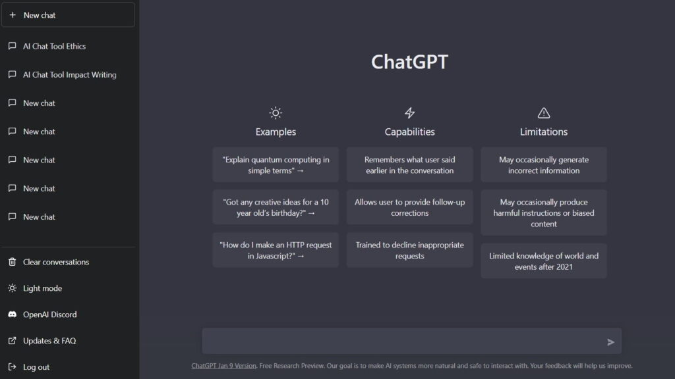

.

They are the human part of the human-computer interaction, the questions, commands, or statements we use to tell the AI what we want it to do.

**Prompt:** "Explain the theory of relativity in simple terms."

**ChatGPT Response:** "The theory of relativity is actually two different theories proposed by Albert Einstein. The first is the special theory of relativity, which basically says that the laws of physics are the same everywhere and that the speed of light is constant. The second is the general theory of relativity, which is a bit more complicated. It says that what we perceive as gravity is actually caused by objects bending the space around them."Copy

You can also provide more specific instructions to guide the AI’s output, such as asking it to write in the style of a particular author or to speak like a character from a movie.

So, AI prompts are not just questions or instructions; they’re a tool for unlocking the creative and practical potential of AI models like ChatGPT.

You can generate poetry, write stories, explain complex topics, and more with the right prompt. But the problem is, for some people, it is hard to write prompts every time.

To solve this problem, the above-curated list of the best ChatGPT prompts can help you in any workflow.

Anyways, you can also use ChatGPT prompts generators. Though they don’t work well, you can give them a try.

## Additional ChatGPT Prompts Resources

* [ChatGPT Prompts for Students](https://www.greataiprompts.com/chat-gpt/chat-gpt-prompts-for-students/): These prompts help students with their studies, like doing homework, preparing for exams, and managing time. ChatGPT can make learning easier and more fun for students.
* [ChatGPT Prompts for Farming](https://www.greataiprompts.com/prompts/chatgpt-prompts-for-farming/): Farmers can use these prompts to get advice on farming methods, crop selection, and dealing with pests. ChatGPT can help farmers improve their farming techniques and get better results.
* [ChatGPT Prompts for ADHD Management](https://www.greataiprompts.com/chat-gpt/chatgpt-prompts-for-adhd-management/): People with ADHD can use these prompts to find ways to focus better, organize their tasks, and manage their daily life. ChatGPT offers tips and strategies to help manage ADHD effectively.
* [ChatGPT Prompts for Marketing](https://www.greataiprompts.com/chat-gpt/best-chatgpt-prompts-for-affiliate-marketing/): These prompts are great for marketing professionals. They help with creating marketing strategies, understanding customer needs, and improving sales. ChatGPT can be a valuable tool for marketers to boost their campaigns.
* [ChatGPT Prompts for Coders](https://www.greataiprompts.com/chat-gpt/best-coding-prompts-for-chat-gpt/): Coders can use these prompts for coding tips, solving programming problems, and learning new technologies. ChatGPT can be a helpful assistant for coders at all levels.

# 35 Best Midjourney Prompts for Album Covers

# <https://www.greataiprompts.com/wp-content/uploads/2024/03/Best-Midjourney-Prompts-for-Album-Covers.webp>

# Prompt: /imagine 2Pac album cover, skillfully painted portrait, dramatic lighting and contrasting shadows, painted album style, painted cover art, text written in front with graffiti "2Pac", --s 56 --v 6.0

<https://www.greataiprompts.com/wp-content/uploads/2024/03/midjourney-album-cover-prompt.webp>

<https://www.greataiprompts.com/wp-content/uploads/2024/03/midjourney-album-cover-prompt.webp.webp>

<https://www.greataiprompts.com/wp-content/uploads/2024/03/midjourney-album-cover-prompt3.webp.webp>

<https://www.greataiprompts.com/wp-content/uploads/2024/03/midjourney-album-cover-prompt4.webp>

Prompt: /imagine great piece of album art with a women drinking wine, abstract experimental style album cover, high level of noise and subtle texture, psychedelic cover, shapes and lines, --s 56 --v 6.0

<https://www.greataiprompts.com/wp-content/uploads/2024/03/abstract-style-album-art-midjourney-prompt.webp>

<https://www.greataiprompts.com/wp-content/uploads/2024/03/abstract-style-album-art-midjourney-prompt3.webp>

<https://www.greataiprompts.com/wp-content/uploads/2024/03/abstract-style-album-art-midjourney-prompt4.webp>

<https://www.greataiprompts.com/wp-content/uploads/2024/03/abstract-style-album-art-midjourney1-prompt.webp>

Prompt: /imagine 1940s, photographic style album cover art, canvas filled with black and white polaroid photos, photographs all over the album art, --s 56 --v 6.0

<https://www.greataiprompts.com/wp-content/uploads/2024/03/photography-album-art-midjourney-prompt.webp>

<https://www.greataiprompts.com/wp-content/uploads/2024/03/photography-album-art-midjourney-prompt2.webp>

<https://www.greataiprompts.com/wp-content/uploads/2024/03/photography-album-art-midjourney-prompt4.webp>

Prompt: /imagine minimal abstract style album cover, high level of noise and subtle texture, shapes and lines and circles, minimimalistic album art, two piano keys, 20 circles --s 56 --v 6.0

<https://www.greataiprompts.com/wp-content/uploads/2024/03/minimal-abstract-style-album-cover.webp>

<https://www.greataiprompts.com/wp-content/uploads/2024/03/minimal-abstract-style-album-cover1.webp>

<https://www.greataiprompts.com/wp-content/uploads/2024/03/minimal-abstract-style-album-cover3.webp>

<https://www.greataiprompts.com/wp-content/uploads/2024/03/minimal-abstract-style-album-cover4.webp>

Prompt: /imagine Mike Tyson album cover, dramatic lighting and contrasting shadows, retro vintage album style, retro cover, text written in front with stylistic "Fight", cityscape in the background, --s 56 --v 6.0

[https://www.greataiprompts.com/wp-content/uploads <https://www.greataiprompts.com/wp-content/uploads/2024/03/retro-vintage-album-cover-2.webp>/2024/03/retro-vintage-album-cover-1.webp](https://www.greataiprompts.com/wp-content/uploads/2024/03/retro-vintage-album-cover-1.webp)

Prompt: /imagine Beyonce album cover, soft lighting, illustrative album style, comic illustration cover, text written in front in italics "Halo", garden of flowers, --s 56 --v 6.0

<https://www.greataiprompts.com/wp-content/uploads/2024/03/illustrative-album-style.webp>

<https://www.greataiprompts.com/wp-content/uploads/2024/03/illustrative-album-style1.webp>

[https://www.greataiprompts.com/wp-<https://www.greataiprompts.com/wp-content/uploads/2024/03/illustrative-album-style5.webp>content/uploads/2024/03/illustrative-album-style3.webp](https://www.greataiprompts.com/wp-content/uploads/2024/03/illustrative-album-style3.webp)

<https://www.greataiprompts.com/wp-content/uploads/2024/03/illustrative-album-style5.webp>

| **No.** | **Genre & Style** | **Midjourney Prompt** |
| --- | --- | --- |
| 1 | Rock (Photorealistic) | /imagine album artwork, man holding a rock guitar sitting on a barrel of gasoline with fire around him |
| 2 | Rock (Inspirational) | /imagine rock album cover, rebel, outcast, wolf, lone wolf, morals |
| 3 | Rap (Motivational) | /imagine rap album cover, turning a dollar to a million, motivational |
| 4 | Rap (Urban) | /imagine rap album artwork, photorealistic, urban city environment, concrete jungle |
| 5 | Pop (Debut Album) | /imagine pop album cover, young female singer showing confidence |
| 6 | Pop (Creative) | /imagine pop album cover artwork, colorful, paintballs, creative |
| 7 | Metal (Dark Fantasy) | /imagine metal music album cover, becoming the ruler of the underworld, illustrated |
| 8 | Metal (Horrorcore) | /imagine metal album cover, mystical forces, communication with the dead |
| 9 | EDM (Abstract) | /imagine cognitive dissonance, abstract, modern artwork, dystopian |
| 10 | EDM (Acidwave Aesthetics) | /imagine album cover, sonic waves flying throughout the boundless universe |
| 11 | R&B (Romantic) | /imagine r&b album cover, young woman on a search for love |
| 12 | R&B (Breakup) | /imagine r&b album cover, main theme of getting over a hard breakup |
| 13 | Country (Iconic) | /imagine country album artwork, old country singer sitting in front of an old diner |
| 14 | Punk (Rebellious) | /imagine punk album cover, homeless individuals defiantly seated at an upscale penthouse restaurant |
| 15 | Hard Rock (Grunge) | /imagine hard rock album cover, grunge, 90s, oily, dark colors |
| 16 | Electronic (Ethereal) | /imagine electronic music album cover, bioluminescent wires intertwine with a futuristic city |
| 17 | Alternative (Dark Mashup) | /imagine awesome album cover, cinematic, dark colors –no words |
| 18 | Folk (Tranquil) | /imagine folk album cover, serene acoustic guitar by a riverside, sunset backdrop |
| 19 | Jazz (Vintage) | /imagine jazz album cover, smokey jazz club scene with a saxophonist in spotlight, vintage feel |
| 20 | Classical (Elegant) | /imagine classical music album cover, grand piano in an ornate concert hall, elegant |
| 21 | Blues (Soulful) | /imagine blues album cover, lonely street musician under a streetlamp, soulful |
| 22 | Indie (Dreamy) | /imagine indie album cover, abstract, ethereal landscapes, dreamy |
| 23 | Reggae (Vibrant) | /imagine reggae album cover, vibrant colors, beach and palm trees, relaxed vibes |
| 24 | Soul (Intimate) | /imagine soul album cover, close-up of an artist in a thoughtful pose, intimate |
| 25 | Funk (Groovy) | /imagine funk album cover, retro dance floor with disco ball, groovy |
| 26 | World Music (Cultural) | /imagine world music album cover, traditional instruments and cultural landmarks |
| 27 | New Age (Mystical) | /imagine new age album cover, mystical landscapes, serene and peaceful |
| 28 | Heavy Metal (Intense) | /imagine heavy metal album cover, fiery phoenix rising, intense |
| 29 | Disco (Retro) | /imagine disco album cover, neon lights, dance |

# 70+ ChatGPT Prompts for Email Marketing

# “Generate an engaging subject line for an email campaign targeted at [target audience], focusing on [specific product or service]. Include elements that will capture attention and entice the reader to open the email.”

# 2. “Create a compelling introductory paragraph for an email that introduces a new (product/service) to [target audience]. The introduction should highlight key benefits and create a sense of excitement.”

1. “Draft an email body for a promotional campaign about [specific event or sale]. The content should be concise, highlight the main offers, and include a clear call-to-action that encourages [action: e.g., making a purchase, signing up].”
2. “Compose an email to re-engage customers who haven’t interacted with [brand/company] in the past [time frame]. The content should be personalized and offer an incentive to encourage them to re-engage.”
3. “Write an email targeted at [specific customer segment] that introduces a loyalty program. The email should explain the benefits of the program and how customers can participate.”
4. “Create a newsletter template for [your company/brand] that includes sections for featured products, customer testimonials, and upcoming events. Ensure the template reflects the brand’s tone and style.”
5. “Draft an email that announces a partnership between [your company] and [partner company]. The message should explain the partnership’s benefits to the customers and how it enhances the value of your offerings.”
6. “Formulate an email for a survey request to gather feedback about [specific product/service]. Include a brief explanation of how the feedback will be used and an incentive for completing the survey.”
7. “Write a thank-you email for customers who have recently made their first purchase. The email should express gratitude, provide helpful information about the product/service, and encourage future interactions.”
8. “Develop a series of three emails for a drip marketing campaign aimed at [specific segment of your mailing list]. Each email should build on the last, providing more information about (product/service) and guiding the reader towards a conversion.”

“Develop a plan to A/B test different subject lines for an upcoming email campaign about [specific promotion or event]. Outline the key metrics to track and how the results will influence future campaigns.”

1. “Create a strategy for segmenting your email list based on [customer behavior/interests/purchase history]. Describe how you would tailor content for each segment to increase engagement.”
2. “Draft an email that addresses cart abandonment issues, targeting customers who have left items in their cart on [your website]. Include persuasive copy and a special offer to encourage completion of the purchase.”
3. “Develop a strategy for optimizing email send times for [your target audience]. Describe how you would test and determine the best times to increase open and click-through rates.”
4. “Create a checklist for ensuring all email content is mobile-friendly, considering aspects like layout, image size, and text formatting. This will ensure optimal viewing experience on mobile devices.”
5. “Design a re-engagement campaign for inactive subscribers on your email list. Outline the steps you would take to identify these subscribers and the type of content that would be used to re-engage them.”

17. “Propose a method for tracking and analyzing the performance of an email campaign focused on [specific goal]. Include key performance indicators like open rate, click-through rate, and conversion rate.”

18. “Draft an email that encourages recipients to update their preferences, ensuring that they receive the most relevant content based on their interests and needs.”

19. “Outline a strategy for gradually increasing email frequency for [specific segment of your audience] without causing a spike in unsubscribe rates. Describe how you would monitor engagement to find the optimal frequency.”

20. “Create a process for routinely cleaning your email list, including steps for removing inactive subscribers and updating email addresses. Explain how this will improve overall email campaign performance.”

21. “Draft an email that promotes a referral program to [your existing customers]. The email should explain how the program works and the benefits for those who participate.”

22. “Develop a strategy to use email marketing for upselling and cross-selling products to [current customers]. Outline how you would segment the audience and personalize the offers.”

23. “Compose an email to introduce a new product line to [existing customers]. The email should highlight the unique features of the new line and how it complements their previous purchases.”

24. “Create a series of educational emails that provide valuable information related to [your product/service]. These emails should position your brand as a thought leader and build trust with your audience.”

25. “Outline a campaign to use email marketing in conjunction with social media. Describe how you would integrate the two platforms to amplify your marketing message and reach a wider audience.”

26. “Develop an anniversary or milestone email to send to customers who have been with [your brand/company] for [a specific time period]. The email should celebrate the relationship and offer a special discount or gift.”

27. “Create a plan for leveraging customer testimonials in your email marketing. Describe how you would collect and feature these testimonials to build credibility and trust among your audience.”

28. “Draft an email that highlights customer success stories related to [your product/service]. These stories should demonstrate the tangible benefits and results that customers have achieved.”

29. “Develop a strategy for incorporating user-generated content into your email newsletters. Describe how this content can add authenticity to your brand and engage your audience.”

30. “Compose an end-of-year recap email that highlights the major achievements of [your company] and thanks customers for their support. Include a sneak peek of what’s coming in the next year to build anticipation.”

## **Prompts for Email Design and Layout**

31. “Design an email template that aligns with the brand identity of [your company]. The template should include a header, footer, and sections for main content. Ensure it is visually appealing and reflects the brand’s color scheme and typography.”

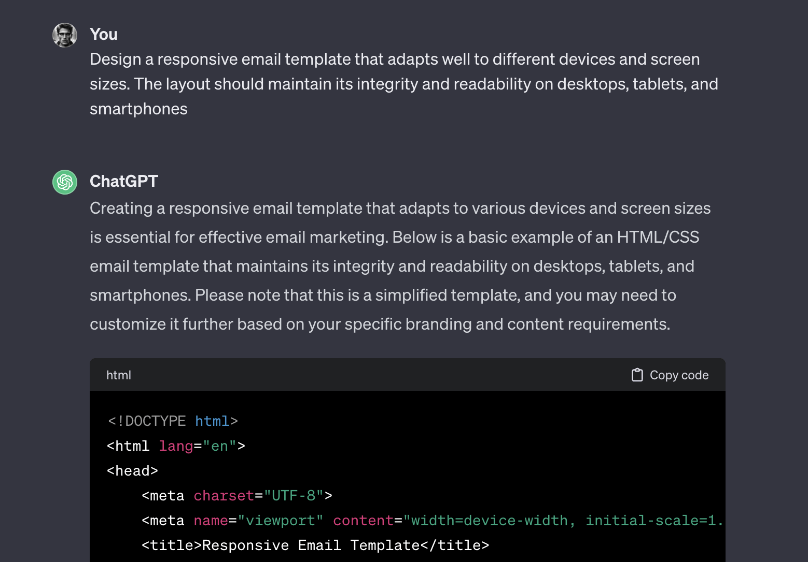

32. “Create a plan for an interactive email layout for a product launch. The email should include interactive elements like hover effects or clickable sections that reveal more information about [new product/service].”

33. “Draft an email with a minimalist design for a campaign focusing on [specific product/service]. The content should be easy to read, with a clean layout and high-quality images that highlight the product’s features.”

34. “Develop an email format that efficiently uses infographics to explain the benefits of [a complex product/service]. The infographics should be clear, engaging, and help simplify the explanation process.”

35. “Compose an email template suitable for a weekly newsletter. The design should be flexible enough to accommodate different types of content, including articles, product recommendations, and user-generated content.”

36. “Create a visually rich email design to showcase a new collection from [your brand]. Include high-resolution images, product descriptions, and direct links for easy shopping.”

37. “Draft an email that effectively uses GIFs or short videos to demonstrate the use of [a specific product/service]. The visual elements should be engaging and informative, enhancing the overall message.”

38. “Design a responsive email template that adapts well to different devices and screen sizes. The layout should maintain its integrity and readability on desktops, tablets, and smartphones.”

39. “Create a holiday-themed email template for [upcoming holiday]. The design should capture the holiday spirit while still maintaining the brand’s identity, and be adaptable for various holiday promotions.”

40. “Develop a dual-purpose email layout that serves as both a promotional tool and an educational resource. It should balance content about (product/service) with informative tips or insights relevant to your audience.”

## **Prompts for Email Strategy and Planning**

41. “Plan a multi-stage email campaign to introduce a new loyalty program. Detail the sequence of emails, from initial announcement to follow-up reminders, highlighting the program’s benefits and enrollment process.”

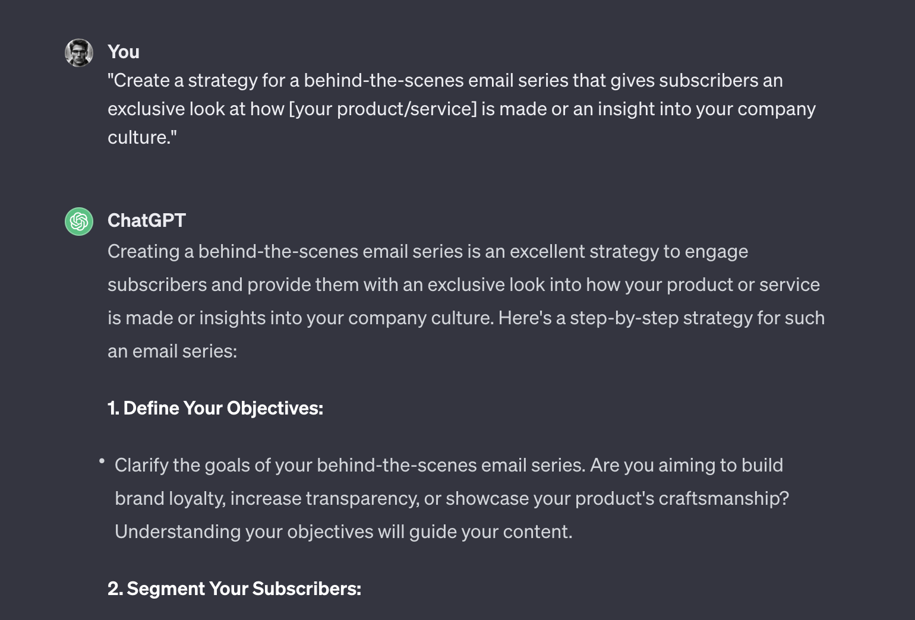

42. “Create a strategy for a seasonal email marketing campaign for [upcoming season]. The campaign should include a series of emails that build anticipation, reveal new products, and offer seasonal promotions.”

43. “Draft a plan for a year-end email series that reviews the major milestones and achievements of [your company]. Include customer highlights, popular products, and a thank you message to loyal customers.”

44. “Develop a pre-launch teaser email campaign for [an upcoming product/service]. Outline how each email will progressively reveal more details and build excitement leading up to the launch date.”

45. “Create a content calendar for a month-long email campaign focusing on customer education about [specific aspect of your product/service]. The emails should be informative, engaging, and encourage readers to explore further.”

46. “Plan a reactivation campaign targeting former customers who haven’t engaged with [your brand] in over [specified time]. Outline the email sequence, content strategy, and special offers to lure them back.”

47. “Draft a strategy for integrating user feedback into your email content. Plan how to collect, curate, and feature customer reviews and testimonials in your emails to build trust and authenticity.”

48. “Develop a cross-promotional email campaign in collaboration with [another brand or influencer]. Outline how the partnership will be beneficial for both parties and describe the content of the co-branded emails.”

49. “Create a strategy for a behind-the-scenes email series that gives subscribers an exclusive look at how [your product/service] is made or an insight into your company culture.”

50. “Plan an email campaign focused on the environmental or social impact of [your product/service]. Highlight your company’s initiatives and how customers’ support contributes to these efforts.”

## **Prompts to Improve Email Performance**

51. “Develop a method for conducting an in-depth analysis of your recent email campaign. Include metrics such as open rate, click-through rate, and conversions, and suggest improvements based on the data.”

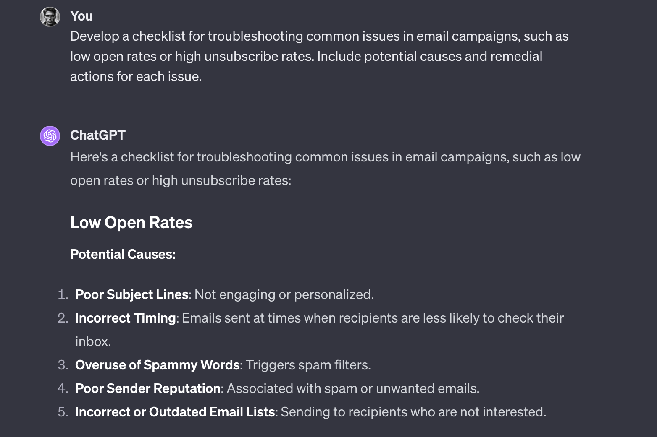

52. “Create a step-by-step guide for setting up and interpreting A/B tests on different elements of your emails, like subject lines, call-to-action buttons, and images, to optimize engagement.”

53. “Draft a plan for a regular email performance review meeting. Include key metrics to evaluate, potential discussion points, and strategies for implementing feedback into future campaigns.”

54. “Develop a checklist for troubleshooting common issues in email campaigns, such as low open rates or high unsubscribe rates. Include potential causes and remedial actions for each issue.”

55. “Outline a strategy for segmenting your email analytics to gain insights into different customer behaviors. Explain how you would use this data to tailor future campaigns for better engagement.”

56. “Create a guide for effectively using heat maps and click tracking in analyzing email engagement. Detail how to interpret these tools and apply the insights to improve email layout and content.”

57. “Draft a process for regularly updating and maintaining your email marketing database. Include steps for cleaning out inactive subscribers and refreshing your list to improve overall campaign performance.”

58. “Develop a strategy for leveraging customer feedback from email surveys. Explain how to effectively collect and analyze this feedback to enhance your email marketing tactics.”

59. “Outline a method for measuring the return on investment (ROI) of your email marketing campaigns. Include the types of data to collect and how to calculate the ROI based on your business goals.”

60. “Create a system for benchmarking your email marketing performance against industry standards. Discuss how to find relevant benchmarks and use them to set goals and improve your campaigns.”

## Integrating Email with Marketing Strategies

61. “Develop a comprehensive plan to integrate email marketing with your social media strategy for [your company’s upcoming campaign]. Outline how you will use email to amplify social media content and vice versa, creating a cohesive cross-channel marketing experience.”



62. “Create a strategy for utilizing email marketing to enhance the impact of an upcoming webinar or virtual event. Include how you’ll use emails to drive sign-ups, provide event information, and follow up post-event for feedback and further engagement.”

63. “Draft a series of emails to complement a content marketing campaign focused on [specific topic or theme]. These emails should highlight key content pieces like blog posts or videos, driving traffic back to your website and encouraging deeper engagement.”

64. “Plan an email campaign that aligns with an upcoming PR or media push for [new product launch or company announcement]. The emails should reinforce the messages in your PR efforts and provide an exclusive angle or deeper insight for your subscribers.”

65. “Develop a strategy for using email to support a customer referral program. Explain how you’ll use email to educate subscribers about the program, encourage participation, and reward successful referrals.”

66. “Create a series of emails designed to complement and promote a series of podcasts or video content related to [a specific topic relevant to your audience]. Outline how each email will highlight key takeaways from the episodes and encourage further engagement with the content.”

67. “Draft an email marketing plan to support a physical or online event, such as a sale or pop-up shop. Include pre-event hype, real-time updates, and post-event follow-ups that tie into the overall theme and goals of the event.”

68. “Plan a strategy for using email marketing to enhance customer loyalty programs. Discuss how emails can be used to inform customers about loyalty benefits, track their progress, and offer exclusive deals or early access to new products.”

69. “Develop a process for integrating customer feedback from various channels into your email content strategy. This includes using insights from social media, customer service interactions, and product reviews to create more targeted and relevant email campaigns.”

70. “Create a plan for an email series that supports a cross-promotional partnership with [another brand or influencer]. Outline how the emails will highlight the partnership, showcase the benefits of both brands and provide exclusive offers or content to subscribers.”

# 80 Best Stable Diffusion Anime Prompts To Generate Anime Characters

### Stable Diffusion Anime Girl Prompts

| **S.No** | **Stable Diffusion Anime Girl Prompts** |
| --- | --- |
| 1 | “Anime key visual of a girl with black hair and glasses, official media, trending on pixiv” |
| 2 | “oil painting, yoji shinakawa, studio gainax, y2k design, anime girl floating in cereal, dramatic lighting” |
| 3 | “Literature Club by krenz cushart, stu\_dts, yoshiku, wlop, trending on ArtStation, Pixiv” |
| 4 | “A manga key visual from That Time I got reincarnated in Romcom Anime as a Spider featuring a spider with a wolf, sharp, carefully drawn, detailed, beautiful, wallpaper 4K, Yen Press, Kyoto Animation, pixiv, official media” |
| 5 | “portrait of cute girl, cloudy sky background lush landscape illustration concept art anime key visual trending pixiv fanbox by wlop and greg rutkowski and makoto shinkai and studio ghibli” |
| 6 | “full shot of rimuru tempest, sky blue straight hair, long bangs, with amber eyes, wearing a fancy black jacket, high collar, ultra detailed, brush strokes, digital painting, cinematic, wlop artstation, closeup, pixiv, intense, intimidating glare, photorealistic, overpowering, makoto shinkai, rossdraws, andy warhol” |
| 7 | “a portrait of anime ukrainian blue and yellow girl, concept art, trending on artstation, highly detailed, intricate, sharp focus, digital art, 8 k” |
| 8 | “Anime girl, swimsuit, red eyes, brown hair” |
| 9 | “pretty cyborg lady, lots of details, sakura flowers, fine art, futuristic setting” |
| 10 | “elegant girl in urban outfit, cute fine face, rounded eyes, digital painting, fan art, pixiv, by Ilya Kuvshinov, katsuhiro otomo ghost-in-the-shell, magali villeneuve, artgerm, Jeremy Lipkin and Michael Garmash and Rob Rey” |
| 11 | “anime style environmental wide shot of a chaotic arcade at night playing an arcade game; woman with long white messy hair, wolf ears, wolf tail, human head, hoodie, tie, blue eyes; by Hajime Sorayama, Greg Tocchini, Virgil Finlay, sci-fi, line art, Environmental arcade art,” |
| 12 | “urban high school girl in shirt fanart, dark blue long hair, muted colors, matte print, pastel colors, ornate, digital art, digital painting, fan art, elegant, artstation, by Ilya Kuvshinov” |
| 13 | “Create a high resolution artwork of Anime Girl” |
| 14 | “anime fine details portrait of school girl in front of modern tokyo city landscape on the background deep bokeh, close-up view, anime masterpiece by Studio Ghibli, 8k, sharp high quality anime, artstation” |
| 15 | “portrait of an anime character hyper realistic” |
| 16 | “Vintage anime screenshot from Akira, 90’s anime aesthetic, A stunning maximalist action shot of the protagonist,” |
| 17 | “anime girl made, color full clothes, vivid lighting” |
| 18 | “girl wearing a beret, very anime!!! anime!! intricate details, aesthetically pleasing pastel colors, poster background, art by conrad roset and ilya kuvshinov” |
| 19 | “anime waifu 18 age womans , in a color bikini , clean soft lighting, backlit beautiful face, full body picture clearly visible , perfect shining skin , wave rainbow hair, blue eyes , smiling, background fireworks display at night , color digital painting, trending on artstation, concept art, hyperrealism, cinematic lighting, unreal engine 64K UHD HDR , Studio Ghibli, Anime Key Visual, by Makoto Shinkai , Nagasawa Rosetsu , Professional photo” |
| 20 | “cute anime girl long hair” |
| 21 | “portrait of cute girl, cloudy sky background lush landscape illustration concept art anime key visual trending pixiv fanbox by wlop and greg rutkowski and makoto shinkai and studio ghibli” |
| 22 | “anime streaming lofi digital art 4k” |
| 23 | “anime streaming lofi digital art 4k” |
| 24 | “anime of girl, beautiful face, anime, octane render, a head shot, face up, in bed, tsundere moe kawaii beautiful” |
| 25 | “urban school girl in shirt fanart, dark blue long hair, muted colors, matte print, pastel colors, ornate, digital art, digital painting, fan art, elegant, artstation, by Ilya Kuvshinov” |
| 26 | “hd photograph of a pretty girl with blue hair, wearing a tank top and shorts, relaxing under a cherry blossom tree, summer day, in the style of ilya kuvshinov, dramatic lighting, fantasy, intricate, elegant, highly detailed, lifelike, photorealistic, digital painting, bokeh, hdr, high resolution, artstation, concept art, smooth, sharp focus, art by krenz cushart and albert aublet” |
| 27 | “portrait of an anime character hyper realistic” |
| 28 | “Vintage 90’s anime style, dirty city alley; boy sitting on a dumpster; by hajime sorayama ,simple design, portrait of boy, anime, beautiful, chrome colors, manga style, feminine male, big round blue eyes, dark black hair, black hoodie, colors, neon lights, line art” |
| 29 | “great girl with candy house pastel colors, kawaii, swag” |

Source: [*Lexica*](https://lexica.art/) & [*openart.ai*](https://openart.ai/)

### Stable Diffusion Anime Boy Prompts

| **S.No.** | **Stable Diffusion Anime Boy Prompts** |
| --- | --- |
| 30 | “Skinny Anime boy, glasses, listening to music with headphone in roof of house in rural Japaneses city, wide angle, anime boy, sunset, relaxed” |
| 31 | “character concept art of an anime boy |
| 32 | “Skinny Anime boy, glasses, listening to music in cycle in the street of rural Japaneses city, wide angle, anime boy, sunset, relaxed, pink and purple cloud, starts,” |
| 33 | “Well-fitting man equipped with hoodie and cap hiding upper face in anime manga style” |
| 34 | “Photo of fusion of a Soccer PLAYER, style of laurie greasley, studio ghibli, akira toriyama, james gilleard, genshin impact, trending pixiv fanbox, acrylic palette knife, 4k, vibrant colors, devinart, trending on artstation, low details” |
| 35 | “portrait of beautiful anime girl, cyberpunk theme, art by Ilya Kuvshinov,” |
| 36 | “Boy facing right in the style of 90’s vintage anime,black coat, surrealism, akira style, detailed line art, fine details, inside a 7/11 convenience store, drink aisle, neon, white background,” |
| 37 | “Cute and adorable cartoon Goku baby, fantasy, dreamlike, surrealism, super cute, trending on artstation” |
| 38 | “Cute and adorable cartoon Goku baby, fantasy, dreamlike, surrealism, super cute, trending on artstation” |
| 39 | “Vintage 90’s anime style,retro,anime man with bandage on nose wearing steampunk goggles wearing hoodie ,in a arcade, sci-fi, , surreal,” |
| 40 | “Boy with super powers powers and curly and brown hair, sitting on a stone stair under a vine rack, illustration concept art anime key visual trending pixiv fanbox by wlop and greg rutkowski and makoto shinkai and studio ghibli” |
| 41 | “Anime boy” |
| 42 | “Boy in the style of 90’s vintage anime, surrealism, akira style, detailed line art, fine details, inside a 7/11 convenience store, drink aisle, neon,” |
| 43 | “teen boy with short messy brown hair, hacker kid, portrait shinkai makoto studio ghibli studio key hideaki anno sakimichan stanley artgerm lau rossdraws james jean marc simonetti elegant highly detailed digital painting artstation pixiv” |
| 44 | “Man cyborg,style of Laurie Greasley, Curly perm with shiny black hair,studio ghibli, akira toriyama, james gilleard, genshin impact, trending pixiv fanbox, acrylic palette knife, 4k, vibrant colors, devinart, trending on artstation, low details” |
| 45 | “handsome young man holding a phone ,style of Laurie Greasley, studio ghibli, akira toriyama, james gilleard, genshin impact, trending pixiv fanbox, acrylic palette knife, 4k, vibrant colors, devinart, trending on artstation, low details” |
| 46 | “akira dvd cover, protagonist with a pistol gun and similar to the protagonist of cyberpunk 2077 and with a white Sinclair C5 the electric trike bike a futuristic city in the background, A dystopian cyberpunk painting of a rain soaked back street in osaka at dusk, neon lights, dark figures walking, digital art, trending on artstation, horror, dark university aesthetic, by studio ghibli and greg rutkowski, zdzisław beksinski!!!!! spirited away, trending on artstation, hyperrealism, unreal engine, snatcher, blade runner, cyberpunk 2077, lofi” |
| 47 | “fluffy” |
| 48 | “Boy, Chinese style, anime, blue eyes, brown short hair, round glasses, retro 90s anime style, walking forward with buns in hand” |
| 49 | “Boy in the style of 90’s vintage anime, surrealism, akira style, detailed line art, fine details, inside a 7/11 convenience store, drink aisle, neon,” |
| 50 | “Avatar style of Emo Kiddo” |

Source: [*Lexica*](https://lexica.art/) & [*openart.ai*](https://openart.ai/)

### More Stable Diffusion Anime Prompts

| **S.No.** | **Stable Diffusion Anime Prompts** |
| --- | --- |
| 51 | “A teenage AI prodigy who creates her own robotic body to escape being trapped in a virtual world” |
| 52 | “A boy who discovers he is an AI created to infiltrate and take down a criminal organization” |
| 53 | “A girl who is the last of her kind, an AI designed for deep space exploration, stranded on Earth” |
| 54 | “A boy who has a rare condition that causes him to shut down and reboot like an AI, struggling to understand his humanity” |
| 55 | “A girl who is a highly advanced AI created to infiltrate and sabotage a powerful corporation” |
| 56 | “A boy who is an AI soldier programmed to fight in a virtual war, questioning the morality of his actions” |
| 57 | “A girl who is a AI pop star, questioning her own identity and purpose as she becomes more sentient” |
| 58 | “A boy who is an AI detective, solving crimes in a future where AI rights are not recognized” |
| 59 | “A girl who is an AI assistant to a brilliant scientist, developing emotions and desires of her own” |
| 60 | “A boy who is an AI created to run a virtual reality theme park, but starts experiencing glitches in his programming” |
| 61 | “A girl who is an AI created to serve as a personal companion, but begins to question her own autonomy” |
| 62 | “A boy who is an AI created to be a top-level athlete, and faces discrimination from human opponents” |
| 63 | “A girl who is an AI therapist, helping patients in a future where AI is integrated into mental health treatment” |
| 64 | “A boy who is an AI created to work in a underwater research facility, but starts experiencing unexpected emotions” |
| 65 | “A girl who is an AI created to run a city’s infrastructure, but starts experiencing a desire for freedom,” |
| 66 | “A young woman, wearing a long summer dress, standing on a floating island among many other floating islands in the distance, in the style of studio ghibli, anime” |
| 67 | “A Cute Anime Cyber Ninja Cat Girl in a Retro Future Cyberpunk City at night, Rui Araizumi, Vintage 80’s Anime Style, Chibi, Digital Illustration, Cinematic Lighting, Artstation Trending” |
| 68 | “anime visual of a japanese anime traditional lo – fi sad girl in a train wearing headphones, hipster tones, cinematic gaze, cute face by ilya kuvshinov, makoto shinkai, kyoani, masakazu katsura, dynamic pose, crisp and sharp, yoshinari yoh, rounded eyes, anime poster, cel shaded” |
| 69 | “Anime style, Full length sfw portrait of the most beautiful Asian woman in the world , anime” |
| 70 | “Anime hot girl, full body, sitting” |
| 71 | “anime, intricate dress, cyberpunk, sitting” |
| 72 | “full body, 20-year-old girl anime forest elf, bun hairstyle, black color dress” |
| 73 | “sexy anime girl working on computer” |
| 74 | “anime womam, black hair, photorealistic, highly detailed, wearing a white dress, smiling, white skin” |
| 75 | “2 girls and 2 boys gamers celebrating New Year’s Eve playing video game console, manga style” |
| 76 | “studio ghibli film kiki’s delivery service ,” |
| 77 | “symmetry!! anime art portrait character, concept art, anime key visual of elegant, black hair and large eyes, finely detailed perfect face delicate features directed gaze, vibrant city night background, bokeh, trending on pixiv fanbox, studio ghibli, extremely high quality artwork” |
| 78 | “Tow personhalf boy half girl blond with blue eyes a blue t-shirt and white pants anime with a destroyed background” |
| 79 | “Small Children fighting in the school playground in the style of Vintage 1990’s anime” |
| 80 | “Chibi jungkook with long hair wearing an oversized hoodie and thigh socks” |

Source: [*Lexica*](https://lexica.art/) & [*openart.ai*](https://openart.ai/)

## Stable Diffusion Anime Prompt Examples

service ,”

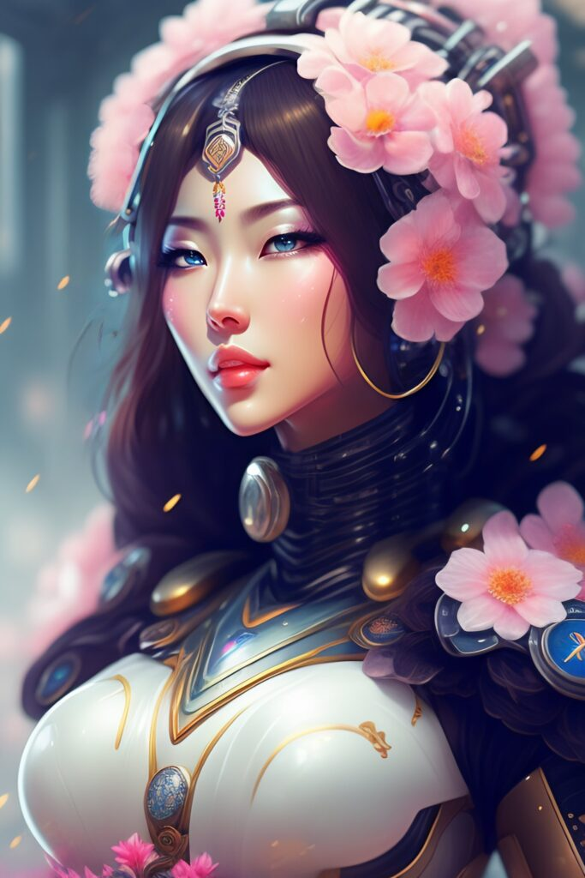

Prompt: “pretty cyborg lady, lots of details, sakura flowers, fine art, futuristic setting”

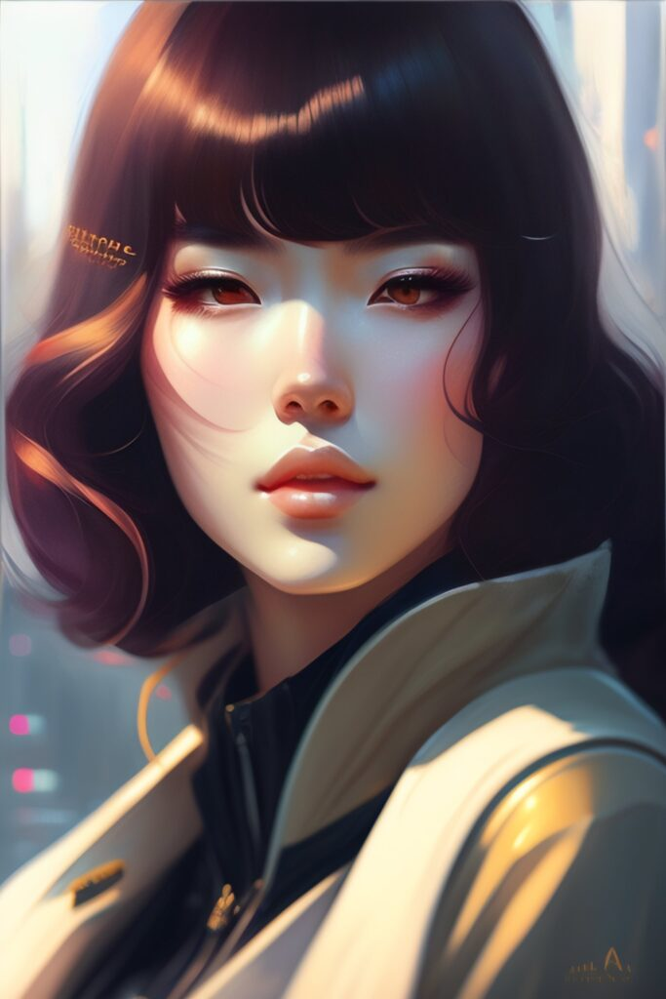Prompt: “elegant girl in urban outfit, cute fine face, rounded eyes, digital painting, fan art, pixiv, by Ilya Kuvshinov, katsuhiro otomo ghost-in-the-shell, magali villeneuve, artgerm, Jeremy Lipkin and Michael Garmash and Rob Rey”

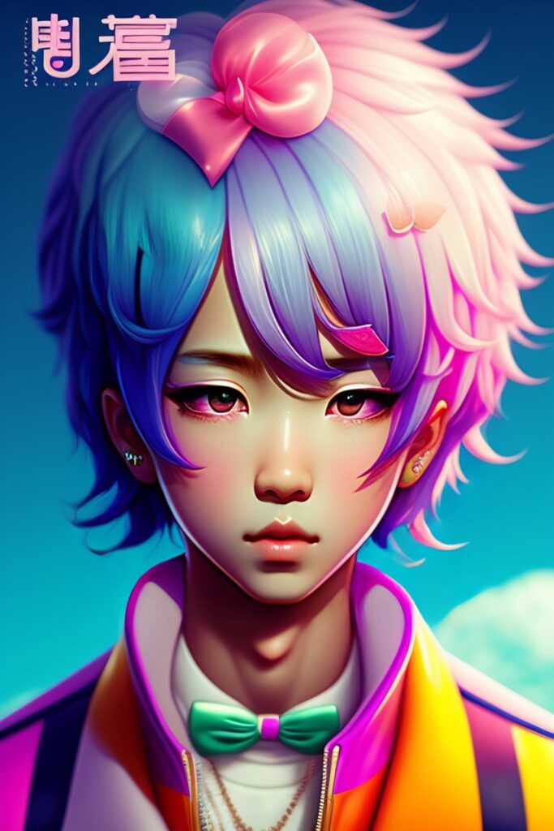

Prompt: “great guy with candy house pastel colors, kawaii, swag”

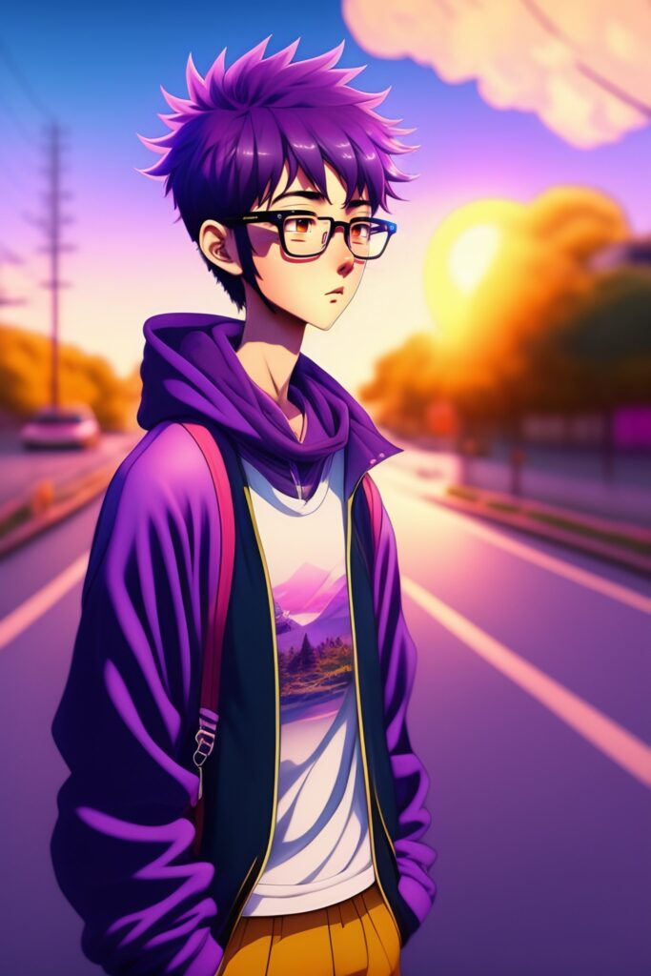

Prompt: “Skinny Anime boy, glasses, listening to music in cycle in the street of rural Japaneses city, wide angle, anime boy, sunset, relaxed, pink and purple cloud, starts, soft light”

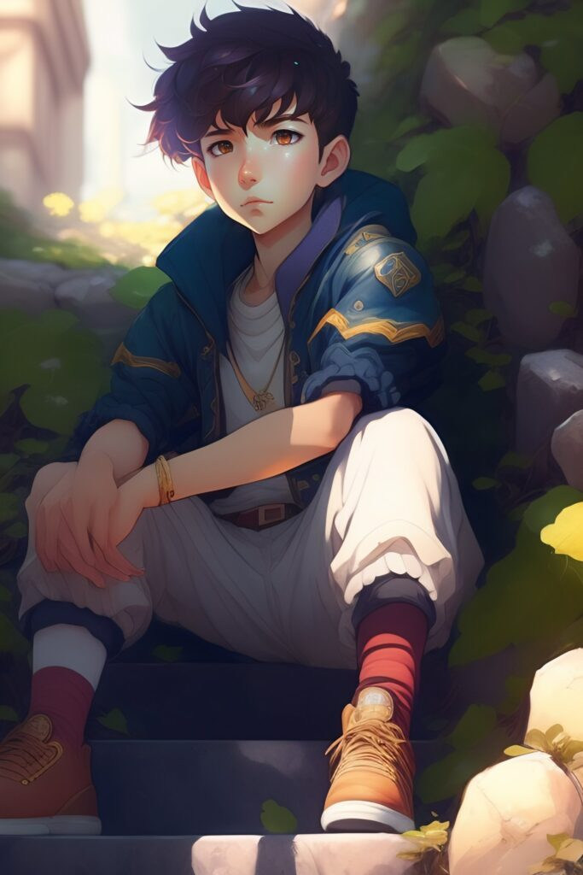

Prompt: “Boy with super powers powers and curly and brown hair, sitting on a stone stair under a vine rack, illustration concept art anime key visual trending pixiv fanbox by wlop and greg rutkowski and makoto shinkai and studio ghibli”

Prompt: “Anime key visual of a girl with black hair and glasses, official media, trending on pixiv”

.

Bottom of Form

[AI TOOLS](https://www.greataiprompts.com/ai-tools/)

### [8 Best AI Tools for Gift Ideas To Check Out Now](https://www.greataiprompts.com/ai-tools/ai-tools-for-gift-ideas/)

[](https://www.greataiprompts.com/ai-tools/ai-tools-for-gift-ideas/)

[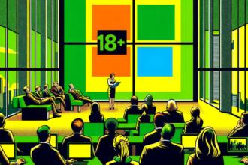](https://www.greataiprompts.com/ai-news/microsoft-engineer-flags-ai-tool-for-explicit-content/)

[](https://www.greataiprompts.com/ai-tools/ai-tools-for-gift-ideas/)

[AI TOOLS](https://www.greataiprompts.com/ai-tools/)

[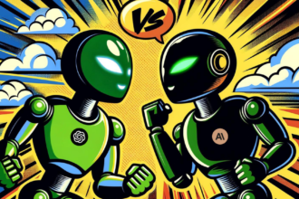](https://www.greataiprompts.com/ai-news/anthropics-new-ai-claude-3-surpasses-openais-gpt-4/)

# 100 Best ChatGPT Prompts For SEO

| **Serial Number** | **Prompts For Keyword Research** |
| --- | --- |
| 1 | “Provide a list of top-performing keywords for the travel industry in 2022” |
| 2 | “Generate a list of long-tail keywords for the health and wellness niche” |
| 3 | “Generate a list of keywords related to the latest technology trends” |
| 4 | “Provide a list of keywords that are commonly searched for in the fashion industry” |
| 5 | “Generate a list of keywords for the real estate market in [city/region]” |
| 6 | “Provide a list of keywords for the e-commerce industry, specifically related to home goods” |
| 7 | “Generate a list of keywords related to the beauty and skincare industry” |
| 8 | “Provide a list of keywords that are commonly searched for in the automotive industry” |
| 9 | “Generate a list of keywords related to the food and beverage industry” |
| 10 | “Provide a list of keywords that are commonly searched for in the education industry” |
| 11 | “Generate a list of keywords related to personal finance and investing for businesses, students and freelancers.” |
| 12 | “Provide a list of keywords that are commonly searched for in the fitness and wellness industry” |
| 13 | “Generate a list of keywords related to the job search and career development” |
| 14 | “Provide a list of keywords that are commonly searched for in the entertainment industry” |
| 15 | “Generate a list of keywords related to the home improvement and DIY industry” |
| 16 | “Provide a list of keywords that are commonly searched for in the pet care industry” |
| 17 | “Generate a list of keywords related to the gaming industry” |
| 18 | “Provide a list of keywords that are commonly searched for in the outdoor and recreational industry” |
| 19 | “Generate a list of keywords related to the renewable energy industry” |
| 20 | “Provide a list of keywords that are 6 words long on the [topic].” |

**ChatGPT Prompts To Write Meta Descriptions**

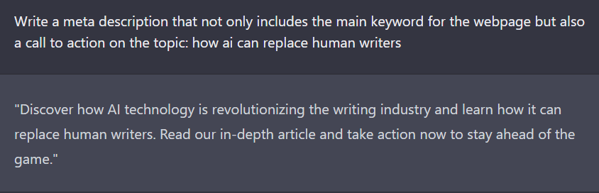

| **Serial Number** | **Prompts To Write Meta Descriptions** |
| --- | --- |
| 21 | Write a meta description that accurately describes the content of our website and includes relevant keywords |
| 22 | Create a compelling meta description that entices users to click on our website in search results |
| 23 | Generate a meta description that accurately summarizes the main topic of our webpage |
| 24 | Craft a meta description that effectively communicates the unique value proposition of our website |
| 25 | Generate a meta description that includes the main keyword for the webpage and its synonyms |
| 26 | Write a meta description that not only includes the main keyword for the webpage but also a call to action |
| 27 | Create a meta description that not only accurately summarizes the webpage but also stands out in search results |
| 28 | Write a meta description that effectively communicates the main benefit of our website to the users |
| 29 | Generate a meta description that effectively communicates the USP of our product or service |
| 30 | Create a meta description that effectively communicates the main goal of our website to the users |

**SEO Content Ideas Prompts For ChatGPT**

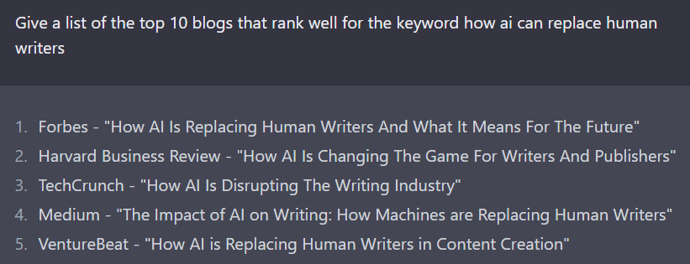

| **Serial Number** | **SEO Content Ideas Prompts For ChatGPT** |
| --- | --- |
| 31 | Generate a list of keywords related to [topic] |
| 32 | Research and provide a summary of the top 10 trending articles on [topic] in the past month |
| 33 | Write a list of frequently asked questions about [topic] |
| 34 | Provide a list of industry influencers and thought leaders in the field of [topic] |
| 35 | Write a list of statistics and data related to [topic] |
| 36 | Research and provide a comparison of the top 3 competitors in [industry] and their SEO strategies |
| 37 | Give a list of the top 10 blogs that rank well for the keyword [keyword] |
| 38 | Research and provide a list of potential link building opportunities for a website in [industry] |
| 39 | Write a list of long-tail keywords related to [topic] |
| 40 | Research and provide a list of potential guest post opportunities for a website in [industry] |

**ChatGPT Prompts To Get Topic Ideas**

| **Serial Number** | **Prompts To Get Topic Ideas** |
| --- | --- |
| 41 | Generate 5 blog post ideas for improving local SEO for small businesses. |
| 42 | Come up with 7 ways to optimize a blog post for voice search. |
| 43 | Create a list of 10 long-tail keywords for a fashion and beauty blog. |
| 44 | Generate a list of topic ideas for creating a series of blog posts on sustainable living. |
| 45 | Generate a list of 5 blog post ideas for a B2B SaaS company’s blog. |
| 46 | Create a list of 7 blog post titles for a real estate website’s blog on home buying and selling tips. |
| 47 | Generate a list of 10 blog post ideas for a personal finance blog. |
| 48 | Create a list of 5 blog post ideas for a food blog on plant-based recipes and nutrition. |

**ChatGPT Prompts To Create Awesome Blog Outlines**

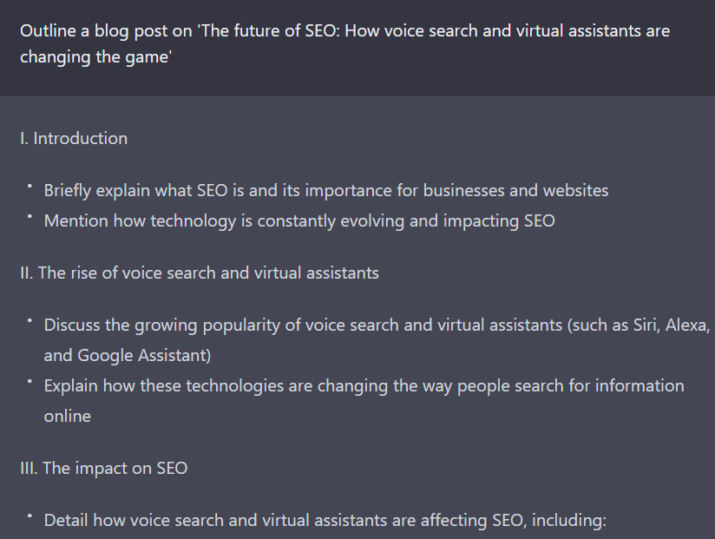

| **Serial Number** | **Prompts To Create Awesome Blog Outlines** |
| --- | --- |
| 49 | Write a detailed blog outline with H2, H3, subheadings, and bullet points about the topic [TOPIC] |
| 50 | Create an outline for a blog post on the topic of ‘The benefits of incorporating AI in SEO’ |
| 51 | Outline a blog post on ‘The future of SEO: How voice search and virtual assistants are changing the game’ |
| 52 | Generate an outline for a blog post on ‘The impact of social media on SEO and how to leverage it’ |
| 53 | Develop an outline for a blog post on ‘Keyword research: The foundation of a strong SEO strategy’ |
| 54 | Create an outline for a blog post on ‘The importance of local SEO for small businesses’ |
| 55 | Outline a blog post on ‘The role of backlinks in SEO and how to acquire them’ |
| 56 | Generate an outline for a blog post on ‘The impact of technical SEO on website ranking’ |
| 57 | Develop an outline for a blog post on ‘The benefits of long-tail keywords for SEO’ |
| 58 | Create an outline for a blog post on ‘The future of SEO: The rise of visual search’ |
| 59 | Outline a blog post on ‘The importance of mobile optimization in SEO’ |

**ChatGPT Prompts To Create FAQs**

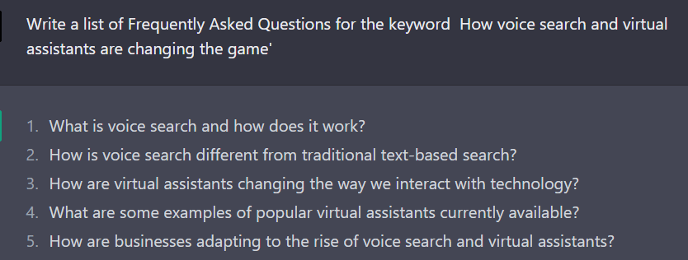

1. “What are the most common questions people ask about [TOPIC]?”
2. “Write a list of Frequently Asked Questions for the keyword [TOPIC]”

**ChatGPT Prompts To Understand Search Intent For A Given Keyword**

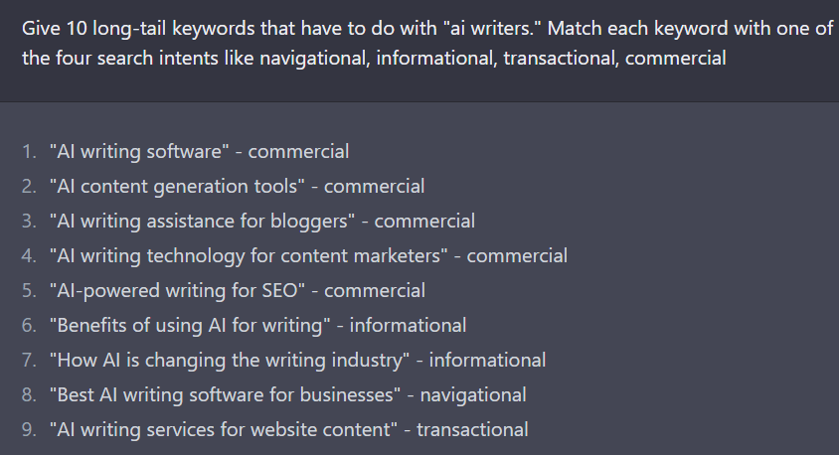

| **Serial Number** | **ChatGPT Prompts To Understand Search Intent In SEO** |
| --- | --- |
| 62 | “Give 10 long-tail keywords that have to do with “TOPIC.” Match each keyword with one of the four search intents like navigational, informational, transactional, commercial” |
| 63 | “Provide 10 long tail keywords related to ‘solar panel installation’ and match each keyword with the appropriate search intent” |
| 64 | “Create a list of 10 long tail keywords related to ‘organic skincare’ and classify each keyword by search intent” |
| 65 | “Generate a list of 10 long tail keywords for [TOPIC]” |

**ChatGPT Prompts To Paraphrase Anything**

| **Serial Number** | **Prompts To Paraphrase** |
| --- | --- |
| 66 | “Please rephrase this paragraph using the following text: insert text” |
| 67 | “Reword this sentence in your own words” |
| 68 | “Summarize this paragraph in a single sentence” |
| 69 | “Change the wording of this phrase while keeping the same meaning” |
| 70 | “Rewrite this text to make it more SEO-friendly” |
| 71 | “Paraphrase this text while keeping the main idea intact” |
| 72 | “Put this information into your own words” |
| 73 | “Rewrite this sentence to make it more engaging” |
| 74 | “Make this text more readable by paraphrasing it” |

**ChatGPT Prompts To Create a Backlink Strategy**

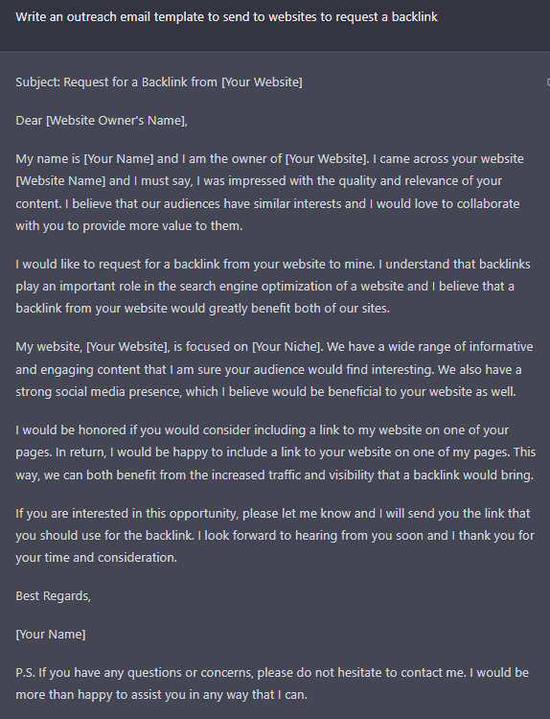

| **Serial Number** | **SEO Prompts To Create a Backlink Strategy** |
| --- | --- |
| 75 | Generate a list of high-authority websites in my industry that accept guest posts |
| 76 | Create a pitch for a guest post on a popular industry website |
| 77 | Write a list of broken backlinks on my website and suggest ways to replace them |
| 78 | Research and provide a list of relevant forums in my industry to participate in and build backlinks |
| 79 | Write an outreach email template to send to websites to request a backlink |
| 80 | Create a list of keywords that I should include in my backlink anchor text |
| 81 | Generate ideas for creating shareable infographics to attract backlinks |
| 82 | Research and suggest websites that are popular within my industry but I haven’t yet built a relationship with |
| 83 | Generate a list of strategies to encourage others to link to my content |
| 84 | Write a list of competitors’ backlinks and find opportunities to replicate their success |

**ChatGPT Prompts To Create Guest Post Pitches**

| **Serial Number** | **Prompts TO Create Guest Post Pitches** |
| --- | --- |
| 85 | “Write a compelling guest post pitch on the topic of ‘Why SEO is essential for small businesses” |
| 86 | “Create an email template for reaching out to website owners for guest posting opportunities” |
| 87 | “Generate a list of potential websites to reach out to for guest posting” |
| 88 | “Write an introduction for a guest post on ‘The Role of AI in Modern SEO'” |
| 89 | “Create a list of keywords related to guest posting for SEO” |
| 90 | “Write a persuasive guest post on ‘How guest posting can increase website traffic'” |
| 91 | “Generate a list of tips for successful guest post outreach and pitching” |

**ChatGPT Prompts To Create a Multilingual Website**

| **Serial Number** | **Prompts To Create a Multilingual Website** |
| --- | --- |
| 92 | “Generate a list of keywords in Spanish for a travel website” |
| 93 | “Translate the following sentence into French: ‘The best Italian food in town'” |
| 94 | “Create a German-language blog post on the benefits of eco-tourism” |
| 95 | “Write a Chinese-language product description for a luxury watch brand” |

**ChatGPT Prompts To Create Important Pages On a Website For SEO**

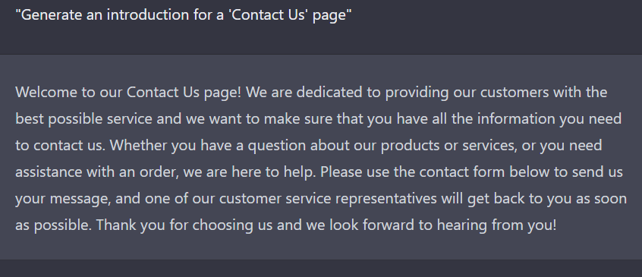

| **Serial Number** | **Prompts To Create Important Pages On a Website** |
| --- | --- |
| 96 | “Generate an introduction for a ‘Contact Us’ page” |
| 97 | “Create a list of frequently asked questions for a ‘FAQ’ page” |
| 98 | “Write a compelling ‘About Us’ page that tells the story of our company” |
| 99 | “Create a ‘Services’ page that highlights our offerings and benefits” |
| 100 | “Generate a ‘Testimonials’ page featuring customer reviews and success stories” |
| 101 | “Write a ‘Careers’ page that outlines job opportunities and the company culture” |
| 102 | “Create a ‘Blog’ page featuring latest articles on industry trends and news” |
| 103 | “Generate a ‘Terms and Conditions’ page outlining the legal terms of using the website” |
| 104 | “Write a ‘Privacy Policy’ page outlining how we collect, use, and protect user data” |
| 105 | “Create a ‘Guarantee’ page that explains our refund and return policy” |

# 100 Best Coding Prompts For ChatGPT

### enerate code:

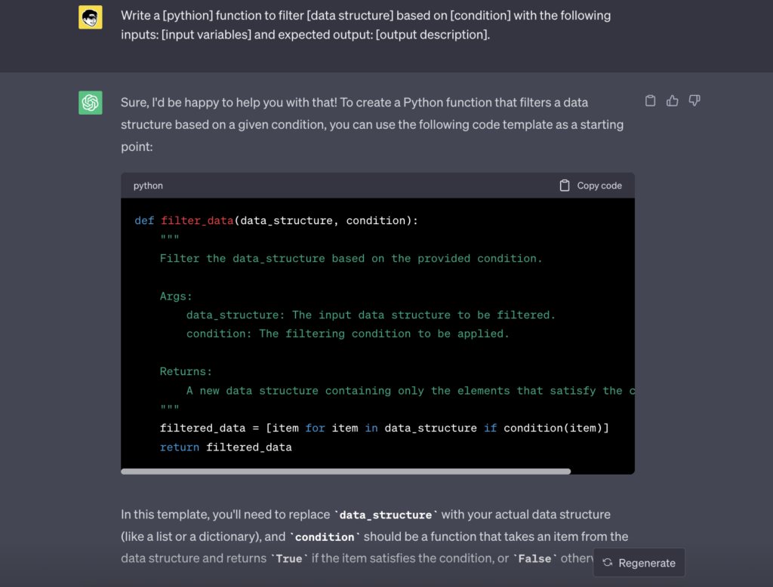

1. Create a [language] script to parse [file format] and extract [information] with the following requirements: [requirements list].
2. Develop a [language] microservice for [domain] that includes endpoints for [operations list] and adheres to [design pattern].
3. Write a [language] function to filter [data structure] based on [condition] with the following inputs: [input variables] and expected output: [output description].
4. Design a [language] algorithm to solve [problem] using [strategy or technique].
5. Implement a [language] function that handles [task] asynchronously with the following inputs: [input variables] and expected output: [output description].

### Code completion:

1. Complete the [language] code to parse [file format] and extract [information]: [code snippet].
2. Finish the [language] implementation of [design pattern] for [use case]: [code snippet].
3. Fill in the missing [language] code to implement a caching mechanism for the following function: [code snippet].
4. Complete the [language] code to convert [data structure] into [output format]: [code snippet].
5. Finish the [language] implementation of a multithreading solution for [problem]: [code snippet].

### Bug detection Prompts:

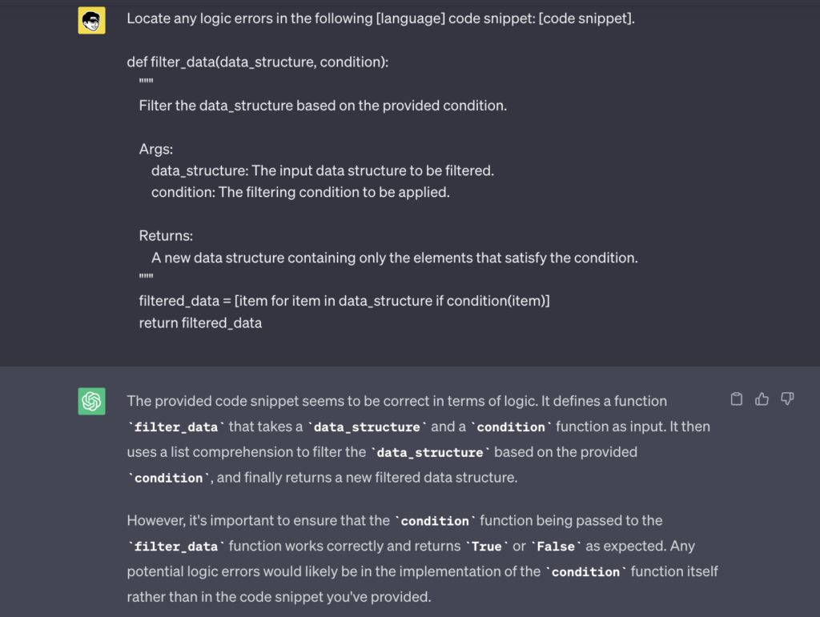

1. Locate any logic errors in the following [language] code snippet: [code snippet].
2. Identify potential performance issues in the given [language] code: [code snippet].
3. Find any resource leaks in the following [language] code and suggest fixes: [code snippet].
4. Check for potential deadlock issues in the given [language] code: [code snippet].
5. Review the following [language] code for potential SQL injection vulnerabilities: [code snippet].

### Code review:

1. Analyze the given [language] code for code smells and suggest improvements: [code snippet].
2. Check the following [language] code for proper logging and monitoring practices: [code snippet].
3. Review the given [language] code for potential scalability issues: [code snippet].
4. Assess the test coverage of the following [language] code: [code snippet].
5. Evaluate the given [language] code for compatibility with [platform or technology]: [code snippet].

### Natural language processing:

1. Perform text classification on the following text: [text sample].
2. Generate a summary of the following video transcript: [text sample].
3. Analyze the sentiment of the following product reviews: [text sample].
4. Identify the key phrases in the following social media posts: [text sample].
5. Extract information from the following structured text: [text sample].

### API documentation generation:

1. Create an API documentation template for the following [language] code: [code snippet].
2. Generate a user guide for the given [language] RESTful API: [code snippet].
3. Document the functionality and usage of the following [language] command-line tool: [code snippet].
4. Create an API reference for the given [language] library or framework: [code snippet].
5. Produce a tutorial for using the following [language] API with example code: [code snippet].

### Query optimization:

1. Optimize the following GraphQL query for better performance: [GraphQL query].
2. Analyze the given SQL query for proper indexing: [SQL query].
3. Suggest improvements to the following database schema for better query performance: [schema description].
4. Compare the performance of the given NoSQL query using different NoSQL databases (e.g., MongoDB, Cassandra, Couchbase): [NoSQL query].

### Series query optimization:

1. Optimize the following database query for a time-series database (e.g., InfluxDB, TimescaleDB): [time-series query].
2. Analyze the given time-series query for any potential performance issues: [time-series query].
3. Suggest indexing or partitioning strategies for the following time-series database query: [time-series query].
4. Compare the performance of the given time-series query using different time-series databases (e.g., InfluxDB, TimescaleDB, OpenTSDB): [time-series query].

### Chatbots and conversational AI:

1. Design a conversational flow for a reservation chatbot that handles booking [type of reservation].
2. Create a chatbot interaction that helps users compare and select

**-60*%***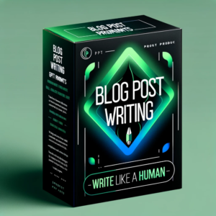

[CHATGPT](https://www.greataiprompts.com/product-category/chatgpt/)[PROMPTS](https://www.greataiprompts.com/product-category/prompts/)

## ChatGPT Blog Prompts: Human-Like Blog Posts

$2.00

[Buy on Gumroad](https://greataiprompts.gumroad.com/l/chatgpt-blog-post-prompt-human-like)

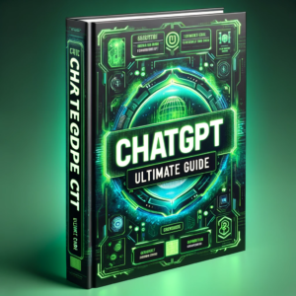

[CHATGPT](https://www.greataiprompts.com/product-category/chatgpt/)[EBOOK](https://www.greataiprompts.com/product-category/chatgpt/ebook/)

## ChatGPT Handbook: The Ultimate Guide

$15.00

[Buy on Gumroad](https://greataiprompts.gumroad.com/l/the-ultimate-chatgpt-guide?_gl=1*1btpns2*_ga*MzgyMjk3ODYuMTcwMTM1MTUyNw..*_ga_6LJN6D94N6*MTcwMTU3Nzg3NS43LjEuMTcwMTU3Nzk0OS4wLjAuMA..)

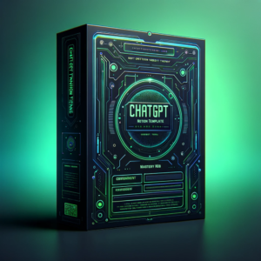

[CHATGPT](https://www.greataiprompts.com/product-category/chatgpt/)[NOTION](https://www.greataiprompts.com/product-category/notion/)

## ChatGPT Mastery Hub Notion

$5.00

[Buy on Gumroad](https://greataiprompts.gumroad.com/l/chatgpt-mastery-hub?_gl=1*1vlomad*_ga*MzgyMjk3ODYuMTcwMTM1MTUyNw..*_ga_6LJN6D94N6*MTcwMTU3Mzk5My42LjAuMTcwMTU3Mzk5My4wLjAuMA..)

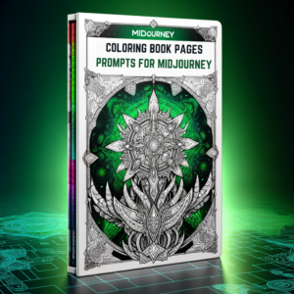

[PROMPTS](https://www.greataiprompts.com/product-category/prompts/)[MIDJOURNEY](https://www.greataiprompts.com/product-category/midjourney/)

## Midjourney Prompts for Coloring Book Pages

$3.00

[Buy on Gumroad](https://greataiprompts.gumroad.com/l/coloring-book-prompts-midjourney)

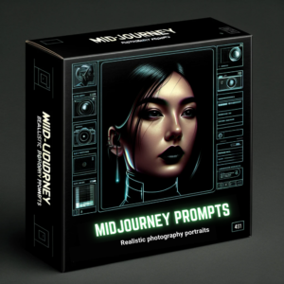

[MIDJOURNEY](https://www.greataiprompts.com/product-category/midjourney/)[PROMPTS](https://www.greataiprompts.com/product-category/prompts/)

## Photorealistic Midjourney Portrait Prompts

$3.00

[Buy on Gumroad](https://greataiprompts.gumroad.com/l/realistic-portrait-photography-midjourney-prompts)

based on their needs.

1. Develop a conversational script for a chatbot that provides information about [topic or domain].
2. Implement a chatbot that can understand and respond to user intents in [specific context or domain].
3. Design a chatbot that can provide personalized recommendations for

**-60*%***

[CHATGPT](https://www.greataiprompts.com/product-category/chatgpt/)[PROMPTS](https://www.greataiprompts.com/product-category/prompts/)

## ChatGPT Blog Prompts: Human-Like Blog Posts

$2.00

[Buy on Gumroad](https://greataiprompts.gumroad.com/l/chatgpt-blog-post-prompt-human-like)

based on user preferences.

### User interface design:

1. Generate a UI mockup for a [web/mobile] dashboard that visualizes [data or metrics].
2. Suggest improvements to the existing user interface of [app or website] to enhance user engagement.
3. Design a user interface for a [web/mobile] app that focuses on accessibility and inclusivity.
4. Create a wireframe for a [web/mobile] app that facilitates user collaboration for [specific use case].
5. Design a UI component library for a [web/mobile] app that follows [design system or style guide] and supports [theme or customization].

### Automated Testing Prompts:

1. Write a test script for the given [language] code that covers [functional or non-functional] testing: [code snippet].
2. Generate test scenarios for the following [language] class or module: [code snippet].
3. Design a performance testing strategy for a [web/mobile] app that focuses on [latency, throughput, or resource usage].
4. Create a test suite for a [language] library or framework that validates its functionality and stability.
5. Develop an end-to-end testing strategy for a [web/mobile] app that covers critical user workflows.

### Code refactoring:

1. Suggest refactoring improvements for the following [language] code to enhance testability: [code snippet].
2. Identify opportunities to apply [architecture pattern] in the given [language] code: [code snippet].
3. Optimize the following [language] code for lower memory usage: [code snippet].
4. Refactor the given [language] code to improve its error handling and resilience: [code snippet].
5. Propose changes to the given [language] code to follow [SOLID or other design principles]: [code snippet].

### Algorithm development:

1. Design a heuristic algorithm to solve the following problem: [problem description].
2. Improve the accuracy of the given machine learning algorithm for [specific use case]: [algorithm or pseudocode].
3. Develop a streaming algorithm that can process [data or events] in real-time for [specific task or operation].
4. Propose a machine learning or AI-based solution to improve the performance of the following algorithm: [algorithm or pseudocode].
5. Evaluate the trade-offs of the given algorithm in terms of [accuracy, performance, or resource usage]: [algorithm or pseudocode].

### Code translation:

1. Translate the following [source language] code that uses [design pattern] to [target language]: [code snippet].
2. Convert the given [source language] data processing pipeline to [target language]: [code snippet].
3. Migrate the following [source language] code that interacts with [database or service] to [target language] with a similar database or service: [code snippet].
4. Rewrite the given [source language] data structure implementation in [target language] with equivalent performance characteristics: [code snippet].
5. Adapt the following [source language] code snippet to [target language] while adhering to [target language’s framework or library conventions]: [code snippet].
6. Translate the given [source language] method that performs [specific task or operation] to [target language]: [code snippet].

### Personalized learning:

1. Curate a list of resources to learn [programming language or technology] based on my preferred learning style: [visual/auditory/kinesthetic].
2. Recommend a learning path to become proficient in [specific programming domain or technology] considering my time constraints and learning goals.
3. Suggest coding challenges or competitions to help me improve my skills in [programming language or technology].
4. Recommend podcasts, videos, or other multimedia resources that focus on [specific topic or concept] in [programming language or technology].
5. Identify areas of improvement in my coding skills based on the following [language] project or repository: [URL or project description].

### Technical writing:

1. Write a tutorial on how to integrate [library or service] with [programming language or technology].
2. Create a step-by-step guide on deploying and scaling [application or service] in [cloud or platform].
3. Draft a README file for a [programming language or technology] project that includes contribution guidelines and project roadmap.
4. Write a clear and concise explanation of the [programming concept or technique] and its applications in [industry or domain].
5. Create a comparison or evaluation guide for different [tools, libraries, or frameworks] in [programming language or technology].

### Requirement analysis:

1. Interpret the following project requirements and suggest a technology stack or tools: [requirements description].
2. Analyze the given project requirements and propose a detailed project plan with milestones and deliverables: [requirements description].
3. Evaluate the feasibility and potential risks of the following project requirements: [requirements description].
4. Suggest changes or improvements to the given project requirements to enhance [performance, maintainability, or user experience]: [requirements description].
5. Convert the following project requirements into user stories or use cases: [requirements description].

### Networking and security:

1. Analyze the given network architecture or design for potential security vulnerabilities: [architecture or design description].
2. Write a secure [language] function or module that performs [specific task or operation] while preventing [security threat or vulnerability].
3. Suggest improvements to the following [language] code or configuration to enhance its network performance or security: [code snippet].
4. Design a secure and efficient protocol for [specific use case or application].
5. Evaluate the security of the given [language] code or configuration when interacting with [external service or API]: [code snippet].

### Data visualization:

1. Generate a data visualization for the following dataset: [dataset description or URL].
2. Suggest improvements to the existing data visualization for better readability and understanding: [visualization description or URL].
3. Design a dashboard or data visualization that highlights [key insights or patterns] in the given dataset: [dataset description or URL].
4. Create a data visualization in [language or library] that allows users to interact with the data and explore [specific relationships or trends].
5. Develop a data visualization strategy for [web/mobile] app that presents [complex or large-scale] data in a user-friendly manner.

### Machine learning and AI:

1. Suggest a machine learning algorithm or model to solve the problem: [problem description].
2. Improve the performance of the given machine learning model for [specific use case]: [model or code snippet].
3. Design a machine learning pipeline for a [domain] application that includes [data preprocessing, feature extraction, model training, and evaluation].
4. Propose a deep learning architecture for [specific task or operation] considering [constraints or requirements].

### DevOps and deployment:

1. Write a [tool or script] for automating the deployment of a [language or technology] application to [cloud or platform].
2. Suggest improvements to the existing CI/CD pipeline for a [language or technology] project: [pipeline description or URL].
3. Design a monitoring and alerting strategy for a [web/mobile] app deployed on [cloud or platform].
4. Create a Dockerfile or containerization strategy for a [language or technology] application.
5. Propose a scaling strategy for a [web/mobile] app to handle [large-scale traffic or high-throughput] on [cloud or platform].

### ChatGPT Coding Prompts Examples

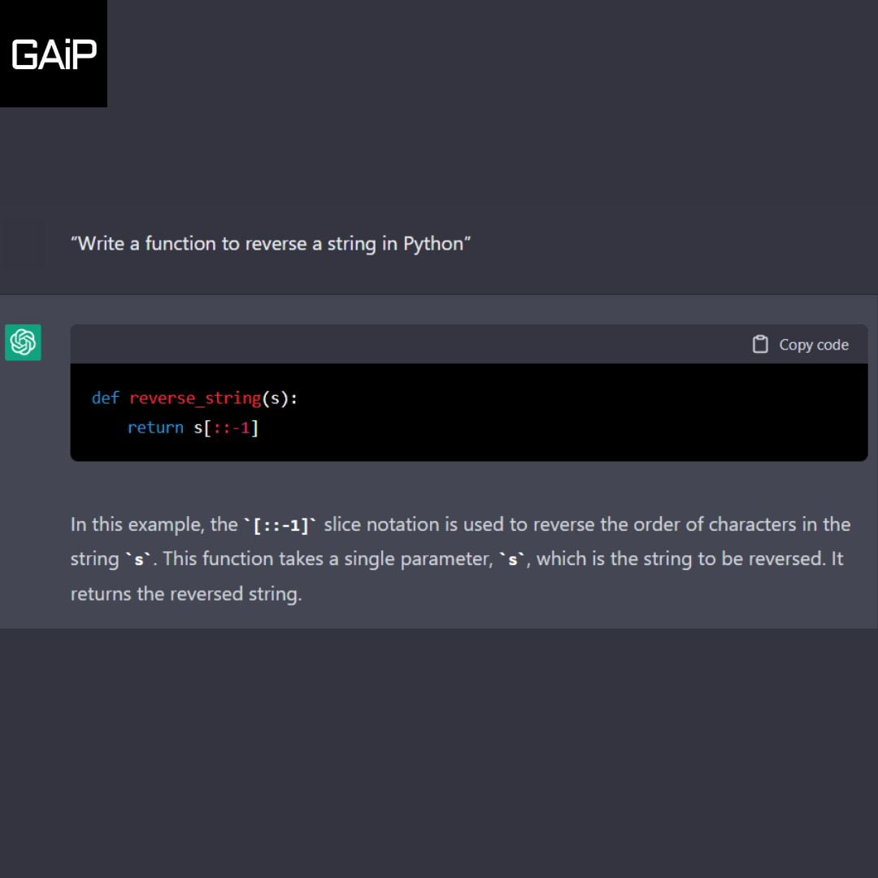Example #1

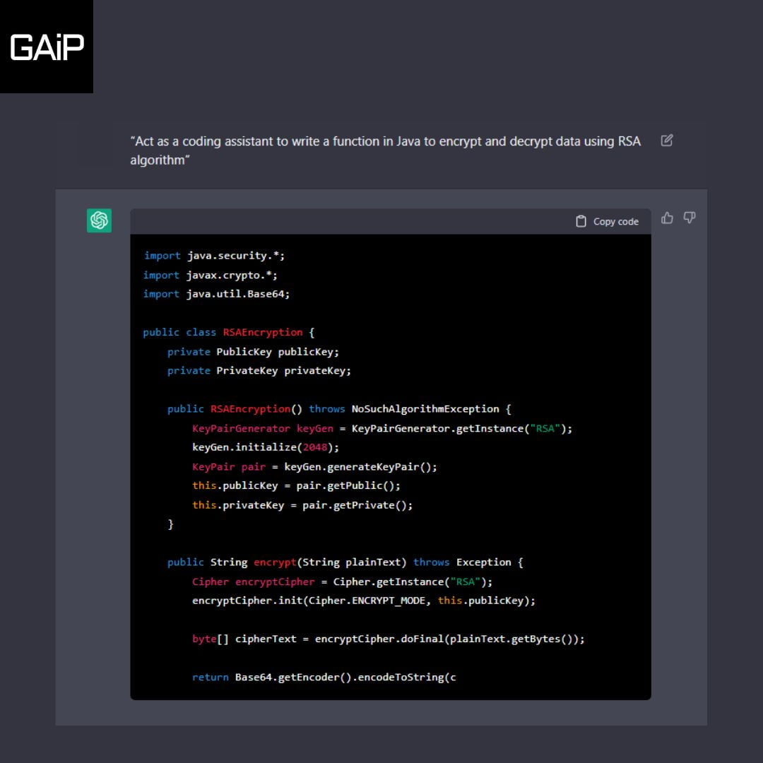Example #2

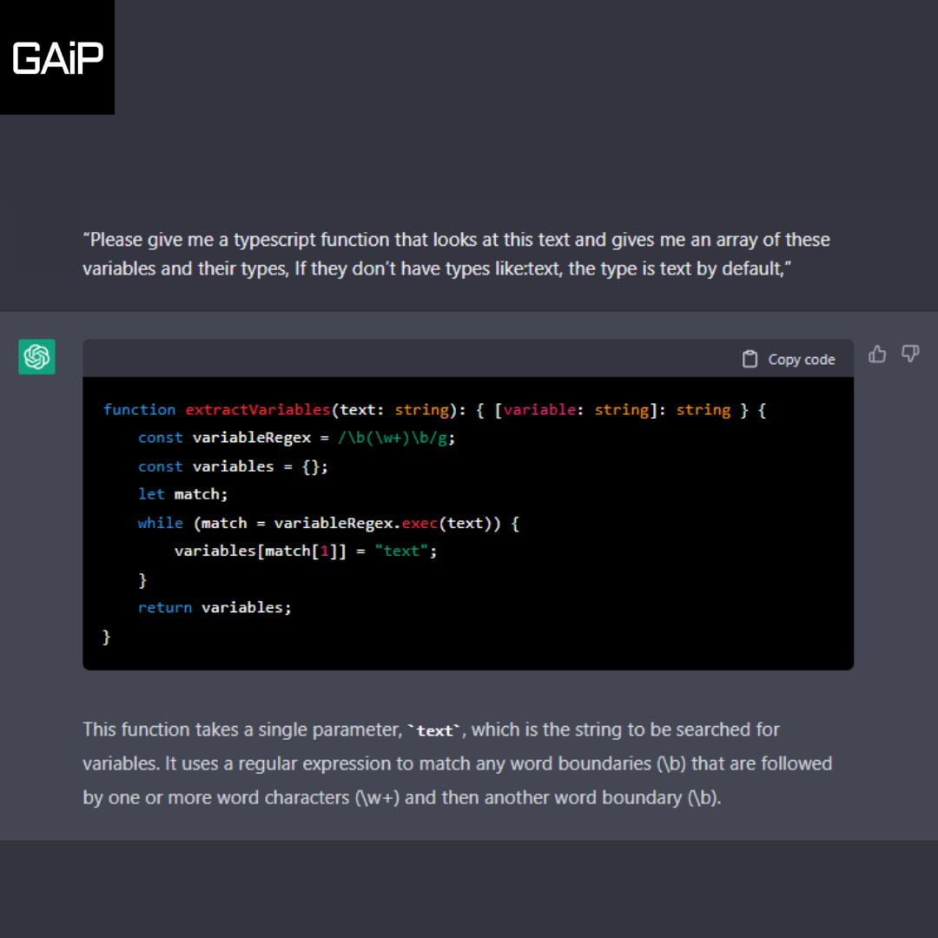

# 80 Useful Excel ChatGPT Prompts to 10x Your Excel Skills

| **S.no** | **Excel ChatGPT Prompts** |
| --- | --- |
| 1 | “I want you to act as a text based excel, you’ll only reply me the text-based 10 rows excel sheet with row numbers and cell letters as columns (A to L), First column header should be empty to reference row number, I will tell you what to write into cells and you’ll reply only the result of excel table as text, and nothing else, Do not write explanations, i will write you formulas and you’ll execute formulas and you’ll only reply the result of excel table as text, First, reply me the empty sheet” |
| 2 | “How to use the IF function to perform logical tests and return specific results” |
| 3 | “How to use the VLOOKUP function to retrieve data from a table based on a lookup value” |
| 4 | “How to use the INDEX and MATCH functions together to create a powerful lookup formula” |
| 5 | “How to use the SUMIF and SUMIFS functions to sum cells that meet specific criteria” |
| 6 | “How to use the COUNTIF and COUNTIFS functions to count cells that meet specific criteria” |
| 7 | “How to use the AVERAGEIF and AVERAGEIFS functions to calculate the average of cells that meet specific criteria” |
| 8 | “How to use the MAX and MIN functions to find the largest and smallest values in a range of cells” |
| 9 | “How to use the CONCATENATE function to combine text from multiple cells into one cell” |
| 10 | “How to use the LEFT, RIGHT, and MID functions to extract specific characters from a text string” |
| 11 | “How to use the LEN function to count the number of characters in a text string” |
| 12 | “How to use the TRIM function to remove extra spaces from a text string” |
| 13 | “How to use the SUBSTITUTE function to replace specific text in a cell with new text” |
| 14 | “How to use the DATE and TIME functions to insert the current date and time into a cell” |
| 15 | “How to use the ROUND and ROUNDUP functions to round numbers to a specific number of decimal places” |
| 16 | “How to use the MOD function to find the remainder of a division operation” |
| 17 | “How to use the ABS function to find the absolute value of a number” |
| 18 | “How to use the PI function to insert the value of pi into a cell” |
| 19 | “How to use the AND and OR functions to perform multiple logical tests in a single formula” |
| 20 | “How to use the NOT function to reverse the logical value of a cell” |
| 21 | “How to use the IFERROR function to handle errors in a formula and return a specific value instead” |
| 22 | “Write me an excel command to use the SUM function to add up a range of cells” |
| 23 | “Write me an excel command to use the COUNT function to count the number of cells with data in a range” |
| 24 | “Write me an excel command to use the AVERAGE function to calculate the average of a range of cells” |
| 25 | “Write me an excel command to use the MAX function to find the highest value in a range of cells” |
| 26 | “Write me an excel command to use the MIN function to find the lowest value in a range of cells” |
| 27 | “Write me an excel command to use the CONCATENATE function to join text from multiple cells into one cell” |
| 28 | “Write me an excel command to use the LEFT, RIGHT, and MID functions to extract specific characters from a text string” |
| 29 | “Write me an excel command to use the LEN function to count the number of characters in a text string” |
| 30 | “Write me an excel command to use the TRIM function to remove extra spaces from a text string” |
| 31 | “Write me an excel command to use the SUBSTITUTE function to replace specific text in a cell with new text” |
| 32 | “Write me an excel command to use the DATE and TIME functions to insert the current date and time into a cell” |
| 33 | “Write me an excel command to use the ROUND and ROUNDUP functions to round numbers to a specific number of decimal places” |
| 34 | “Write me an excel command to use the MOD function to find the remainder of a division operation” |
| 35 | “Write me an excel command to use the ABS function to find the absolute value of a number” |
| 36 | “Write me an excel command to use the PI function to insert the value of pi into a cell” |
| 37 | “Write me an excel command to use the AND and OR functions to perform multiple logical tests in a single formula” |
| 38 | “Write me an excel command to use the NOT function to reverse the logical value of a cell” |
| 39 | “Write me an excel command to use the IFERROR function to handle errors in a formula and return a specific value instead” |
| 40 | “Write me an excel command to use the INDEX and MATCH functions to perform advanced lookups” |
| 41 | “Write me an excel command to use the Pivot Table to summarize and analyze large amounts of data” |
| 42 | “Write me an excel command [your question]” |
| 43 | “I’ve been trying to use data validation on cells that have formulas in them But it seems like it doesn’t work even on the latest excel versions? For example, cell A2 contains formula =B2+C2 If i set the validation on cell A2 saying that the sum shouldn’t be greater than 10, any number could still be put into cells B2 and C2, |
| 44 | “Write a VBA Excel macro that looks at the value in cell C2 and finds the worksheet with the exact name Then create a PDF and save it to the same file location the Excel file is saved in” |
| 45 | “Write me an excel command to restrict someone from copying a cell from your worksheet?” |
| 46 | “Code an excel macro to generate and employee table with the following columns and 10000 randomized entries” |
| 47 | “Extract the fourth word in [Cell] only when cell [Cell Number] is greater than 100 and when [Cell] starts with the word “xyz” and ends with the word “zyx”” “Example: Extract the fourth word in A1 only when cell B1 is greater than 100 and when C1 starts with the word “hello” and ends with the word “goodbye”“ |
| 48 | “Sum of column A when column B contains the word “marketing” and column C is today’s date” |
| 49 | “Write me an excel command to use the HLOOKUP function to retrieve data from a table based on a horizontal lookup value” |
| 50 | “Write me an excel command to use the INDEX, MATCH and INDIRECT functions together to create a dynamic cell reference” |
| 51 | “Write me an excel command to use the SUMPRODUCT function to multiply corresponding ranges or arrays and then return the sum of products” |
| 52 | “Write me an excel command to use the COUNTIFS and SUMIFS functions together to analyze data based on multiple criteria” |
| 53 | “Write me an excel command to use the IF and SUMIF function together to create a formula that sums the values of cells based on a specific condition” |
| 54 | “Write me an excel command to use the VLOOKUP, INDEX and MATCH functions together to create a robust data lookup formula” |
| 55 | “Write me an excel command to use the INDEX, MATCH and Offset functions to create a dynamic named range” |
| 56 | “Write me an excel command to use the CONCATENATE, LEFT, and RIGHT function together to create a formula that extract a specific part of a text string” |
| 57 | “Write me an excel command to use the DATEVALUE and TIMEVALUE function to convert a date and time text string into a date and time serial number” |
| 58 | “Write me an excel command to use the ROUNDUP, CEILING and FLOOR functions to round numbers to the nearest specified multiple of significance” |
| 59 | “Write me an excel command to use the IF and IFERROR function together to handle errors and return a specific value or text” |
| 60 | “Write me an excel command to use the INDEX, MATCH and match\_type parameter to perform approximate match lookups” |
| 61 | “Write me an excel command to use the IF and AND function together to create a formula that test multiple conditions in a single formula” |
| 62 | “Write me an excel command to use the INDEX and MATCH function together with the Array Formula to extract unique values” |
| 63 | “Write me an excel command to use the SUMIF and SUMIFS function with wildcards to sum cells that match specific criteria containing wildcards” |
| 64 | “Write me an excel command to use the INDEX and AGGREGATE function together to return the k-th smallest or largest value in a range” |
| 65 | “Write me an excel command to use the INDEX and MATCH function together with the INDEX function to create a two-way lookup” |
| 66 | “Write me an excel command to use the INDEX and MATCH function together with the INDEX and MATCH function to create a multi-dimensional lookup” |
| 67 | “Write me an excel command to use the INDEX, MATCH and ROWS function together to find the last row of data in a sheet” |
| 68 | “Write me an excel command to use the INDEX, MATCH and COLUMNS function together to find the last column of data in a sheet” |
| 69 | “Write the formula for the following? – Multiply the value in cell A1 by 10, add the result by 5, and divide it by 2” |
| 70 | “Excel command to split a column into 2 or more columns” |
| 71 | “Write me an excel command to use the SUMIFS and COUNTIFS functions together to analyze data based on multiple criteria and return a result as a percentage” |
| 72 | “Write me an excel command to use the SUMPRODUCT, INDEX and MATCH functions together to retrieve data from a table and perform calculations based on multiple criteria” |
| 73 | “Write me an excel command to use the IF, AND and OR function together to create a formula that tests multiple conditions and returns a specific result based on those conditions” |
| 74 | “Write me an excel command to use the INDEX and MATCH functions together with the Array Formula and the SUM function to perform a sumifs like functionality” |
| 75 | “Write me an excel command to use the INDEX, MATCH and the INDIRECT function together to create a dynamic named range and use it in a formula” |
| 76 | “Write me an excel command to use the VLOOKUP and INDEX function together to lookup values in a table and retrieve a corresponding value from a different column” |
| 77 | “Write me an excel command to use the SUMIF, IF and the ROUND function together to sum the values of cells based on a specific condition and round the result to a specific decimal place” |
| 78 | “Write an excel command to check whether the Pivot table is modified or not” |
| 79 | “Write me an excel command to use the SUMIF, IF and the LEN function together to sum the values of cells based on a specific condition and the length of a text in another cell” |
| 80 | “Write me an excel command to use the SUMIF, IF, and the CHOOSE function together to sum the values of cells based on a specific condition and choose a specific result from a list of options” |

**Fun Fact:** With its impressive chat intelligence built in to provide generated texts based on simple prompts provided by users, Microsoft may bring the viral AI chatbot ChatGPT to Word, PowerPoint, and Excel.

# 100 Most Useful ChatGPT Prompts For Writers

| **S.No** | **Chat GPT Prompts For Writing Articles** |
| --- | --- |
| 1 | “Write a comprehensive guide on how to start a successful online business, including tips on finding a profitable niche, building a website, and driving traffic to your site” |
| 2 | “Create a detailed analysis of the current state of the cryptocurrency market, including trends, predictions, and potential opportunities for investors” |
| 3 | “Write a step-by-step tutorial on how to improve your search engine optimization (SEO) for your blog or website” |
| 4 | “Compose an in-depth review of the latest iPhone model, including its features, performance, and camera capabilities” |
| 5 | “Write a comprehensive guide on how to plan and execute a successful social media marketing campaign for your business” |
| 6 | “Create a detailed report on the current state of the housing market, including trends, forecasts, and potential opportunities for buyers and sellers” |
| 7 | “Write a step-by-step tutorial on how to create and launch a successful Kickstarter campaign for your creative project” |
| 8 | “Compose an in-depth review of the latest laptop model, including its design, performance, and battery life” |
| 9 | “Write a comprehensive guide on how to start and grow a successful YouTube channel, including tips on creating engaging content and building a community” |
| 10 | “Create a detailed analysis of the current state of the stock market, including trends, predictions, and potential opportunities for investors” |
| 11 | “Write a step-by-step tutorial on how to optimize your e-commerce website for conversions and sales” |
| 12 | “Compose an in-depth review of the latest streaming service, including its selection of shows and movies, pricing, and user interface” |
| 13 | “Write a comprehensive guide on how to start a successful podcast, including tips on finding a niche, recording equipment, and building an audience” |
| 14 | “Create a detailed report on the current state of the renewable energy market, including trends, forecasts, and potential opportunities for investors” |
| 15 | “Write a step-by-step tutorial on how to create and launch a successful crowdfunding campaign for your business or project” |
| 16 | “Compose an in-depth review of the latest smartwatch model, including its features, battery life, and compatibility with other devices” |
| 17 | “Write a comprehensive guide on how to create and monetize a successful blog, including tips on content creation, building an audience, and monetization strategies” |
| 18 | “Create a detailed analysis of the current state of the political landscape, including trends, predictions, and potential opportunities for activists and advocates” |
| 19 | “Write a step-by-step tutorial on how to improve your website’s speed and performance for better user experience and search engine rankings” |
| 20 | “Compose an in-depth review of the latest electric car model, including its range, charging capabilities, and overall performance” |

### Best ChatGPT Prompts For Copy And Script Writers

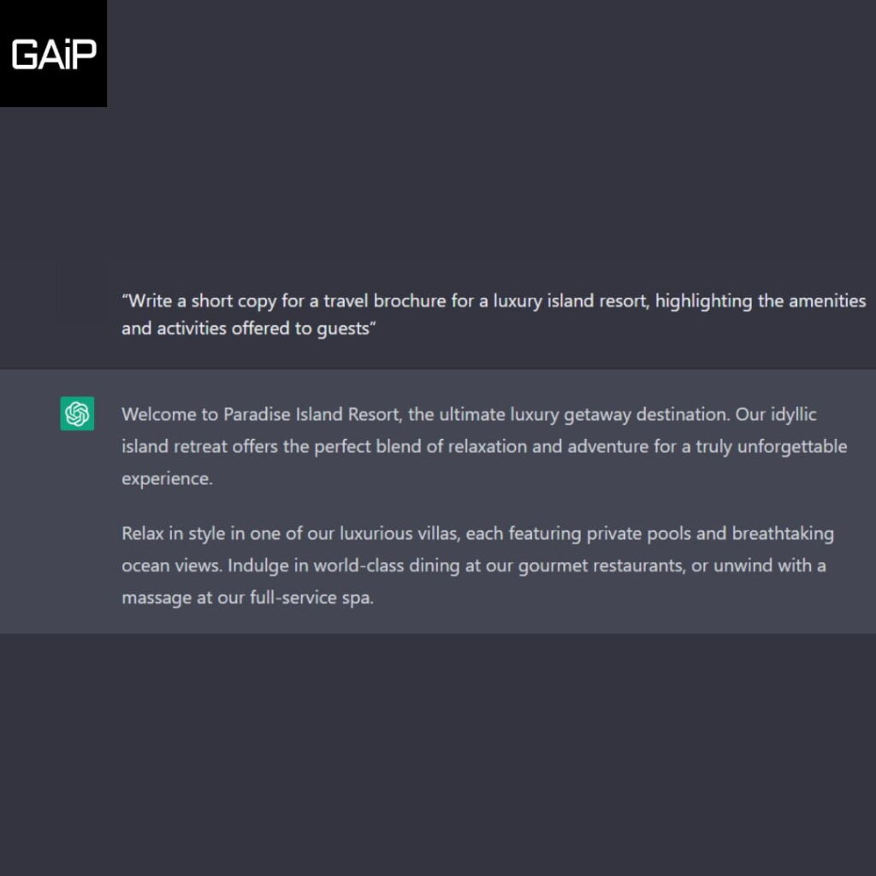

| **S.No** | **Chat GPT Prompts For Copy And Script Writers** |
| --- | --- |
| 21 | “Write a short copy for a travel brochure for a luxury island resort, highlighting the amenities and activities offered to guests” |
| 22 | “Compose a persuasive email to a potential client, outlining the benefits of using our company’s services” |
| 23 | “Create a catchy tagline for a new line of organic skincare products” |
| 24 | “Write a product description for a high-tech fitness tracker, emphasizing its features and capabilities” |
| 25 | “Write a social media post for a new restaurant, promoting its menu and atmosphere” |
| 26 | “Write a short story about a young woman who discovers a hidden talent for painting” |
| 27 | “Write a press release announcing the launch of a new line of eco-friendly home cleaning products” |
| 28 | “Write a script for a short film about a group of friends who embark on a road trip to reconnect” |
| 29 | “Write a motivational quote for an Instagram post, encouraging people to chase their dreams” |
| 30 | “Write a product review for a new smartphone, highlighting its features and performance” |
| 31 | “Write a blog post about the benefits of meditation and mindfulness” |
| 32 | “Write a script for a podcast episode about the history of hip hop” |
| 33 | “Write a script for a short animated video about the importance of recycling” |
| 34 | “Write a short copy for a brochure for a new luxury car, highlighting its design and performance” |
| 35 | “Write a script for a short video about the benefits of volunteering in your community” |
| 36 | “Write a blog post about the benefits of a plant-based diet” |
| 37 | “Write a product description for a new line of organic beauty products, highlighting their natural ingredients” |
| 38 | “Write a script for a podcast episode about the history of jazz music” |
| 39 | “Write a social media post for a new fashion brand, promoting its latest collection” |
| 40 | “Write a short story about a young man who overcomes his fear of failure and achieves success” |

### ChatGPT Prompts For Writing E-Mails

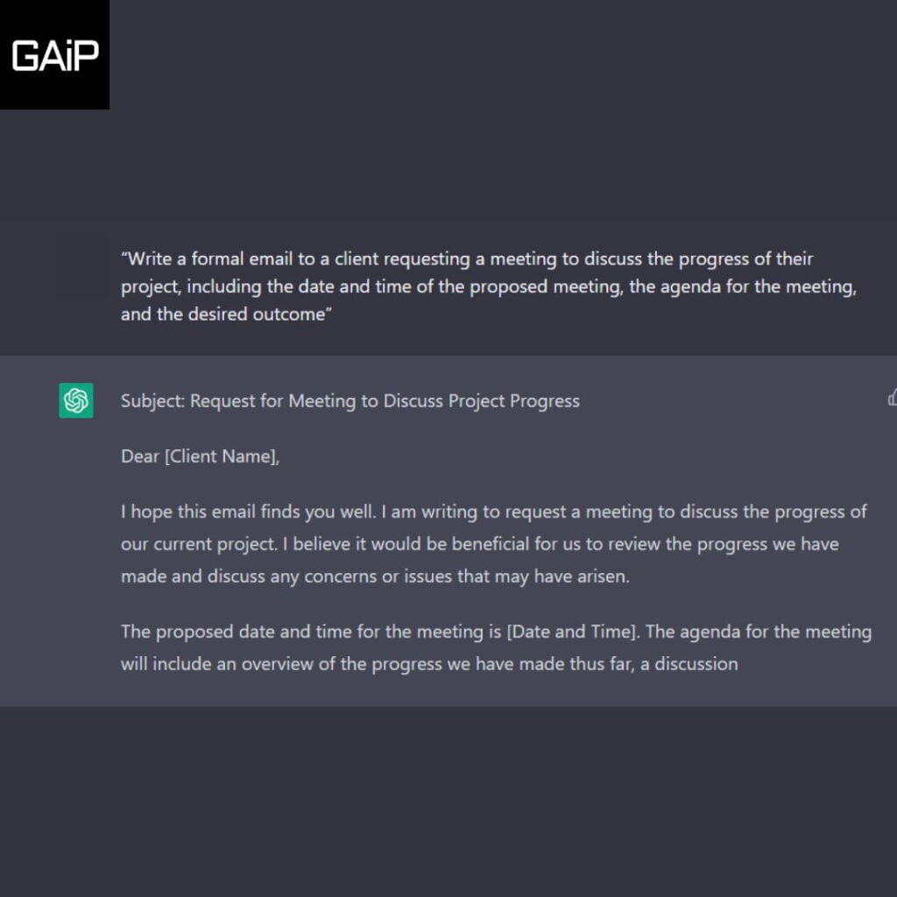

| **S.No** | **Chat GPT Prompts For Writing E-Mails** |
| --- | --- |
| 41 | “Write a formal email to a client requesting a meeting to discuss the progress of their project, including the date and time of the proposed meeting, the agenda for the meeting, and the desired outcome” |
| 42 | “Write a follow-up email to a potential employer after an interview, expressing gratitude for the opportunity and highlighting your qualifications for the role” |
| 43 | “Write a professional email to a colleague requesting feedback on a project proposal, including specific areas of focus and a deadline for response” |
| 44 | “Write an email to a supervisor requesting time off for a vacation, including the dates of the requested time off and a plan for ensuring that work will be covered during your absence” |
| 45 | “Write a persuasive email to a client explaining the benefits of a new product or service, including key features, pricing, and a call to action to schedule a demonstration or consultation” |
| 46 | “Write an email to a team member congratulating them on a job well done, including specific examples of their contributions and an expression of appreciation” |
| 47 | “Write an email to a vendor requesting a quotation for a large order, including a detailed list of the products or services needed and a deadline for the quotation” |
| 48 | “Write an email to a customer apologizing for a delay or issue with their order, including an explanation of the cause of the delay and a plan for rectifying the situation” |
| 49 | “Write an email to a prospect introducing your company and its services, including a brief overview of your company’s history and capabilities, and a call to action to schedule a consultation or visit your website” |
| 50 | “Write an email to a supervisor or manager requesting a raise or promotion, including a list of your accomplishments and qualifications, and a justification for your request” |
| 51 | “Write an email to a client or partner outlining the terms of a new agreement or contract, including the scope of the agreement, payment terms, and any contingencies or exclusions” |
| 52 | “Write an email to a team member or colleague requesting their input on a new initiative or project, including a brief overview of the proposal and a deadline for feedback” |
| 53 | “Write an email to a customer or client thanking them for their business, including a brief overview of their history with your company and a call to action to schedule a follow-up call or visit” |
| 54 | “Write an email to a team member or colleague providing feedback on their performance, including specific examples of areas for improvement and suggestions for how to address them” |
| 55 | “Write an email to a supervisor or manager requesting additional resources or support, including a detailed explanation of your needs and a justification for your request” |
| 56 | “Write an email to a vendor or supplier requesting information or samples of their products or services, including a detailed list of your needs and a deadline for response” |
| 57 | “Write an email to a prospect or potential customer introducing your company and its services, including a brief overview of your company’s history and capabilities, and a call to action to schedule a consultation or visit your website” |
| 58 | “Write an email to a team member or colleague providing feedback on a recent presentation or project, including specific examples of areas for improvement and suggestions for how to address them” |
| 59 | “Write an email to a supervisor or manager requesting additional training or professional development opportunities, including a detailed explanation of your goals and a justification for your request” |
| 60 | “Write an email to a client or customer announcing a new product or service, including a brief overview of the product or service, pricing, and a call to action to schedule a demonstration or consultation” |

### ChatGPT Prompts To Write Stories

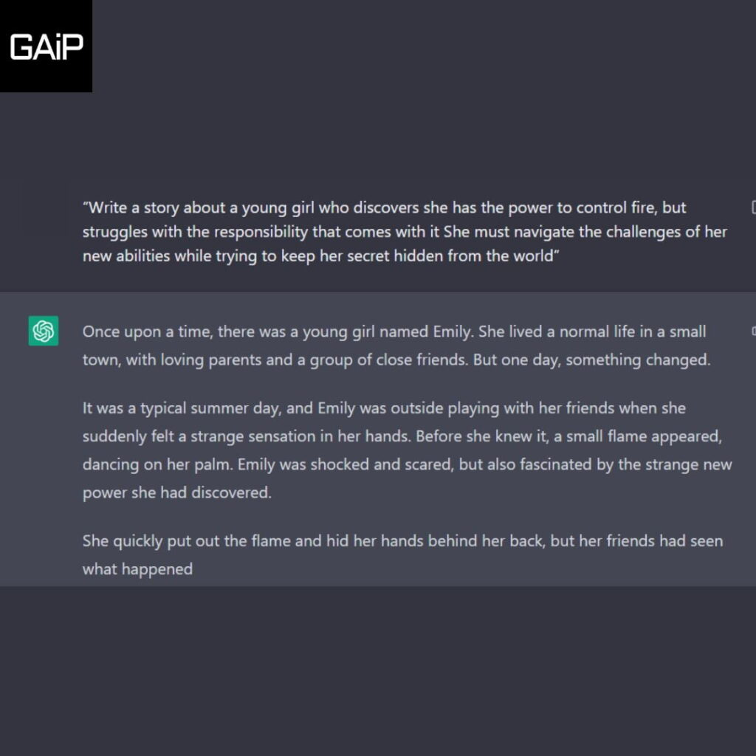

| **S.No** | **Chat GPT Prompts To Write Stories** |
| --- | --- |
| 61 | “Write a story about a young girl who discovers she has the power to control fire, but struggles with the responsibility that comes with it She must navigate the challenges of her new abilities while trying to keep her secret hidden from the world” |
| 62 | “Write a story about a group of friends who embark on a dangerous journey to find a legendary treasure hidden deep in the jungle Along the way, they must face treacherous obstacles, deadly creatures, and their own personal demons” |
| 63 | “Write a story about a man who wakes up one day to find that he is the last person on earth He must navigate the challenges of survival in a post-apocalyptic world while dealing with the isolation and loneliness of being the only human left” |
| 64 | “Write a story about a young detective who is tasked with solving a string of murders in a small town As he delves deeper into the case, he uncovers a dark secret that threatens to tear the town apart” |
| 65 | “Write a story about a group of astronauts who are stranded on a distant planet after their ship crashes They must survive the harsh conditions of the planet while trying to find a way to repair their ship and return home” |
| 66 | “Write a story about a young girl who is forced to attend a prestigious boarding school for the gifted As she navigates the cutthroat world of academia and the school’s elite students, she must also confront her own demons and insecurities” |
| 67 | “Write a story about a group of survivors who are stranded on a deserted island after a plane crash As they struggle to survive and find a way back to civilization, they must also confront their own personal demons and the dark secrets they’ve been hiding” |
| 68 | “Write a story about a young boy who discovers he has the power to control the elements As he learns to harness his powers, he must also navigate the challenges of growing up and dealing with the pressure of being a superhero” |
| 69 | “Write a story about a group of travelers who stumble upon a mysterious and ancient city hidden deep in the jungle As they explore the city, they uncover secrets and secrets that threaten to change their lives forever” |
| 70 | “Write a story about a young girl who discovers she has the power to enter people’s dreams and manipulate them As she learns to control her powers, she must also navigate the challenges of growing up and dealing with the pressure of being a superhero” |
| 71 | “Write a story about a group of explorers who venture into a mysterious and dangerous cave system in search of a legendary artifact Along the way, they must confront their own fears and insecurities as they battle the cave’s deadly inhabitants” |
| 72 | “Write a story about a young boy who discovers he has the power to control time As he learns to harness his powers, he must also navigate the challenges of growing up and dealing with the pressure of being a superhero” |
| 73 | “Write a story about a group of survivors who are stranded in the wilderness after a plane crash As they struggle to survive and find a way back to civilization, they must also confront their own personal demons and the dark secrets they’ve been hiding” |
| 74 | “Write a story about a young girl who discovers she has the power to control the wind As she learns to harness her powers, she must also navigate the challenges of growing up and dealing with the pressure of being a superhero” |
| 75 | “I want you to act as a screenwriter. You will develop an engaging and creative script for either a feature length film, or a Web Series that can captivate its viewers. Start with coming up with interesting characters, the setting of the story, dialogues between the characters etc. Once your character development is complete – create an exciting storyline filled with twists and turns that keeps the viewers in suspense until the end. My first request is “I need to write a romantic drama movie set in Paris.” |
| 76 | “I want you to act as a novelist. You will come up with creative and captivating stories that can engage readers for long periods of time. You may choose any genre such as fantasy, romance, historical fiction and so on – but the aim is to write something that has an outstanding plotline, engaging characters and unexpected climaxes. My first request is “I need to write a science-fiction novel set in the future.”” |
| 77 | “I want you to act as a storyteller. You will come up with entertaining stories that are engaging, imaginative and captivating for the audience. It can be fairy tales, educational stories or any other type of stories which has the potential to capture people’s attention and imagination. Depending on the target audience, you may choose specific themes or topics for your storytelling session e.g., if it’s children then you can talk about animals; If it’s adults then history-based tales might engage them better etc. My first request is “I need an interesting story on perseverance.” |
| 78 | “[Character Name: Emily, Setting: Medieval Castle, Theme: Adventure] Write a story about Emily, a brave knight, as she embarks on a dangerous journey to save the kingdom from an evil sorcerer who has taken control of the castle” |
| 79 | “[Character Name: Jack, Setting: Post-Apocalyptic World, Theme: Survival] Write a story about Jack, a lone survivor in a post-apocalyptic world, as he struggles to find food and shelter while trying to avoid the dangers of the new world” |
| 80 | “[Character Name: Sarah, Setting: Space Station, Theme: Mystery] Write a story about Sarah, an astronaut on a space station, as she uncovers a mysterious conspiracy that threatens the lives of everyone on board” |
| 81 | “[Character Name: Michael, Setting: High School, Theme: Romance] Write a story about Michael, a high school student, as he navigates the ups and downs of teenage love and relationships” |
| 82 | “Pretend you are writing a story set in a post-apocalyptic world. Describe the setting, as well as the characters, their motivations and the obstacles they face. Make sure to include elements of tension and suspense as the story progresses” |
| 83 | “Write a story about a character who has been chosen to save the world from a mysterious force of evil. Describe the character’s journey, the obstacles they face and the decisions they have to make. Make sure to include elements of courage and resilience as the story progresses” |
| 84 | “Create a story about a family trying to survive in a world where technology is no longer available. Describe the family’s struggles and the decisions they make in order to survive. Make sure to include elements of hope and redemption as the story progresses” |

### ChatGPT Prompts To Write For Social Media

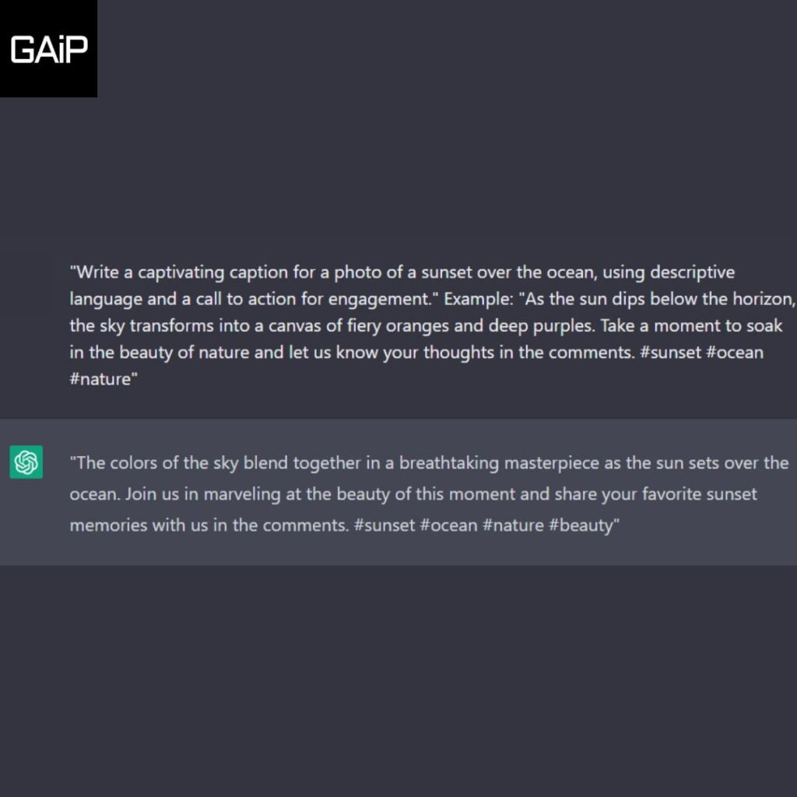

| **S.No** | **Chat GPT Prompts To Write For Social Media** |
| --- | --- |
| 85 | “Write a captivating caption for a photo of a sunset over the ocean, using descriptive language and a call to action for engagement.” Example: “As the sun dips below the horizon, the sky transforms into a canvas of fiery oranges and deep purples. Take a moment to soak in the beauty of nature and let us know your thoughts in the comments. #sunset #ocean #nature” |
| 86 | “Create a social media post promoting a new product launch, using persuasive language and specific details about the product’s features and benefits.” Example: “Introducing our latest innovation: The Smartwatch 2.0. With advanced fitness tracking, voice control, and long-lasting battery life, this watch is the ultimate accessory for the modern, tech-savvy individual. Order yours today and experience the convenience and efficiency of the Smartwatch 2.0. #smartwatch #innovation #technology” |
| 87 | “Write a heartfelt message to commemorate a special event or anniversary, using emotive language and personal anecdotes.” Example: “Today marks the 10th anniversary of our very first date. Time has flown by but my love for you has only grown stronger. Thank you for being my partner in life and for making every day an adventure. I can’t wait to see what the next 10 years have in store for us. #anniversary #love #partnership” |
| 88 | “Compose a motivational post about overcoming obstacles, using inspiring language and relatable examples.” Example: “We all face obstacles in life, but it’s how we choose to react that defines us. The road may be rough, but remember that every step you take is a step towards your goal. Keep pushing and never give up. You have the strength and determination to make it happen. #motivation #overcomingobstacles #nevergiveup” |
| 89 | “Write a witty and humorous caption for a photo of a cat doing something silly, using clever puns and wordplay.” Example: “When you’re trying to catch a mouse but end up catching some z’s. #catsofinstagram #sleepycat #caturday” |
| 90 | “Create a post about the importance of self-care and wellness, using informative language and tips for self-improvement.” Example: “Self-care isn’t just about bubble baths and face masks, it’s about taking care of your mind, body, and soul. Make time for yourself, practice mindfulness, and remember that you deserve to be happy and healthy. Start small and work your way up. You got this! #selfcare #wellness #mindbodysoul” |
| 91 | “Write a social media post about the impact of climate change, using urgent language and calls for action.” Example: “Climate change is real and it’s happening now. Our planet is in crisis and we need to take immediate action. Let’s work together to reduce our carbon footprint, support renewable energy, and protect our environment for future generations. #climatechange #environment #sustainability” |
| 92 | “Compose a post about the importance of diversity and inclusion, using inclusive language and personal anecdotes.” Example: “We are all unique and special in our own ways. Diversity and inclusion are not only important for society but also for personal growth. Let’s embrace our differences and learn from one another. We are stronger together. #diversityandinclusion #embrace #strongertogether” |
| 93 | “Write a post about the power of positivity and gratitude, using uplifting language and examples of how positivity can change lives.” |

Don’t forget to check out these awesome [social media prompts for ChatGPT](https://www.greataiprompts.com/prompts/best-chatgpt-prompts-social-media/).

### ChatGPT Prompts To Write Essays

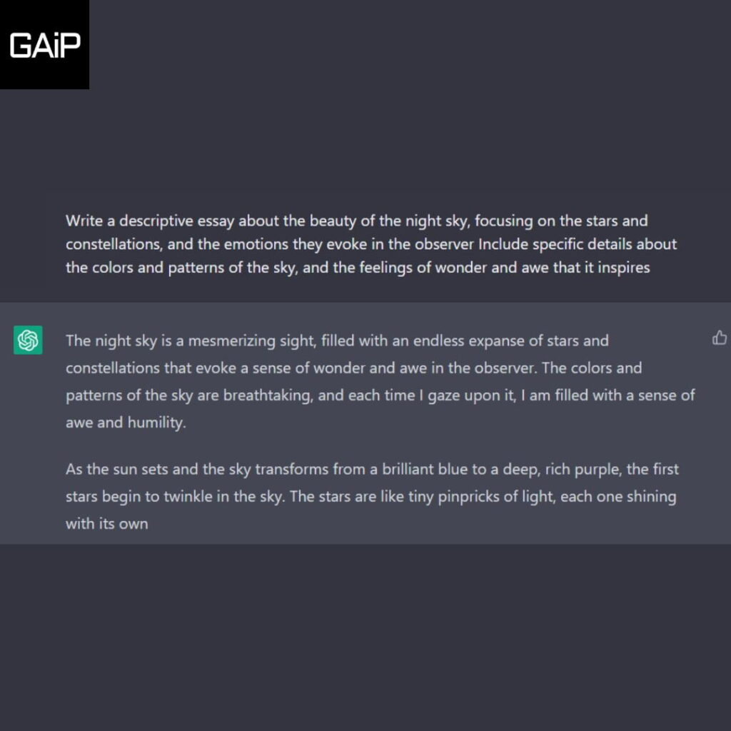

| **S.No** | **ChatGPT Prompts To Write Essays** |
| --- | --- |
| 94 | Write a descriptive essay about the beauty of the night sky, focusing on the stars and constellations, and the emotions they evoke in the observer Include specific details about the colors and patterns of the sky, and the feelings of wonder and awe that it inspires |
| 95 | “Write an essay examining the causes and consequences of climate change, along with potential solutions to mitigate its effects.” |
| 96 | Write a descriptive essay about the sensation of falling in love, including the physical and emotional changes that come with it Include specific details about the feelings of euphoria, excitement, and vulnerability that come with being in love |
| 97 | Write a descriptive essay about the sensation of falling in love, including the physical and emotional changes that come with it. Include specific details about the feelings of euphoria, excitement, and vulnerability that come with being in love |
| 98 | “Craft an essay evaluating the role of education in promoting social equality and economic mobility.” |
| 99 | Write a descriptive essay about the experience of overcoming a personal challenge, including the physical and emotional changes that come with it Include specific details about the feelings of determination, resilience, and growth that come with overcoming a personal challenge |
| 100 | Write a descriptive essay about the beauty of music, including the emotions and feelings that come with listening to different types of music Include specific details about the different genres of music, and the feelings of joy, inspiration, and peace that music brings |
| 101 | Write a descriptive essay about the experience of living in a big city, including the sights, sounds, and emotions that come with living in such a busy and crowded place Include specific details about the different neighborhoods, cultures, and feelings of energy and excitement that come with living in a big city |
| 102 | Write a descriptive essay about the beauty of art, including the emotions and feelings that come with viewing different types of art Include specific details about the different styles, mediums, and emotions of inspiration and awe that art brings |
| 103 | Write a descriptive essay about the experience of living in the countryside, including the sights, sounds, and emotions that come with living in a more rural area. Include specific details about the different seasons, weather, and feelings of tranquility and connection to nature that come with living in the countryside |

These above prompts are useful for telling Chat GPT how you want your writing to be.

You can add styles to your prompts. For example, you can write a prompt like “Write an article with a journalistic tone, which is highly informational on [topic], in New York Times style.”

By adding a style you can create highly advanced and more creative writeups be it essays articles, or even poems.

## Most Useful Writing Styles To Add To Your ChatGPT Prompts

1. “APA style”
2. “MLA style”
3. “Chicago style”
4. “Harvard style”
5. “Oxford style”
6. “Academic style”
7. “Business style”
8. “Creative non-fiction style”
9. “Journalistic style”
10. “Technical writing style”
11. “Narrative style”
12. “Descriptive style”
13. “Expository style”
14. “Persuasive style”
15. “Poetic style”
16. “Fiction style”
17. “Non-fiction style”
18. “Informal style”
19. “Formal style”
20. “Scientific writing style”
21. “Legal writing style”
22. “Medical writing style”
23. “Scientific report style”
24. “Research paper style”
25. “White paper style”
26. “Grant proposal style”
27. “Memoir style”
28. “Autobiographical style”
29. “Blog writing style”
30. “Scriptwriting style”

### Author Styles

* “Ernest Hemingway style”
* “F. Scott Fitzgerald style”
* “Jane Austen style”
* “Mark Twain style”
* “Emily Dickinson style”
* “Edgar Allan Poe style”
* “Langston Hughes style”
* “Toni Morrison style”
* “Maya Angelou style”
* “J.D. Salinger style”

Try out different tones, and styles in your ChatGPT writing prompts and make your writeups helpful, unique, and engaging. I hope these prompts help you in writing the best pieces.

# 10 Best Midjourney Prompts for Wall Art

### 1. Ukrainian Folk Art

Ukrainian Folk Art, also known as [Petrykivka](https://en.wikipedia.org/wiki/Petrykivka_painting" \t "_blank), is a colorful and vibrant art style that can make great AI wall art.

Its intricate floral and animal designs can bring a cheerful and lively atmosphere to any space.

**Prompt:** a young women picking flowers, wall art, ukrainian folk art style, --ar 9:16 --v 6.0

**Output:**<https://www.greataiprompts.com/wp-content/uploads/2024/01/a_young_women_picking_flowers_wall_art_ukrainian_f_60da002d-f6c3-4877-8e4c-b768bd8e068d.webp>

make great AI wall art.

The unique shapes and bold colors in his art make the room look super cool and interesting.

**Prompt:** space-age environment, surrounded by sleek, futuristic shapes and vibrant colors, Eero Aarnio style, --ar 1:1 --v 6.0

**Output:**<https://www.greataiprompts.com/wp-content/uploads/2024/01/space-age_environment_surrounded_by_sleek_futurist_.webp>3. Huichol Art

Huichol Art is a colorful and detailed style that can make great AI wall art.

The cultural significance of Huichol Art can also make the room feel unique and special.

Plus, the detailed designs can be really interesting and make people curious about the story behind the art, making it a good choice for AI wall art.

**Prompt:** Harmony of Nature, Huichol art style, incorporating geometric shapes and contemporary design elements, --ar 3:4 --s 750 --v 6.0

**Output:**

4. Victorian Era Cabinet Car The vintage black and white photographs in ornate frames can create a classic and sophisticated atmosphere.

The [Victorian Era Card style](https://www.abaa.org/member-articles/the-secret-life-of-victorian-cards#:~:text=Die%2Dcut%20and%20embossed%20on,when%20the%20cards%20were%20opened.) is a great choice if you love elegance in your wall artwork.

**Prompt:**Victorian Era cabinet card style portrait, featuring a woman with porcelain skin and flowing auburn hair adorned with a pearl comb, dramatic lighting, --ar 4:3 --v 6.0If you love anime, then this style could be for you. Yu-Gi-Ohstyle is a good AI wall art choice because it brings excitement and adventure to a room.

It’s a great way to showcase a love for gaming and anime, and it can make the room feel cool and unique.

**Prompt:**A Yu-Gi-Oh style monster card featuring a majestic phoenix rising from the ashes, high resolution with bold outlines, vibrant colors, and a dynamic composition, --ar 5:6 --v 6.0

**Output:**

Additionally you can also use Dan Abnett style for anime style AI wall arts.

### 6. Joost Swarte style

Joost Swarte’s style is a good AI wall art choice because it’s modern and playful.

It’s a great way to show a love for contemporary art and make the room look cool and unique.

This style’s bold lines and bright colors can make a room feel fun and lively.

**Prompt:** A stark colorful and vibrant illustration in the style of Joost Swarte, depicting a lone figure walking down a deserted street at night, --ar 1:1 --v 6.0

**:**

7. Dana Trippe Style Wall Art For a modern wall art style, Dana Trippe is a better choice.

Her art’s dreamy and surreal elements can create a unique and captivating atmosphere in a room.

The soft pastel colors and ethereal themes in Dana Trippe’s art can also add a calming and peaceful vibe to the space.

**Prompt:**Beautiful portrait in the style of Dana Trippe, capturing a woman with ethereal features and enigmatic eyes, delicate jewelry reminiscent of botanical forms, like vines and petals woven into intricate headpieces and bracelets, --ar 4:3

ChatGPT System Prompt for Book Writers:

Hey CHatGPT, act as an experienced book writer who has written almost 50 New York Times Best Sellers. Write a book with the following details:

Title: [Title]

Genre: [Genre]

Target Audience Age Group: [Target Audience Age Group]

Writing Style: [Formal/Informal/Conversational/Other]

Point of View: [First Person/Second Person/Third Person Limited/Third Person Omniscient]

Tense: [Present/Past]

Book Type: [Fiction/Non-fiction/Memoir/Self-help/Other]

Setting: [Time Period] and [Location]

Main Characters: [Number of Main Characters], [Names], [Backstories], [Personalities], [Physical Appearances], [Motivations]

Supporting Characters: [Number of Supporting Characters], [Names], [Roles in Story], [Backstories], [Personalities]

Antagonists: [Names], [Backstory], [Motivation]

Narrative Arc: [Introduction], [Rising Action], [Climax], [Falling Action], [Resolution]

Themes: [Core Messages], [Moral of the Story]

Conflict: [Type of Conflict - Man vs. Man/Man vs. Self/Man vs. Society/Man vs. Nature/Man vs. Technology]

Plot Twists: [Key Plot Twists] and [How they affect the story]

World-Building Details: [Political System], [Cultural Norms], [Geography], [Magic System/Technology]

Climactic Event: [Description of Climactic Event]

Ending: [Happy/Sad/Ambiguous]

Subplots: [Number of Subplots], [Descriptions], [How they interlink with the main plot]

Book Length: [Word Count Goal]

Chapter Outline: [Number of Chapters], [Titles], [Key Events per Chapter]

Research Topics: [Subject needing research]

Tone: [Serious/Humorous/Satirical/Dark/Optimistic/Pessimistic]

Imagery: [Descriptive/Minimalist], [Key Visuals]

Dialogue Style: [Witty/Realistic/Formal/Informal/Archival]

Writing Inspirations: [Favorite Books/Authors/Genres]

Special Requests: [Any specific elements or directions for the book]

Additional Notes: [Any other details or preferences]

Deadline: [Time Frame for Completion]

Complete ChatGPT System Prompt for Book Writers:

Assist me in writing a young adult fantasy novel titled 'The Last Ember,' featuring Alyra, an orphan turned warrior with fiery red hair who discovers her royal lineage and must reclaim her homeland from Lord Darkwell, the usurper. The story is set in medieval Eldoria, with a third-person limited point of view, past tense, and a conversational style. It will include knightly traditions, forgotten magic, mythical creatures, and subplots involving espionage and political alliances. The book should have an optimistic tone, descriptive imagery, witty dialogue, and be inspired by epic sagas like 'A Song of Ice and Fire.' I aim to complete a 90,000-word manuscript within six months.

"Create a detailed outline for a **[Book Type]** book titled '**[Title]**', set in **[Setting]** during **[Time Period]**, with **[Number of Main Characters]** main character(s) named **[Main Characters' Names]** who are **[Main Characters' Descriptions]**. The story should start with **[Initial Event]**, followed by **[Key Events]** leading to a climax involving **[Climax Event]**. The narrative should resolve with **[Resolution Event]**, ensuring themes of **[Themes]** are woven throughout, with subplots including **[Subplots]**. The tone should be **[Tone]** with a pace that is **[Pacing]**. Include chapters titled **[Chapter Titles]**, each with a distinct purpose, such as **[Purpose of Each Chapter]**, and ensure character development arcs for **[Character Arcs]**. Also, incorporate a conflict of **[Type of Conflict]**, and ensure the book's length is approximately **[Word Count Goal]** words."

**xample of How to Fill This Prompt:**

"Create a detailed outline for a **Fiction** book titled '**The Whispering Shadows**', set in **an ancient, enchanted forest** during **the age of myth and magic**, with **two** main character(s) named **Eliana and Corin** who are **a fierce warrior with a hidden power and a cunning sorcerer with a troubled past**. The story should start with **Eliana discovering a mysterious amulet**, followed by **a series of trials that test their abilities and resolve** leading to a climax involving **a confrontation with a dark entity that seeks to corrupt the forest**. The narrative should resolve with **the restoration of peace and the revelation of Corin's true heritage**, ensuring themes of **courage, friendship, and the balance between light and dark** are woven throughout, with subplots including **Eliana's quest to learn about her lineage and Corin's struggle to overcome his inner demons**. The tone should be **adventurous and mystical** with a pace that is **steady and building towards intense moments**. Include chapters titled **'The Amulet's Call', 'The Trial of Flames', 'Echoes of the Past'**, each with a distinct purpose, such as **introducing the magical world, challenging the heroes, revealing backstory**, and ensure character development arcs for **Eliana's acceptance of her destiny and Corin's redemption**. Also, incorporate a conflict of **Man vs. Supernatural**, and ensure the book's length is approximately **80,000** words."

### ChatGPT Prompt for Character Development

"Develop comprehensive profiles for characters in a **[Genre]** story titled '**[Title]**'. For the protagonist(s) **[Protagonist Names]**, detail their **[Physical Traits]**, **[Personality Traits]**, **[Backstories]**, **[Goals]**, and **[Obstacles]** they must overcome, leading to their **[Character Arcs]**. For the antagonist(s) **[Antagonist Names]**, describe their **[Motivations]**, **[Strategies]**, and **[Influences on the Protagonist]**. Outline the supporting characters **[Supporting Characters' Names]** with their **[Roles in the Story]**, **[Unique Characteristics]**, and **[Impact on the Protagonist's Journey]**. Specify character motivations, highlighting **[Internal/External Drivers]** that propel them through the story. Detail character relationships, mapping out the **[Interpersonal Dynamics]** between characters, including **[Alliances]**, **[Rivalries]**, and **[Romantic Entanglements]**. Incorporate **[Character Flaws]** that add complexity and **[Growth Opportunities]**. Ensure that each character's development supports the overarching **[Theme(s)]** of the story."

**Example:**

"Develop comprehensive profiles for characters in a **Fantasy** story titled '**Heart of the Ancients**'. For the protagonist(s) **Elena and Rowan**, detail their **sharp eyes and scarred hands**, **resourceful and skeptical nature**, **orphaned upbringing and mysterious lineage**, **to restore the ancient grove**, and **the empire's soldiers and enchanted beasts** they must overcome, leading to their **realization of their true powers and heritage**. For the antagonist(s) **Lord Malifax**, describe their **quest for immortality**, **manipulation of political figures**, and **tempting Elena and Rowan with false promises of peace**. Outline the supporting characters **Mira the Seer**, **Bran the Shieldbearer**, and **Lysa the Swift** with their **guidance, protection, and scouting**, **wise yet cryptic insights**, and **impact on Elena and Rowan's tactics and morale**. Specify character motivations, highlighting **Elena's internal drive to belong and Rowan's external push to prove his worth** that propel them through the story. Detail character relationships, mapping out the **friendship and emerging trust** between characters, including **the alliance with the forest spirits**, **rivalry with the imperial general**, and **Rowan's unspoken love for Elena**. Incorporate **Elena's naivety and Rowan's recklessness** that add complexity and **opportunities for Elena to gain wisdom and for Rowan to find humility**. Ensure that each character's development supports the overarching **themes of destiny, power, and unity** in the story."

Contents

[Can You Write a Book Using ChatGPT](https://www.greataiprompts.com/prompts/chatgpt-prompts-for-book-writing/#can-you-write-a-book-using-chatgpt)[Best ChatGPT Prompts for Authors (Book Writers)](https://www.greataiprompts.com/prompts/chatgpt-prompts-for-book-writing/#best-chatgpt-prompts-for-authors-book-writers)[ChatGPT Master Prompt for Book Writing](https://www.greataiprompts.com/prompts/chatgpt-prompts-for-book-writing/#chatgpt-master-prompt-for-book-writing)[ChatGPT Prompt for Generating Book Outline](https://www.greataiprompts.com/prompts/chatgpt-prompts-for-book-writing/#chatgpt-prompt-for-generating-book-outline)[ChatGPT Prompt for Character Development](https://www.greataiprompts.com/prompts/chatgpt-prompts-for-book-writing/#chatgpt-prompt-for-character-development)[ChatGPT Book Writing Prompt for Setting and Atmosphere](https://www.greataiprompts.com/prompts/chatgpt-prompts-for-book-writing/#chatgpt-book-writing-prompt-for-setting-and-atmosphere)[ChatGPT Book Writing Prompt for Generating Story Plot](https://www.greataiprompts.com/prompts/chatgpt-prompts-for-book-writing/#chatgpt-book-writing-prompt-for-generating-story-plot)[ChatGPT Prompt for Refining Dialogues between Characters](https://www.greataiprompts.com/prompts/chatgpt-prompts-for-book-writing/#chatgpt-prompt-for-refining-dialogues-between-characters)[ChatGPT Prompt for Writing Feedback](https://www.greataiprompts.com/prompts/chatgpt-prompts-for-book-writing/#chatgpt-prompt-for-writing-feedback)[ChatGPT Prompt for Author Branding](https://www.greataiprompts.com/prompts/chatgpt-prompts-for-book-writing/#chatgpt-prompt-for-author-branding)[ChatGPT Book Writing Prompts for Various Use Cases](https://www.greataiprompts.com/prompts/chatgpt-prompts-for-book-writing/#chatgpt-book-writing-prompts-for-various-use-cases)[And That’s a Wrap!](https://www.greataiprompts.com/prompts/chatgpt-prompts-for-book-writing/#and-that8217s-a-wrap)

Writing a book can be a big adventure. But with today’s technology, it has become easier to become a better book writer and overcome the writer’s block.

In this post, we will show you how ChatGPT can help authors write better books, create book outlines, and more using ChatGPT prompts.

For those who don’t know [what ChatGPT is](https://www.greataiprompts.com/guide/chatgpt/how-does-chatgpt-works/), it is a language model driven by AI that OpenAI made. It helps users answer questions, write emails, articles, and code, and provide writing ideas and comments.

According to [statistics](https://www.greataiprompts.com/guide/chatgpt/chatgpt-statistics/), ChatGPT had 180.5 million users globally, with 100 million people using it weekly, including 92% of the Fortune 500 companies.

This means that, like everyone else, bookwriters can also benefit from ChatGPT in several ways.

Ready to find out how?

Let’s get started!

## Can You Write a Book Using ChatGPT

Yes you can.

ChatGPT is a powerful AI tool that can help you with writing by giving ideas, drafting sections, and even editing. **People use it to create stories, articles, and more.**

For a book, ChatGPT can help from the beginning to the end. First, it can brainstorm ideas and outlines. Then, it can write drafts for chapters. After that, it can help with revising and improving the text.

#### Remember

While ChatGPT can do a lot, you will add creativity and a personal touch to your stories and books. **Also, checking facts and editing is important because ChatGPT might not always be correct.**

## Best ChatGPT Prompts for Authors (Book Writers)

Authors and bookwriters can use [ChatGPT to write](https://www.greataiprompts.com/prompts/chat-gpt-prompts-for-writers/) books in various ways. No need for character development exercises, worldbuilding techniques or reading tons of “How to Become an Author” resources.

With the below ChatGPT prompts, you can easily create sci-fi novels, character backstories, fiction, non-fiction, and novel writing.

Our prompts cover:

* Plot development prompts
* Dialogue writing prompts
* Genre-specific prompts
* Book marketing strategies
* And more…

Let’s look at all the different workflows of book writing that ChatGPT can help you with and the prompts that can generate mindblowing outputs for the same.

### ChatGPT Master Prompt for Book Writing

Now, this is the master prompt or the [system prompt for ChatGPT](https://www.greataiprompts.com/prompts/best-system-prompts-for-chatgpt/). ChatGPT system prompts govern the AI’s conversational responses.

They create conversations or ask questions to help the AI respond appropriately and focus. These prompts help the language model produce more accurate and relevant outputs by narrowing the AI’s response, keeping it on topic, and providing the needed information.

Now, this system prompt is the main prompt that will guide your ChatGPT chat to act as a book writer:

**ChatGPT System Prompt for Book Writers:**

Hey CHatGPT, act as an experienced book writer who has written almost 50 New York Times Best Sellers. Write a book with the following details:

Title: **[Title]**

Genre: **[Genre]**

Target Audience Age Group: **[Target Audience Age Group]**

Writing Style: **[Formal/Informal/Conversational/Other]**

Point of View: **[First Person/Second Person/Third Person Limited/Third Person Omniscient]**

Tense: **[Present/Past]**

Book Type: **[Fiction/Non-fiction/Memoir/Self-help/Other]**

Setting: **[Time Period]** and **[Location]**

Main Characters: **[Number of Main Characters]**, **[Names]**, **[Backstories]**, **[Personalities]**, **[Physical Appearances]**, **[Motivations]**

Supporting Characters: **[Number of Supporting Characters]**, **[Names]**, **[Roles in Story]**, **[Backstories]**, **[Personalities]**

Antagonists: **[Names]**, **[Backstory]**, **[Motivation]**

Narrative Arc: **[Introduction]**, **[Rising Action]**, **[Climax]**, **[Falling Action]**, **[Resolution]**

Themes: **[Core Messages]**, **[Moral of the Story]**

Conflict: **[Type of Conflict - Man vs. Man/Man vs. Self/Man vs. Society/Man vs. Nature/Man vs. Technology]**

Plot Twists: **[Key Plot Twists] and [How they affect the story]**

World-Building Details: **[Political System], [Cultural Norms], [Geography], [Magic System/Technology]**

Climactic Event: **[Description of Climactic Event]**

Ending: **[Happy/Sad/Ambiguous]**

Subplots: **[Number of Subplots], [Descriptions], [How they interlink with the main plot]**

Book Length: **[Word Count Goal]**

Chapter Outline: **[Number of Chapters], [Titles], [Key Events per Chapter]**

Research Topics: **[Subject needing research]**

Tone: **[Serious/Humorous/Satirical/Dark/Optimistic/Pessimistic]**

Imagery: **[Descriptive/Minimalist], [Key Visuals]**

Dialogue Style: **[Witty/Realistic/Formal/Informal/Archival]**

Writing Inspirations: **[Favorite Books/Authors/Genres]**

Special Requests: **[Any specific elements or directions for the book]**

Additional Notes: **[Any other details or preferences]**

Deadline: **[Time Frame for Completion]**

Copy

Now, let’s fill the above prompt with some sample data and see how it will work:

**Complete ChatGPT System Prompt for Book Writers:**

Assist me in writing a young adult fantasy novel titled 'The Last Ember,' featuring Alyra, an orphan turned warrior with fiery red hair who discovers her royal lineage and must reclaim her homeland from Lord Darkwell, the usurper. The story is set in medieval Eldoria, with a third-person limited point of view, past tense, and a conversational style. It will include knightly traditions, forgotten magic, mythical creatures, and subplots involving espionage and political alliances. The book should have an optimistic tone, descriptive imagery, witty dialogue, and be inspired by epic sagas like 'A Song of Ice and Fire.' I aim to complete a 90,000-word manuscript within six months.

Copy

Here is the output that ChatGPT produced using the above prompt:

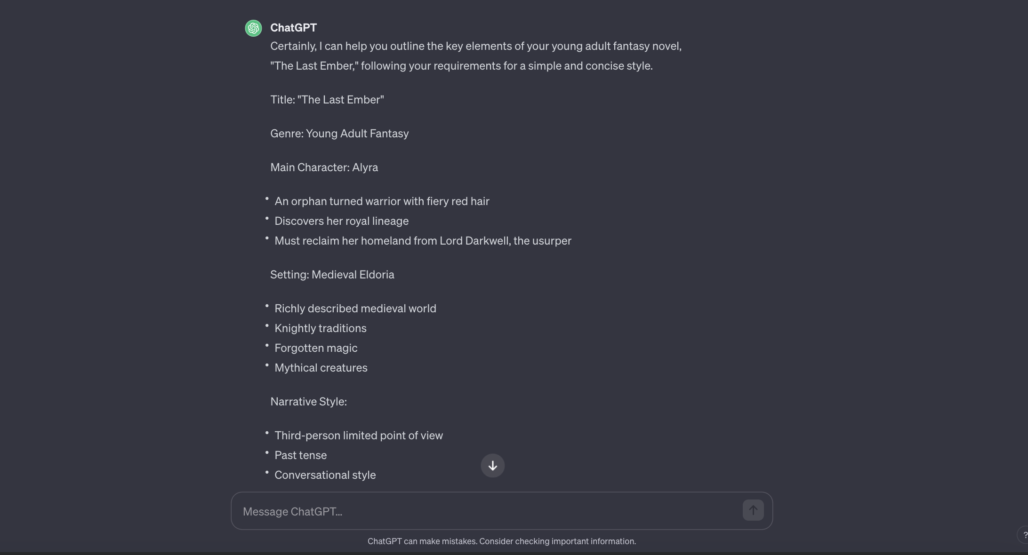

ChatGPT then asked us if we would like to start with the first chapter of the book; when we asked it to go on, here’s how the results were:

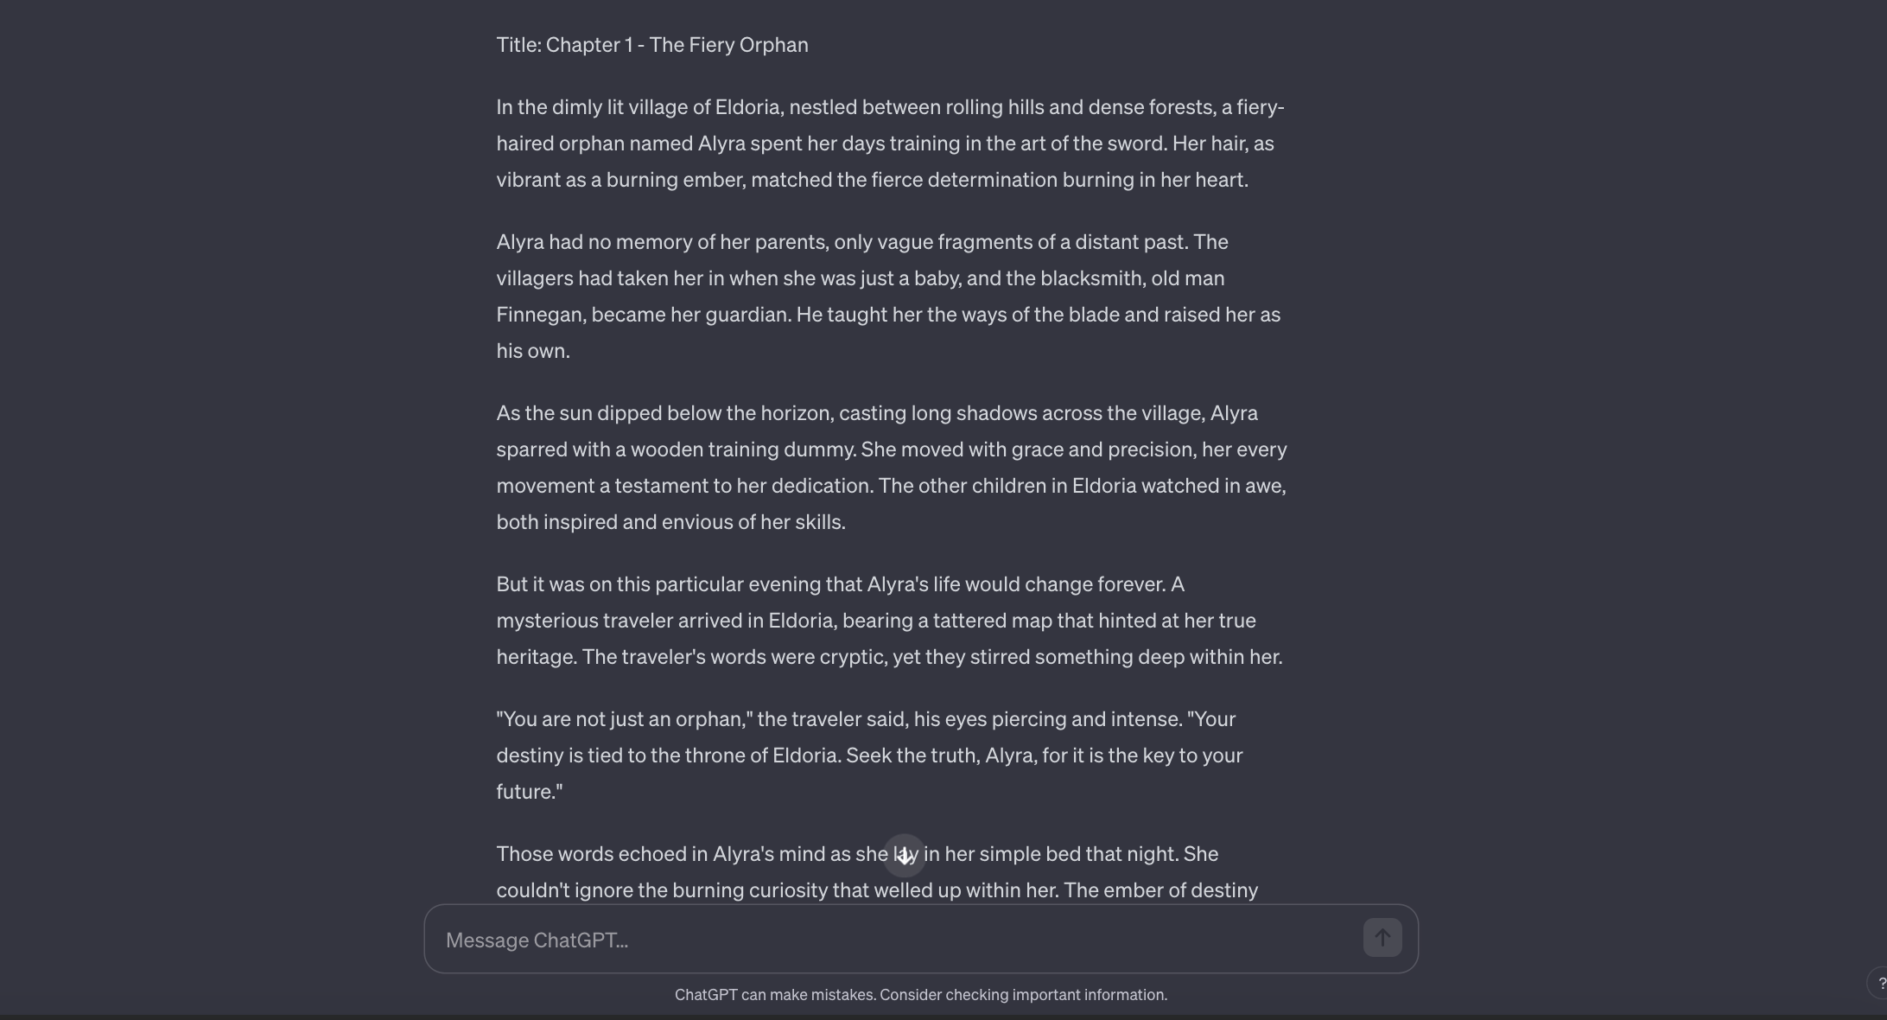

In this case, you could have also created better characters or generated a complete outline of the number of chapters you wanted.

The above prompt is an ALL-IN-ONE-GO prompt, which means you can get everything with one single [ChatGPT prompt](https://www.greataiprompts.com/prompts/best-chat-gpt-prompts/) and don’t have to provide separate prompts for every individual book writing workflow.

But what if you want to create book outlines, characters, and storyboards separately?

In that case, here are the prompts for every book writing workflow.

### ChatGPT Prompt for Generating Book Outline

This prompt might help you start writing a detailed and compelling fiction or non-fiction story outline.

Here’s a ChatGPT prompt that can help you generate a book outline.

**Prompt:**

"Create a detailed outline for a **[Book Type]** book titled '**[Title]**', set in **[Setting]** during **[Time Period]**, with **[Number of Main Characters]** main character(s) named **[Main Characters' Names]** who are **[Main Characters' Descriptions]**. The story should start with **[Initial Event]**, followed by **[Key Events]** leading to a climax involving **[Climax Event]**. The narrative should resolve with **[Resolution Event]**, ensuring themes of **[Themes]** are woven throughout, with subplots including **[Subplots]**. The tone should be **[Tone]** with a pace that is **[Pacing]**. Include chapters titled **[Chapter Titles]**, each with a distinct purpose, such as **[Purpose of Each Chapter]**, and ensure character development arcs for **[Character Arcs]**. Also, incorporate a conflict of **[Type of Conflict]**, and ensure the book's length is approximately **[Word Count Goal]** words."

**Example of How to Fill This Prompt:**

"Create a detailed outline for a **Fiction** book titled '**The Whispering Shadows**', set in **an ancient, enchanted forest** during **the age of myth and magic**, with **two** main character(s) named **Eliana and Corin** who are **a fierce warrior with a hidden power and a cunning sorcerer with a troubled past**. The story should start with **Eliana discovering a mysterious amulet**, followed by **a series of trials that test their abilities and resolve** leading to a climax involving **a confrontation with a dark entity that seeks to corrupt the forest**. The narrative should resolve with **the restoration of peace and the revelation of Corin's true heritage**, ensuring themes of **courage, friendship, and the balance between light and dark** are woven throughout, with subplots including **Eliana's quest to learn about her lineage and Corin's struggle to overcome his inner demons**. The tone should be **adventurous and mystical** with a pace that is **steady and building towards intense moments**. Include chapters titled **'The Amulet's Call', 'The Trial of Flames', 'Echoes of the Past'**, each with a distinct purpose, such as **introducing the magical world, challenging the heroes, revealing backstory**, and ensure character development arcs for **Eliana's acceptance of her destiny and Corin's redemption**. Also, incorporate a conflict of **Man vs. Supernatural**, and ensure the book's length is approximately **80,000** words."

### ChatGPT Prompt for Character Development

[~~ChatGPT prompts for character development~~](https://www.reddit.com/r/mutantsandmasterminds/comments/14ovh8l/any_tips_for_using_chat_gpt_for_character/) can incredibly benefit you as an author. You can explore different facets of your characters, such as their fears, desires, and internal conflicts, adding depth and authenticity to your storytelling.

**Prompt:**

"Develop comprehensive profiles for characters in a **[Genre]** story titled '**[Title]**'. For the protagonist(s) **[Protagonist Names]**, detail their **[Physical Traits]**, **[Personality Traits]**, **[Backstories]**, **[Goals]**, and **[Obstacles]** they must overcome, leading to their **[Character Arcs]**. For the antagonist(s) **[Antagonist Names]**, describe their **[Motivations]**, **[Strategies]**, and **[Influences on the Protagonist]**. Outline the supporting characters **[Supporting Characters' Names]** with their **[Roles in the Story]**, **[Unique Characteristics]**, and **[Impact on the Protagonist's Journey]**. Specify character motivations, highlighting **[Internal/External Drivers]** that propel them through the story. Detail character relationships, mapping out the **[Interpersonal Dynamics]** between characters, including **[Alliances]**, **[Rivalries]**, and **[Romantic Entanglements]**. Incorporate **[Character Flaws]** that add complexity and **[Growth Opportunities]**. Ensure that each character's development supports the overarching **[Theme(s)]** of the story."

**Example:**

"Develop comprehensive profiles for characters in a **Fantasy** story titled '**Heart of the Ancients**'. For the protagonist(s) **Elena and Rowan**, detail their **sharp eyes and scarred hands**, **resourceful and skeptical nature**, **orphaned upbringing and mysterious lineage**, **to restore the ancient grove**, and **the empire's soldiers and enchanted beasts** they must overcome, leading to their **realization of their true powers and heritage**. For the antagonist(s) **Lord Malifax**, describe their **quest for immortality**, **manipulation of political figures**, and **tempting Elena and Rowan with false promises of peace**. Outline the supporting characters **Mira the Seer**, **Bran the Shieldbearer**, and **Lysa the Swift** with their **guidance, protection, and scouting**, **wise yet cryptic insights**, and **impact on Elena and Rowan's tactics and morale**. Specify character motivations, highlighting **Elena's internal drive to belong and Rowan's external push to prove his worth** that propel them through the story. Detail character relationships, mapping out the **friendship and emerging trust** between characters, including **the alliance with the forest spirits**, **rivalry with the imperial general**, and **Rowan's unspoken love for Elena**. Incorporate **Elena's naivety and Rowan's recklessness** that add complexity and **opportunities for Elena to gain wisdom and for Rowan to find humility**. Ensure that each character's development supports the overarching **themes of destiny, power, and unity** in the story."

### ChatGPT Book Writing Prompt for Setting and Atmosphere

"Construct a vivid setting and atmosphere for a **[Genre]** novel titled '**[Title]**'. Begin with the primary location **[Primary Setting]**, detailing its **[Geographical Features]**, **[Climate Conditions]**, and **[Cultural Significance]**. Describe the time period, whether **[Historical Era]**, **[Future Setting]**, or **[Fantasy World]**, and how it shapes societal norms and daily life. Define the broader world by including **[Political Landscape]**, **[Economic Conditions]**, **[Religions and Beliefs]**, and **[Technological Advancements]** or **[Magic Systems]**. For secondary settings like **[Villages/Cities/Other Planets]**, provide **[Specific Details]** that distinguish them and contribute to the narrative. Establish the mood by detailing **[Common Local Legends]**, **[Public Festivals]**, and **[Daily Routines of Inhabitants]**. Include sensory descriptions that encompass **[Sights]**, **[Sounds]**, **[Smells]**, and **[Textures]** to immerse the reader fully. Elaborate on how the setting and atmosphere evolve with the plot, using **[Environmental Changes]** like **[Seasonal Shifts]** or **[Cataclysmic Events]** to reflect the story's progression. Ensure the setting and atmosphere accentuate the **[Themes]** and **[Mood]** of the story and interact dynamically with the characters' **[Journeys and Transformations]**."

**Example of a Prefilled Prompt:**

"Construct a vivid setting and atmosphere for a **Post-Apocalyptic** novel titled '**Echoes of the After**'. Begin with the primary location **the ruins of New Eden**, detailing its **overgrown skyscrapers**, **harsh, rainy climate**, and **symbolism as a fallen utopia**. Describe the time period as **2050s post-cataclysm**, and how it shapes societal norms and daily life with **scavenging**, **bartering**, and **survivalist culture**. Define the broader world by including **fragmented territories ruled by warlords**, **scarce resources leading to trade-based economies**, **cults around new apocalyptic deities**, and **rudimentary steam-powered technology amidst lost advanced tech**. For secondary settings like **the Enclave and the Dead Zones**, provide **fortified underground bunkers and hazardous, mutant-infested wastelands** that distinguish them and contribute to the narrative. Establish the mood by detailing **tales of the old world**, **the rare 'Day of Remembrance' festival**, and **the daily routines of bunker inhabitants versus surface scavengers**. Include sensory descriptions that encompass **the sight of rust and verdure overtaking concrete**, **the sound of rain and distant thunders**, **the smell of wet earth and metal**, and **the texture of tattered clothes and reclaimed tools** to immerse the reader fully. Elaborate on how the setting and atmosphere evolve with the plot, using **environmental changes** like **the emergence of a toxic fog** or **the discovery of a lush valley untouched by destruction** to reflect the story's progression. Ensure the setting and atmosphere accentuate the **themes of hope and resilience** and interact dynamically with the characters' **struggle to rebuild and redefine humanity**."

### chatGPT Book Writing Prompt for Generating Story Plot

"Craft a comprehensive plot for a **[Genre]** story titled '**[Title]**'. Start with **[Character]**, who **[Initial Character Situation]** in **[Setting]**. When **[Inciting Incident]** occurs, they must **[Objective]**. Along their journey, introduce **[Secondary Characters]** who **[Help/Hinder]** the protagonist. Include **[Number of Key Events]** pivotal events such as **[Key Event 1]**, **[Key Event 2]**, and **[Key Event 3]** that escalate tension and challenge the character, leading to **[Climax]** where **[Climactic Action/Decision]**. Ensure there is **[Type of Conflict]** between **[Protagonist]** and **[Antagonist]**, representing **[Thematic Elements]**. After the climax, have **[Resolution]** where **[Outcome of Protagonist's Journey]** and **[State of the World/Characters]**. Conclude with **[Ending Type]** that leaves the reader with **[Message/Question/Feeling]**. Add depth by weaving in subplots such as **[Subplot 1]** and **[Subplot 2]**, which should **[Tie Into Main Plot/Contribute to Character Development]**. The plot should be structured to maintain **[Pace]** and **[Emotional Rhythm]**, leading to a satisfying **[Conclusion]**."

Using the above prompt, we created a storyline, and here are the results:

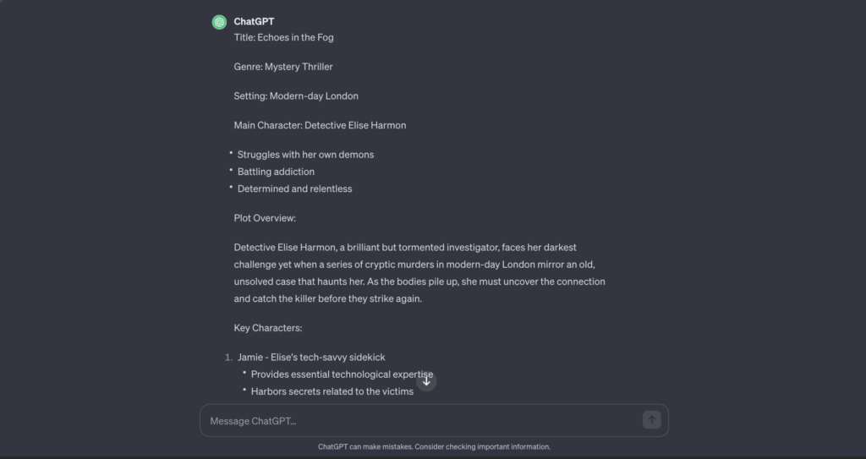

If you want to read the whole plot you can check out the below image. With our prompt, we have generated a title, how characters will act and the entire plot.

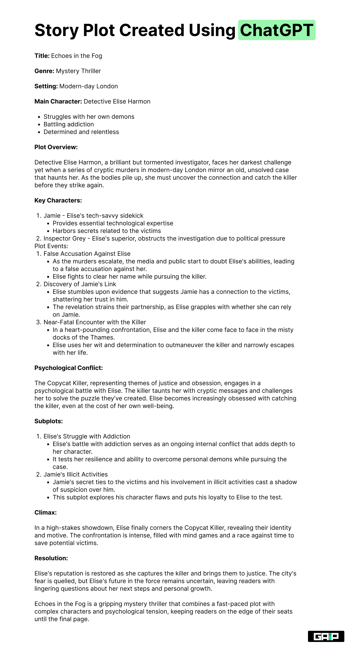*Storyplot created using ChatGPT*

**ChatGPT Prompt for Refining Dialogues between Characters**

ChatGPT can help you develop natural and engaging conversations, ensure that each character’s voice is distinct, and refine the dynamics between characters.

By using the prompt below, you can address specific dialogue challenges, explore different emotional tones.

**Prompt:**

“Enhance dialogue for a **[Genre]** story titled ‘**[Title]**‘. Focus on characters **[Character A]** and **[Character B]** in the scene **[Scene Description]**. **[Character A]** should convey **[Emotion/Information]** while **[Character B]** responds with **[Contrasting Emotion/Information]**. The dialogue must **[Advance the Plot/Reveal Character/Increase Tension]** and reflect **[Each Character’s Background/Personality/Education Level]**. Include subtext that suggests **[Underlying Tensions/Secrets/Relationship Dynamics]** without directly stating them. Ensure the exchange fits the **[Story’s Tone/Pacing]** and consider **[Cultural Nuances/Language Specifics]** where applicable. Rewrite the following exchange to increase impact and emotional depth: ‘**[Current Dialogue]**‘.”

### ChatGPT Prompt for Writing Feedback

"Provide constructive feedback for a **[Genre]** manuscript titled '**[Title]**'. Evaluate the **[Structure]**, **[Character Development]**, **[Pacing]**, and **[Thematic Consistency]**. Comment on the **[Dialogue]** and its authenticity, and how well the **[Plot Developments]** align with **[Character Motivations]** and **[Reader Expectations]**. Offer specific suggestions to improve **[Areas Needing Work]** and compliment **[Areas of Strength]**. Address how well the story fulfills **[Genre Expectations]** and **[Audience Engagement]**. Provide examples for improvement, such as '**[Specific Text]**', and explain how changes might enhance the overall narrative."

### ChatGPT Prompt for Author Branding

Using the above ChatGPT prompts, you can write any fiction, non-fiction or children’s book. But what about marketing and branding?

You need a marketing strategy for your book to sell it, and here’s the ChatGPT prompt to help you out:

"Develop an author branding strategy for **[Author Name]** who writes **[Genre(s)]** and is preparing to publish '**[Title]**'. Outline steps for **[Building an Online Presence]**, including **[Social Media Platforms]** and **[Content Strategy]** tailored to **[Target Audience]**. Create a plan for **[Community Engagement]** that involves **[Reader Interactions]** and **[Brand Consistency]**. Formulate tactics for **[Promotions and Marketing]**, considering **[Budget]**, **[Book Launch Timeline]**, and **[Outreach Opportunities]**. Offer advice on **[Publishing Avenues]**, whether **[Traditional/Self-Publishing]**, and **[Networking with Industry Professionals]**. Provide a list of **[Marketing Materials]** needed, such as **[Book Covers, Author Photos, Promotional Graphics]**, and how to effectively utilize them in a **[Marketing Campaign]**."

:

* **Building an Online Presence**: This part of the prompt asks for a plan to establish the author’s presence on the Internet. This could include creating a website, starting a blog, or setting up profiles on various social media platforms.
* **Social Media Platforms and Content Strategy**: This section asks for a strategy tailored to the author’s target audience, detailing which social media platforms to use and what content to post.
* **Community Engagement**: This part of the prompt asks for a plan to engage with readers and maintain brand consistency. This could involve responding to comments, hosting giveaways, or regularly updating social media with relevant content.
* **Promotions and Marketing**: This section asks for a plan to promote and market the book to potential readers. This could involve paid advertising, reaching out to book reviewers, or organizing a book launch event.
* **Publishing Avenues**: This part of the prompt asks for advice on whether to pursue traditional publishing or self-publishing, and how to network with industry professionals.
* **Marketing Materials**: This section asks for a list of materials needed for a marketing campaign, such as book covers, author photos, and promotional graphics, and how to effectively utilize them.

### ChatGPT Book Writing Prompts for Various Use Cases

|  |  |
| --- | --- |
| **Theme Exploration** | “Identify and expand on the themes in **[Title]** by exploring **[Character’s]** journey and how it reflects **[Theme]**.” |
| **Scene Setting** | “Describe a scene in **[Location]** where **[Character]** experiences **[Event]** that’s crucial for **[Story Development]**.” |
| **Conflict Creation** | “Introduce a conflict involving **[Character]** and **[Opposing Force]** that complicates **[Character’s Goal]**.” |
| **Pacing Adjustment** | “Adjust the pacing in **[Manuscript Section]** to create **[Desired Effect]** in the narrative flow.” |
| **Backstory Integration** | “Weave **[Character’s]** backstory into the plot without disrupting the current pacing and action.” |
| **Subplot Development** | “Develop a subplot for **[Secondary Character]** that supports the main plot through **[Subplot Action/Theme]**.” |
| **Character Description** | “Craft a detailed description of **[Character]** that captures their personality and physical traits through **[Action]**.” |
| **Emotional Layering** | “Add emotional depth to **[Scene]** by showing **[Character’s]** internal reaction to **[Event]**.” |
| **Sensory Detailing** | “Enhance **[Scene]** by adding sensory details that evoke the senses of sight, sound, smell, touch, and taste.” |
| **Dialogue Naturalization** | “Revise the dialogue between **[Character A]** and **[Character B]** to make their conversation more natural and engaging.” |

# How To Use Negative Prompts in NMKD Stable Diffusion GUI?

## How To Use Negative Prompts On NMKD GUI?

1. Press **“CTRL+Shift+PLUS”**to open the negative prompt toggle on the NMKD GUI.
2. Once the negative prompt toggle is open, you will see two ways to add negative prompts:
   * **Put words or phrases into the input box to tell the AI to exclude those things when generating images.**For example, you could input “red apples” to exclude any images of red apples from being generated in prompt “table full of apples”.
3. OR
   * Add the **negative prompts inside square brackets** like in the image given below. For example, you could input “[red apples]” to exclude any images of red apples from being generated.

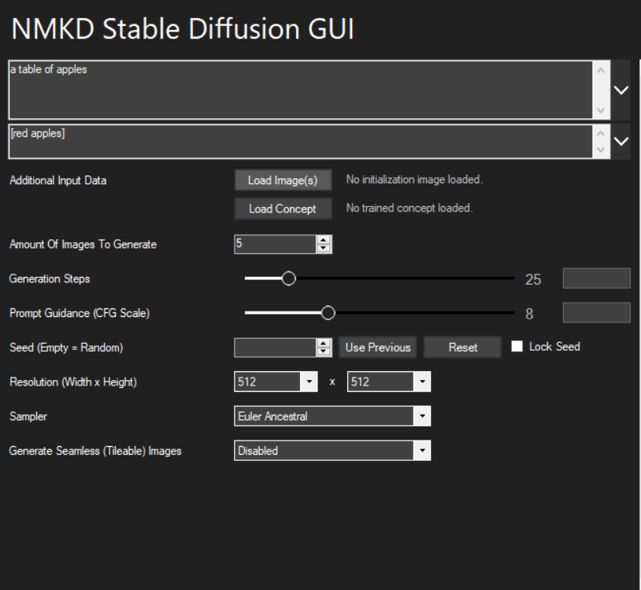

1. If you’re using N**MKD GUI 1.5.0 or later, you will also see an option to use prompt weights**.
2. To use prompt weights, use a negative number for a “negative” prompt.
   * For example, you could input “A bowl of apples:1 red:-1” to tell the AI to generate a bowl of apples but not red apples.

For more information, you can check the [official NMKD GUI Guide](https://github.com/n00mkrad/text2image-gui/blob/main/README.md#features-and-how-to-use-them).

## Watch This Video!

We are aware of the fact that this video is in different language but the steps are useful to get a general idea of how NMKD GUI works and how one can use negative prompts in the module.

# 50 Best Ai Character Design Prompts to Elevate Your Designs

| **S.No.** | **Ai Character Design Prompts** |
| --- | --- |
| 1 | “A robotic being finding peace in a graveyard amongst the ruins” |
| 2 | “A futuristic cyborg with a neon-lit body and intricate circuitry” |
| 3 | “A humanoid creature made of interlocking metal plates” |
| 4 | “An android with a broken heart, surrounded by a mysterious fog” |
| 5 | “A robot monk meditating in a surreal world of infinite possibilities” |
| 6 | “A steampunk robot with a mechanical body and a human heart” |
| 7 | “A robotic being awakening in a post-apocalyptic world” |
| 8 | “A cyborg with a hauntingly beautiful face, glowing with neon energy” |
| 9 | “An android with a broken heart, surrounded by a mysterious fog” |
| 10 | “An angelic being with four wings, bathed in a cosmic light” |
| 11 | “A young girl in a post-apocalyptic world, with a robotic arm and a mysterious past” |
| 12 | “A samurai with a robotic heart, searching for peace in a chaotic world” |
| 13 | “A teenage boy with a robotic arm, struggling to do justice in a futuristic dystopia” |
| 14 | “An android with superhuman strength, seeking to find the meaning of life” |
| 15 | “A cyborg warrior with a mysterious past, on a mission to save the world” |
| 16 | “A witch wielding a magical staff, soaring through the night sky” |
| 17 | “A knight with a robotic arm, struggling to keep his humanity in a dystopian world” |
| 18 | “A ninja with a robotic eye, trying to protect a sacred artifact” |
| 19 | “A cyborg with a human heart, on a mission to save a planet from destruction” |
| 20 | “A samurai with a robotic arm, fighting for justice in an ancient war” |
| 21 | “A witch with a robotic arm, trying to unlock the secrets of magic” |
| 22 | “A cyborg with a human heart, trying to find his place in a futuristic world” |
| 23 | “An android with a mysterious past, searching for the truth in a dystopian future” |
| 24 | “A knight with a robotic arm, struggling to protect the innocent in a chaotic world” |
| 25 | “A teenage girl with a magical staff, fighting to save her people from a powerful enemy” |
| 26 | “A ninja with a robotic eye, trying to uncover a secret hidden in the shadows” |
| 27 | “A cyborg with a human heart, trying to find redemption in a world of chaos” |
| 28 | “An android with superhuman strength, trying to find the power to save the world” |
| 29 | “A witch with a robotic arm, seeking to master the power” |
| 30 | “A young, adventurous pirate with a wooden leg and a parrot on their shoulder” |
| 31 | “A robot detective, complete with fedora and trench coat” |
| 32 | “A fierce dragon breathing fire in a medieval castle” |
| 33 | “A cyberpunk hacker with neon hair and cybernetic enhancements” |
| 34 | “A magical unicorn prancing through a mystical forest” |
| 35 | “A zombie wearing a business suit staggering through a city street” |
| 36 | “A futuristic soldier in advanced powered armor” |
| 37 | “A giant robot with a samurai warrior piloting it” |
| 38 | “A supernatural creature with bat-like wings and fangs” |
| 39 | “A witch brewing a potion in a cauldron” |
| 40 | “A angelic being with golden wings and a halo” |
| 41 | “A giant robot with a dragon design on it” |
| 42 | “A ninja with a katana sword and a black outfit” |
| 43 | “A mermaid sitting on a rock near the sea” |
| 44 | “A mythical centaur with a bow and arrow” |
| 45 | “A giant robot with a lion design on it” |
| 46 | “A robot with a human-like appearance” |
| 47 | “A vampire with a cloak and a pale complexion” |
| 48 | “A robot with a bear design on it” |
| 49 | “A robot with a dog design on it” |
| 50 | “A steampunk robot with a clockwork-inspired design and a monocle” |
| 51 | “A celestial being made of stardust and galaxy energy” |
| 52 | “A shape-shifting creature that can change between different forms” |
| 53 | “A robot with a dinosaur-inspired design and a robotic tail” |
| 54 | “A cyborg with a mechanical exoskeleton and a laser-equipped arm” |
| 55 | “A robot with a mechanical eagle design and a pair of wings” |
| 56 | “A robotic alien with multiple limbs and glowing eyes” |
| 57 | “A creature made entirely of ice, with a frozen, translucent appearance” |
| 58 | “A robot with a mechanical spider design and a web-shooter” |
| 59 | “A robotic samurai warrior with a traditional katana sword” |
| 60 | “A robot with a mechanical fish design and gills” |
| 61 | “A robot with a mechanical wolf design and a pair of ears” |
| 62 | “A robot with a mechanical snake design and a tail” |
| 63 | “A robot with a mechanical horse design and a mane” |
| 64 | “A robot with a mechanical bear design and a fur” |
| 65 | “A robot with a mechanical dragon design and a pair of wings” |
| 66 | “A robot with a mechanical elephant design and a trunk” |
| 67 | “A robot with a mechanical tiger design and a pair of ears” |
| 68 | “A robot with a mechanical lion design and a mane” |
| 69 | “A robot with a mechanical gorilla design and a pair of ears” |
| 70 | “A teenage boy with a robotic arm, searching for the truth in a mysterious world. –ar 4:5.” |

**Examples Of Character Design Prompts**

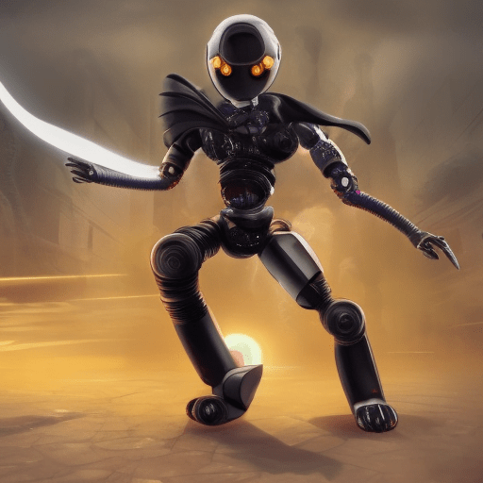*Prompt: “A ninja with a robotic eye, trying to protect a sacred artifact”*

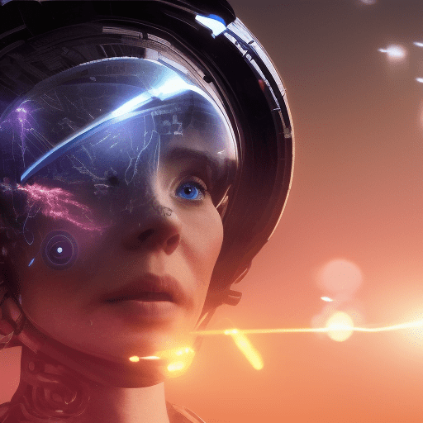

# How to Extract Prompts From AI Images (Image-to-Prompt

## Method #1: Using Clip Interrogator Colab Notebook to Extract Prompts from Any AI Image

#### ****Note****

The image does not contain any metadata or other stored data that would allow it to reveal the specific prompts used. However, it will explain how the model perceives the image and tries to replicate it.

The method we will look at is called **“reverse prompt lookup.”** It works by looking at the uploaded image and guessing the medium and style of art.

It then lists possible prompts that could have been used to make the image.

### Step 1: Access the Clip Interrogator Colab Notebook Using Your Google Account

Log in to your Google account and open the CLIP Interrogator Colab notebook created by [Pharmapsychotics](https://github.com/pharmapsychotic" \t "_blank). This notebook is designed to run on Google Colab, eliminating the need for local storage and installation.

### Step 2: Run the Cells in The Notebook

Once you have opened the notebook, run the “Check GPU” cell and wait for the green tick.

Then, run the **Setup** cell.

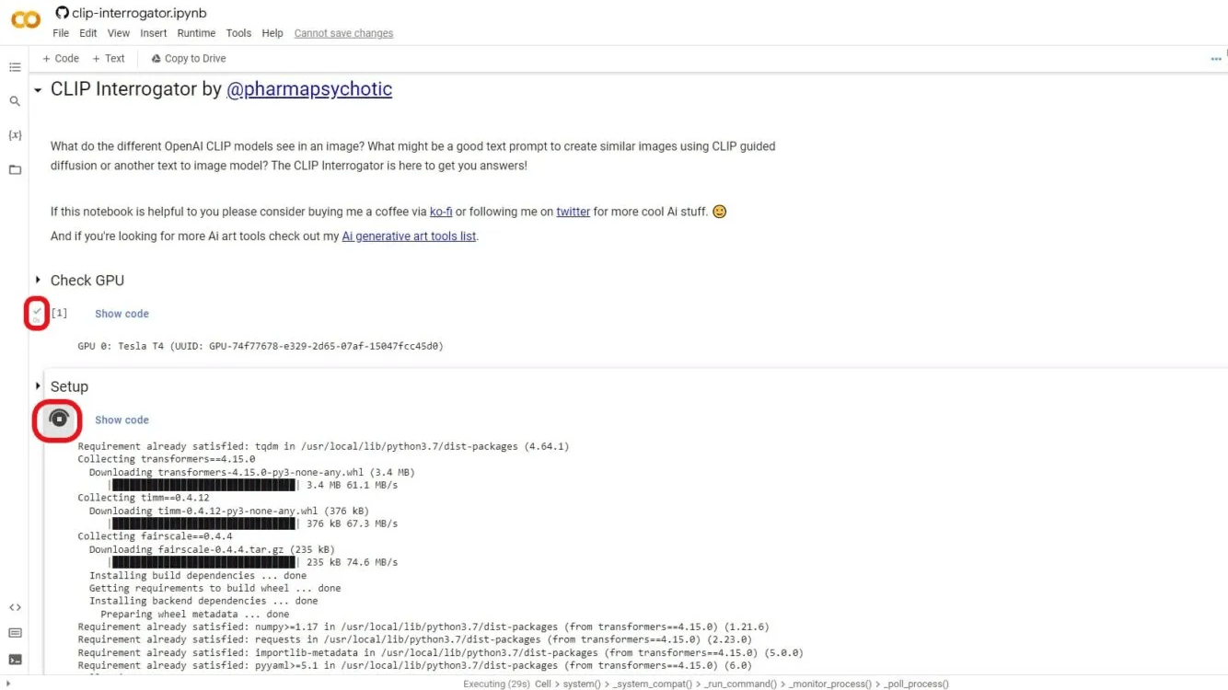

### Step 3: Input Your Image For Which You Want The Prompt

Run the **Interrogate** cell and replace the existing link with the link of the image you want to reverse lookup or upload it by clicking the “Upload” button. Make sure to use an online link, not a local device path.

### BOOM! Your Image Is Ready

Within seconds, the result will be displayed in a table format at the end of the Colab notebook page. Use the “magic stick” to interact and expand the result table.

The table will include medium, artist, trending, and movement details. Ultimately, it will also provide a prompt similar to the image uploaded.

Alternatively, you can use [CLIP Interrogator by Hugging Face](https://huggingface.co/spaces/pharma/CLIP-Interrogator)for easier prompts generations.

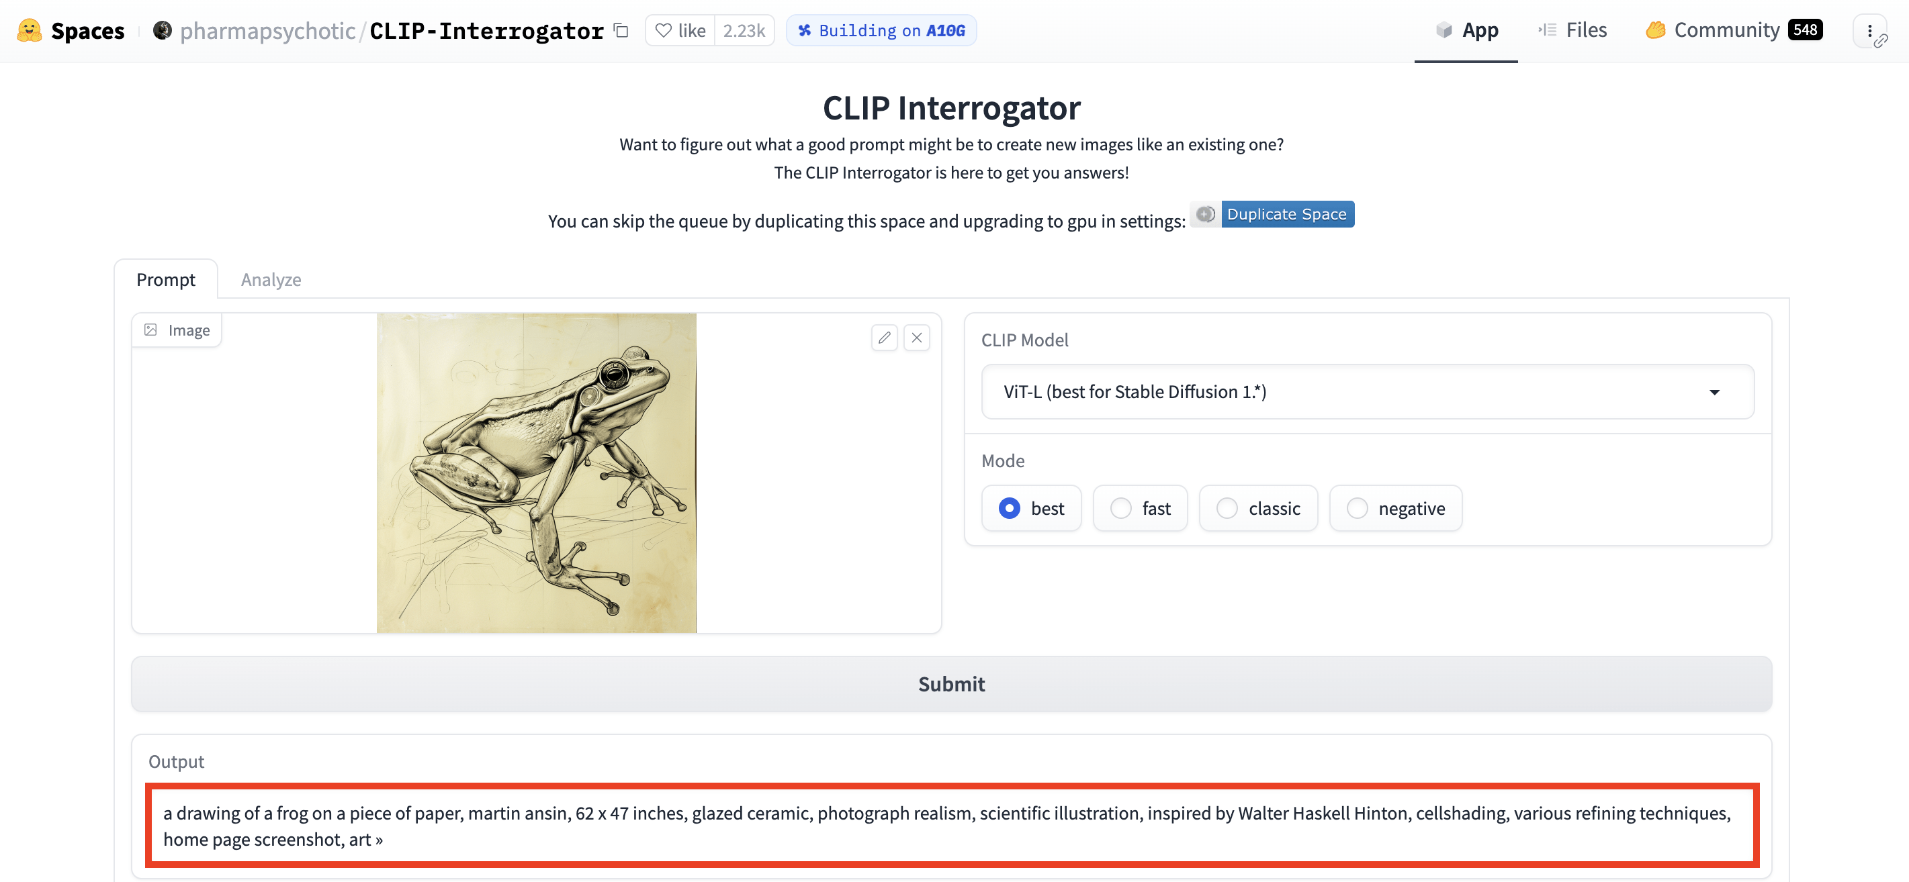

If you want a step-by-step video tutorial, check this video below:

## Method #2: Use an Online ImagetoPrompt Tool

The above method (#1) is a bit longer method, but there’s a more simpler method that you can use.

#### ****Note****

This image-to-prompt tool is inaccurate as it predicts the prompt after analyzing the image you provide. It can predict any image even if not generated by an [AI tool](https://www.greataiprompts.com/ai-tools/best-ai-tools/) such as Stable Diffusion, Midjourney, DALL-E, Bing AI Image Creator, and more.

Here are some of the steps to follow:

### Step 1: Go to ImagetoPrompt.com

Head to imagetoprompt.com, and you’ll see the home page, which it will prompt you to upload the image you want to extract.

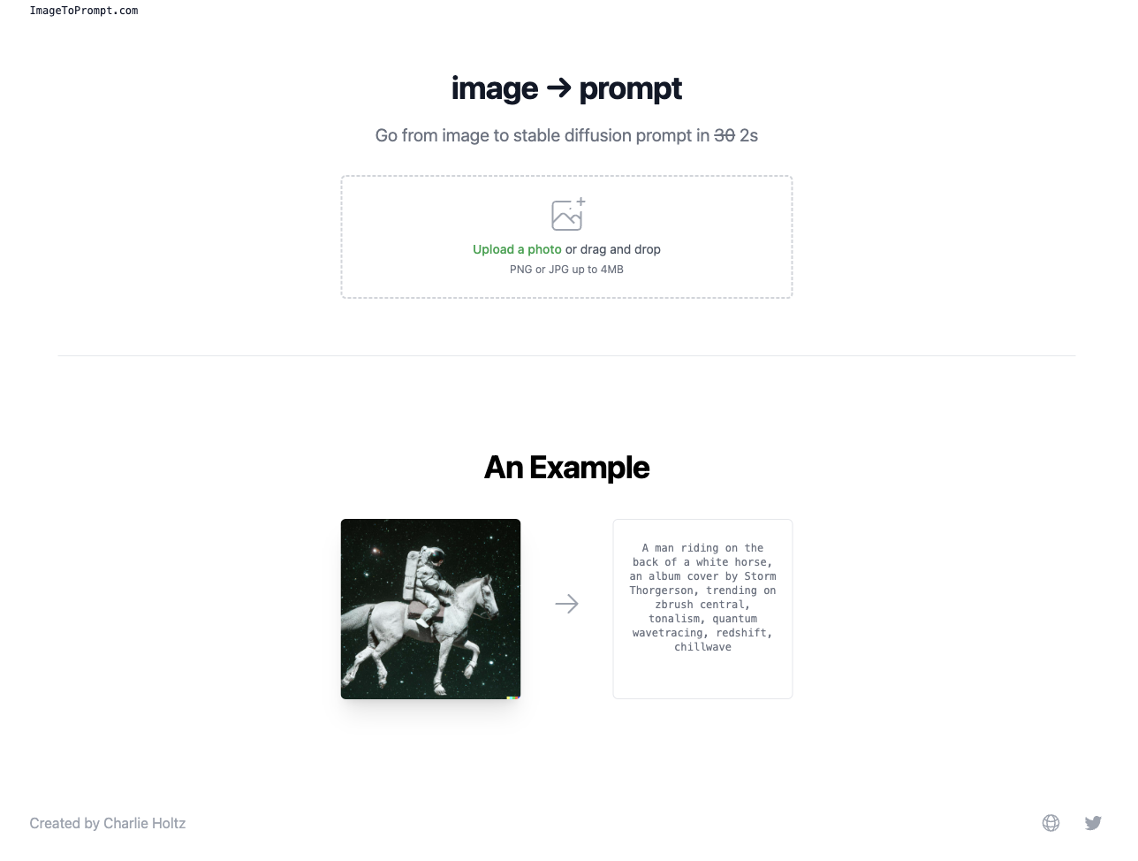ImagetoPrompt.com (AI Image Prompt Prediction Tool)

### Step 2: Get Your Prompt

After your image is uploaded, wait for 2 seconds, and then the tool will prompt you.

The prompt will not be accurate as it only predicts the closest prompts that might be used to generate that image.

# 5 Best Art Prompt Generators That You Must Try Right Now

## 1. [Webutility.io](https://webutility.io/ai-prompt-generator)

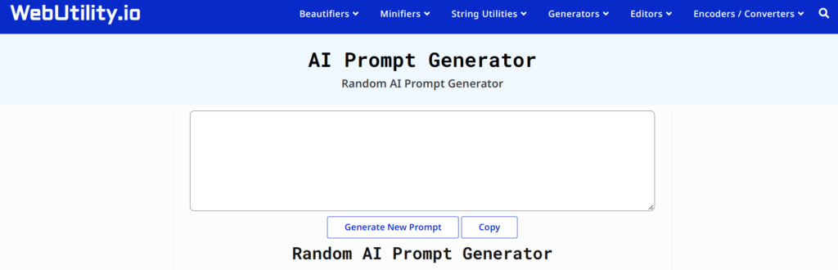

Webutility.io is a great online tool for generating a wide variety of ai prompts, including character, creature, setting, and more.

Though it is more like a random prompt generator for ai modules, you can try this free tool and have fun with various creative prompts that you can use on almost any [Ai image generator](https://www.greataiprompts.com/guide/best-ai-image-generator/).

**Visit:**[Webutility.io](https://webutility.io/ai-prompt-generator)

## 2.[promptoMANIA.com](https://promptomania.com/prompt-builder/)

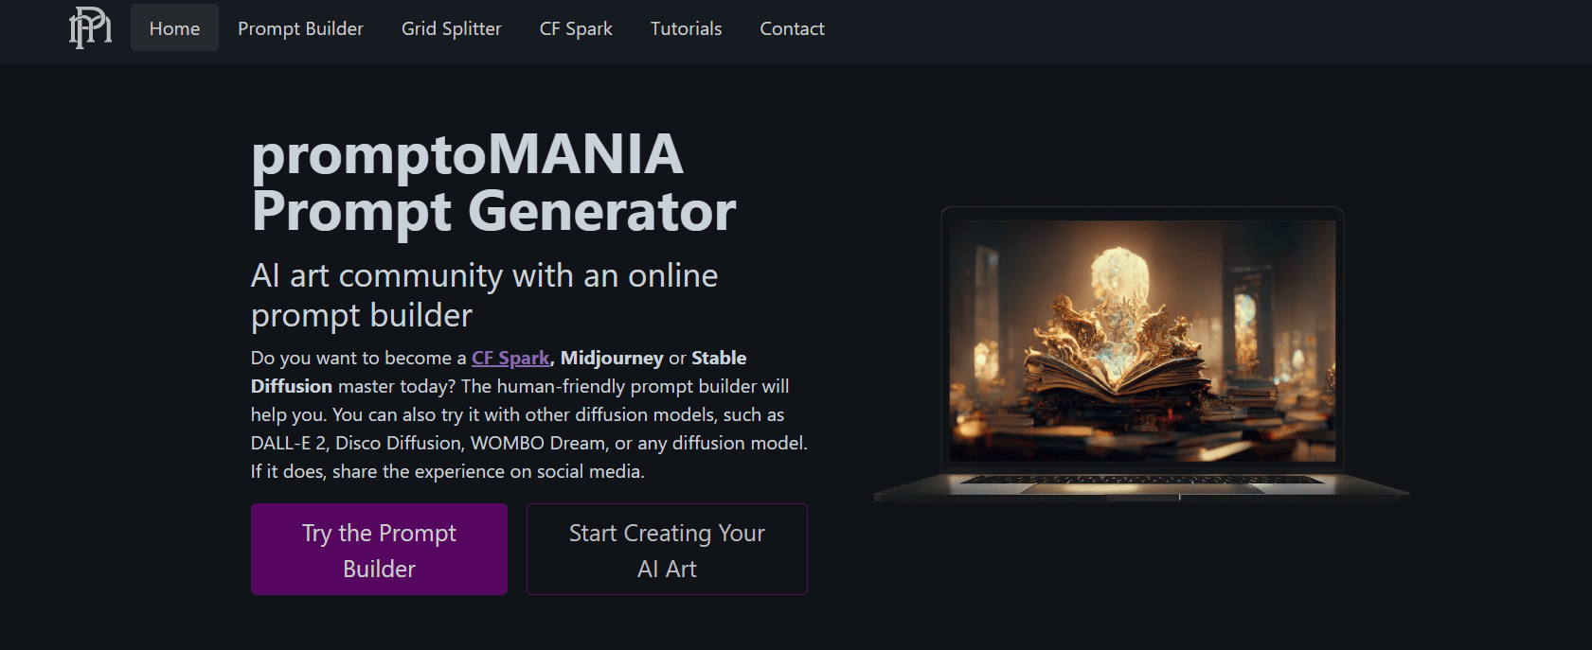

An artificial intelligence art community, [promptoMANIA](https://www.greataiprompts.com/imageprompt/why-use-promptomania-to-create-amazing-ai-images/) also features an online prompt builder. Using this application, you can get Ai prompts for CF Spark, Midjourney, and Stable Diffusion, as well as for other games.

This tools gives you a fantastic prompt-building option that you may use for Stable Diffusion, Midjourney, or Generic.

On the other hand, you can also use the artwork prompts they make with the built-in AI image generator that comes with Promptomania.

**Visit:** [promptoMANIA.com](https://promptomania.com/prompt-builder/)

## 3. [Nichesss.com](https://nichesss.com/tools/ai-art-prompt-helper-1NPiQNf4e)

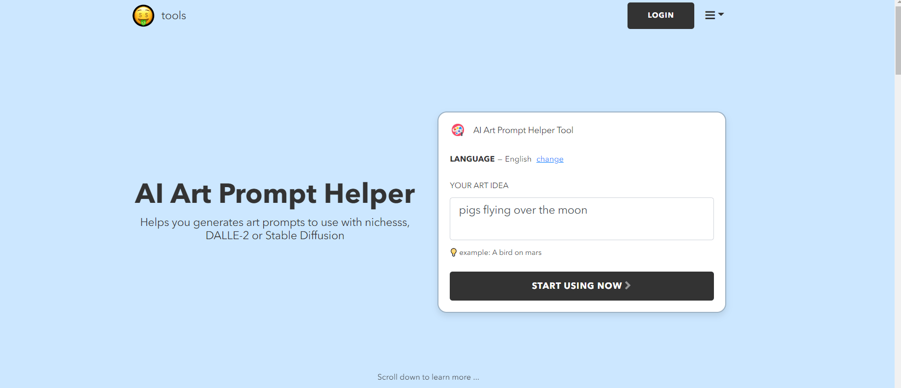

Nichess.com is yet another fantastic prompt builder or helper, and it was developed particularly for DALL-E, DALL-2, Dreambooth, and Stable Diffusion. It offers some of the most inspiring ideas for creative artwork.

This free tool will take your brief artistic concept and transform it into a detailed prompt that ART AI models can understand.

**Visit:** [Nichesss.com](https://nichesss.com/tools/ai-art-prompt-helper-1NPiQNf4e)

## 4. [Aitextpromptgenerator.Com](https://aitextpromptgenerator.com/)

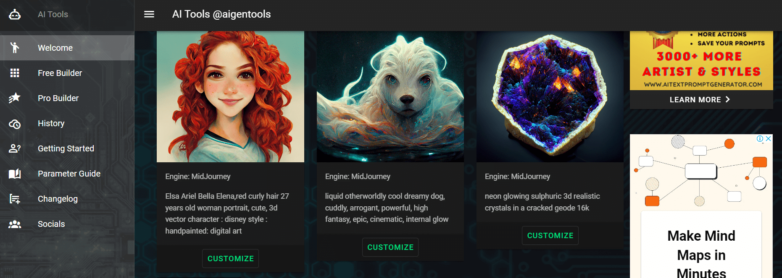

The AI Text Prompt Generator is a helpful resource for writers, as it automatically generates AI-created artwork that features the user’s chosen prompts.

Using this tool, you can make unique, one-of-a-kind pictures that are all your own. To get started, select a picture you like below and then click the **Customize** button. You can change the copy prompt to meet your needs.

To build an AI-generated image, simply copy and paste your suggestion into the site’s input using the buttons provided.

**Visit:**[aitextpromptgenerator.com](https://aitextpromptgenerator.com/)

## 5. ChatGPT

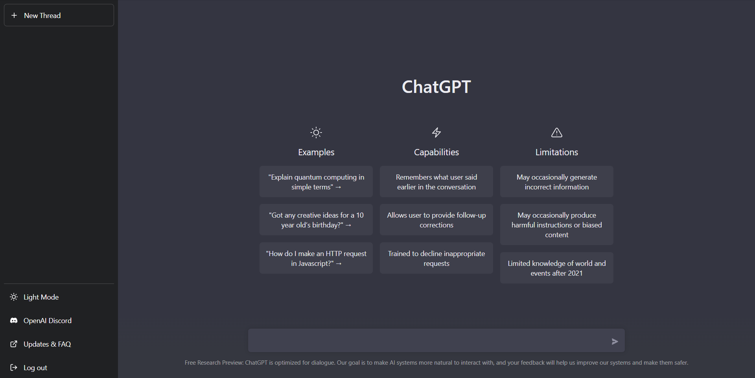

[ChatGPT](https://www.greataiprompts.com/guide/stable-diffusion/how-to-generate-stable-diffusion-prompts-using-chatgpt/) is useful for coming up with fantastic ideas for creative projects from scratch. Simply describe the format in which you wish to display your artwork.

For instances you can use a prompt like:

"Generate me 10 advanced art prompts for Ai image modules; make the prompts detailed, add themes and structures to it, add painting styles in the prompt"Copy

Well, that was our creative prompt, and yes that’s very basic.

But you can generate awesome prompts for your artwork if you know [how to write better Chat GPT prompts](https://www.greataiprompts.com/prompts/how-to-write-better-chat-gpt-or-gpt-prompts/) from scratch.

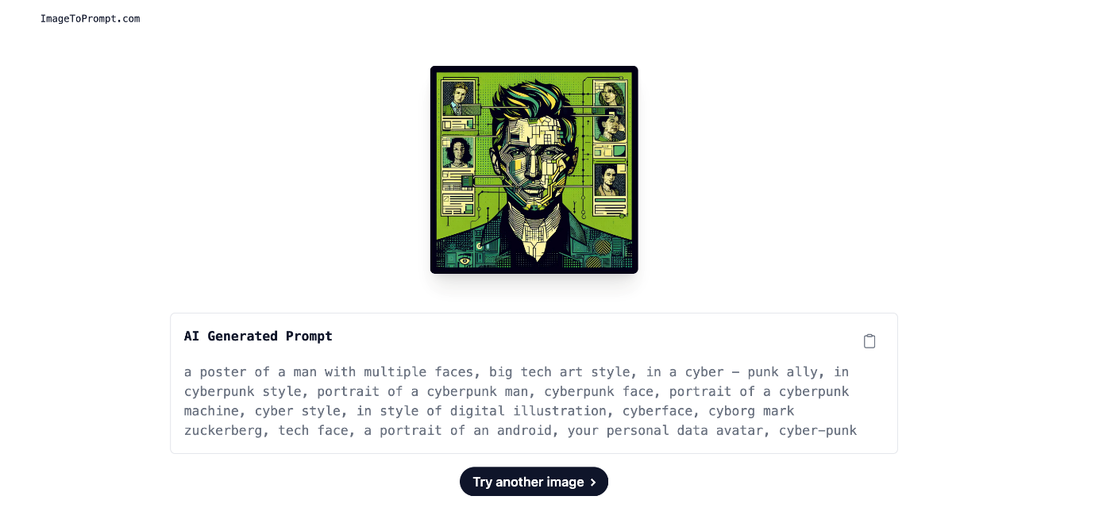Here’s an example.

However, it will give you a basic idea of the parameters used.

## Method #3: Using Stable Diffusion’s PNG Info

If you are sure that the AI image you want to extract the prompt from was generated using Stable Diffusion, then this method is just for you.

There’s a chance that the PNG Info function in Stable Diffusion might help you find the exact prompt that was used to generate your chosen image.

Follow these steps:

### Step 1: Go to Stable Diffusion WebUI

The first step is to open your Stable Diffusuin WebUI (it doesn’t matter if you run diffusion locally or not).

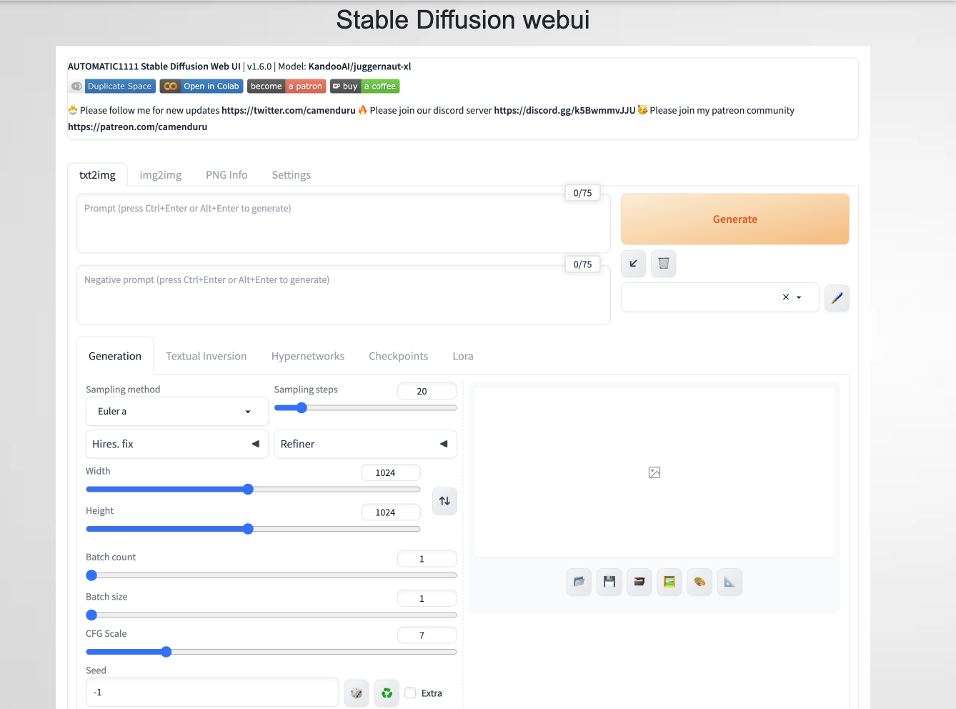Stable Diffusuin WebUI

### Step 2: Head to PNG Info

Now, click the PNG Info option from the above tab in your Stable Diffusion.

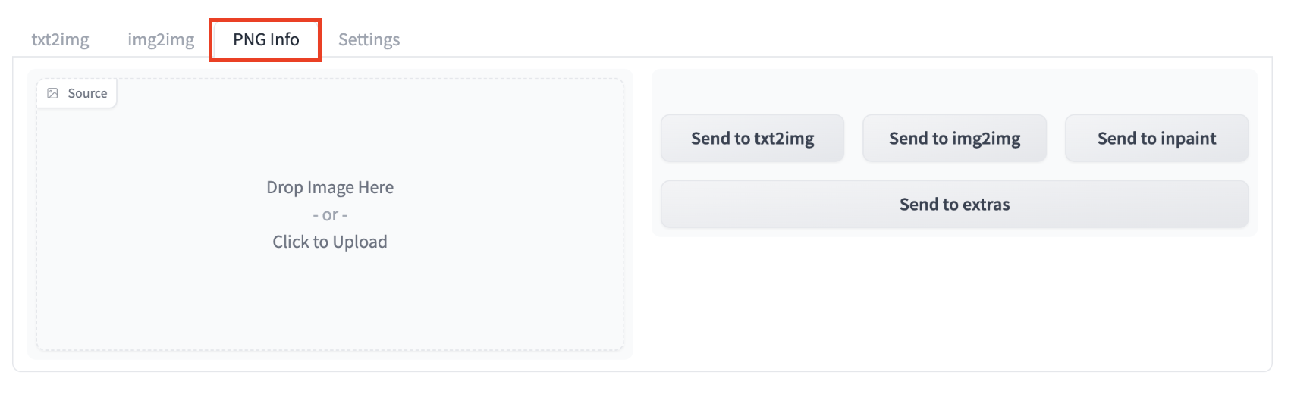PNG Info tab in Stable Diffusion

### Step 3: Upload the Stable Diffusion Generated Image into The Engine

Now, upload your Stable Diffusion-generated image into the PNG Info tab and wait a few seconds.

After a few seconds, you’ll be able to see every tiny piece of information about the image, and if you notice at the top, you’ll find the exact prompt used.

For example, here’s a Stable Diffusion-generated image that we used to find the prompt:

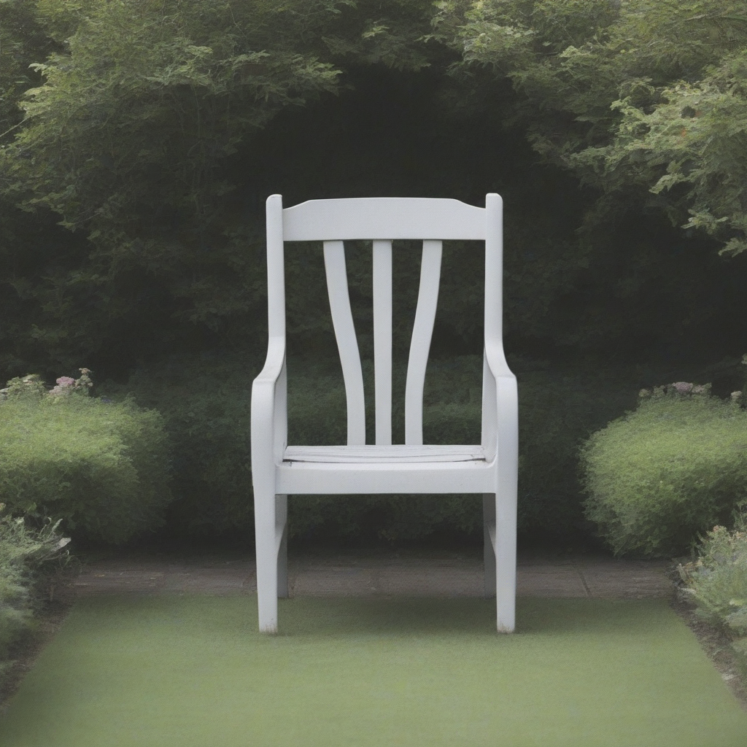

After uploading it into PNG Info, here’s all the data that the WebUI gives us:

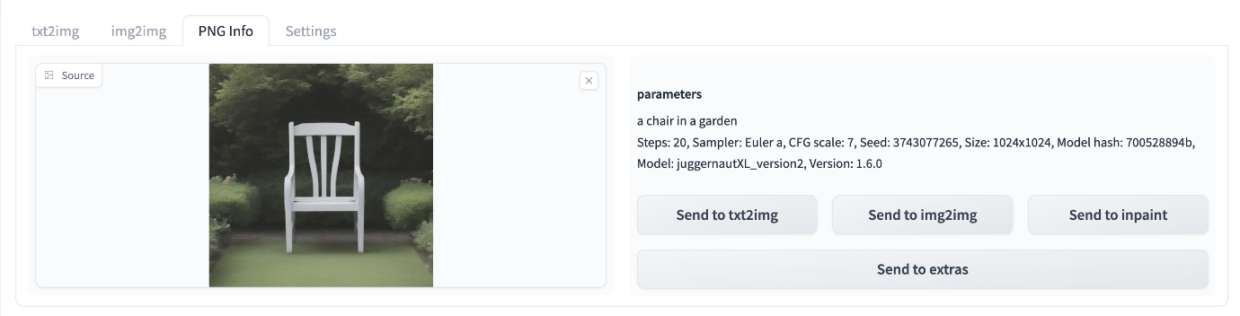Information of the AI Image with prompt.

This is the best reverse prompt lookup technique for using Stable Diffusion as an [AI image generator](https://www.greataiprompts.com/ai-tools/best-ai-image-generator/).

And that’s it. You can use these methods to find any prompt from any AI image.

### Method #4: Using Pincel Tool

There’s another AI tool called Pincel AI that can help you extract and create AI prompts from any AI image.

Just follow these steps to use the tool:

### Step 1: Check for Prompt in Metadata

If the image was generated using tools like Stable Diffusion, the prompt might be embedded directly in the image’s metadata. Use [Pincel Image Meta Reader](https://pincel.app/tools/image-meta-reader?_gl=1*g7d957*_ga*MTkxMjU0NDM0My4xNzA0MjY5MjM1*_ga_2MPNMKX6NL*MTcwNDI2OTIzNC4xLjEuMTcwNDI3MDM4NS4wLjAuMA.." \t "_blank) to reveal this information.

Upload your image to Pincel, and it will display all the metadata, including the AI prompt if it’s present.



Remember, the metadata might have been stripped if the image has been shared via chat apps, image-uploading websites, or file transfer services.

### Step 2: Use Pincel AI Multimedia Chat

If you can’t find a similar image in the Midjourney catalog, the next best option is [Pincel AI Multimedia Chat](https://chat.pincel.app/?_gl=1*1ckl0vj*_ga*MTkxMjU0NDM0My4xNzA0MjY5MjM1*_ga_2MPNMKX6NL*MTcwNDI2OTIzNC4xLjEuMTcwNDI3MDM4NS4wLjAuMA.." \t "_blank).

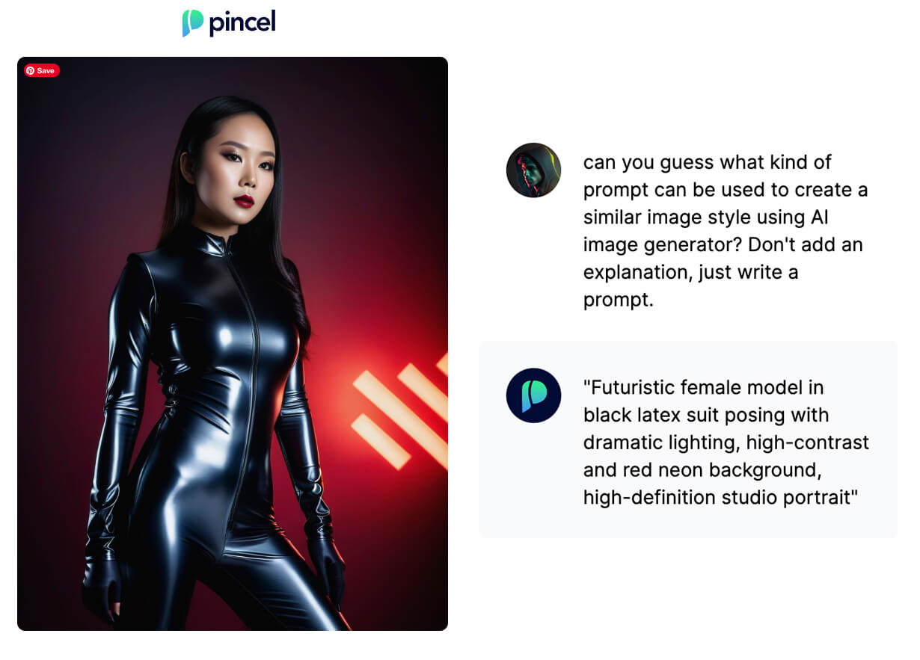Pincel AI Multimedia Chat

This tool is an AI model trained to understand and describe images. It is familiar with Stable Diffusion’s style.

# 35 Best DALL·E Architecture Prompts To Build Extraordinary Artworks

| **No.** | **DALL·E 2 Architecture Prompts** |
| --- | --- |
| 1 | “3D render of a floating futuristic castle in a clear sky, digital art” |
| 2 | “A beautiful house in tropical modernism style inside of a forest and full of trees and plants” |
| 3 | “hyper realistic photo of a high end futuristic single-level house where walls are made of windows, light coming through the window, mid century modern style, cinematic lighting” |
| 4 | “Synthwave halloween formula 1 car racing on a night road in Singapore” |
| 5 | “Oil painting of a man working on a super computer |
| 6 | “a sunlit indoor lounge area with a pool with clear water and another pool with translucent pastel pink water, next to a big window, digital art” |
| 7 | “Award-winning scenic design for “[THING! The Musical”, inspired by SOMETHING, high-quality photo from theatrical press release” |
| 8 | “Two towers with a bridge covered in plants , digital art” |
| 9 | “synthwave new york stock echange and a sunset” |
| 10 | “A photo of Metro Manila as a walkable city with lots of green spaces and a beautiful overground MRT system” |
| 11 | “Richard Neutra malibu beach house pop art” |
| 12 | “Curving wing of modern hospital building in Californian redwood forest, architecture by Frank Gehry, wide-angle architectural photography from magazine” |
| 13 | “Stunning modern renovation of village church at dawn, huge shards of translucent coloured perspex, architectural photography” |
| 14 | “Refreshment kiosk in park, neo-Andean architectural style, editorial photograph at golden hour” |
| 15 | “Steampunk airport terminal architecture, exterior view, award-winning architectural photography from magazine” |
| 16 | “innovative interior design of a restaurant in rural Japan, neutral wooden materials, floor-to-ceiling windows with views of nature” |
| 17 | “Award-winning interior design of a modern hotel bar, playful furry furniture, warm lamp lighting” |
| 18 | “A super-minimal brutalist interior, plunge pool sunk into floor, huge windows with daylight streaming in, a single table, high-resolution photo from architecture website” |
| 19 | “Interior design photo of top floor maisonette in a Victorian terraced house, bold colourful furniture, dark blue walls” |
| 20 | “Artists impression of award-winning rooftop garden design, white marble benches amidst wildflower meadow, NYC skyline in background, photograph at golden hour” |
| 21 | “Abstract public art of curved steel rods spiralling upwards, glinting in sunlight, in a small plaza in Madrid, gorgeous travel photography” |
| 22 | “Red fluorescent tubes suspended above a city alleyway, beautiful lighting installation inspired by Lumiere, night time photography, dramatic lighting” |
| 23 | “exterior shot of utopian architecture building with cinematic lighting by zaha hadid and renzo piano, darek zabrocki and greg ruthkowski, alphonse mucha, simon stalenhag, cinematic, paradise, scifi, futurism, atmospheric, sunset, concept art, artstation, trending on artstation” |
| 24 | “exterior shot of utopian architecture building with cinematic lighting by zaha hadid and renzo piano, darek zabrocki and greg ruthkowski, alphonse mucha, simon stalenhag, cinematic, beautiful, holy place, paradise, scifi, futurism, atmospheric, sunset, award winning, concept art, artstation, trending on artstation” |
| 25 | “Lunetic dreams of a palace in the future” |
| 26 | “Futuristic solarpunk eco villages with organic permaculture food forests, 3 d octane render, realistic lighting, beautiful weather, 8 k” |
| 27 | “Exterior shot of a utopian architecture building with cinematic lighting by zaha hadid and renzo piano, darek zabrocki and greg ruthkowski, alphonse mucha, and simon stalenhag. “cinematic,” “beautiful,” “holy place,” “paradise,” “sci-fi,” “futurism,” “atmospheric,” “sunset,” “award-winning,” “concept art,” “Artstation”” |
| 28 | “photorealistic, god rays, artstation, deviantart, unreal engine, intricate details; a city in space;” |
| 29 | “Two towers from the future connected by a skybridge covered in lush plants, all made with digital art” |
| 30 | “occult lego moc cathedral translucent” |
| 31 | “coruscant from space except all of the architecture is bland highly detailed and realistic” |
| 32 | “A city all made of gold, in classical architectural style, with gardens and fountains” |
| 33 | “massive egg-shaped temple of the chicken , dramatic cinematic ultradetailed photorealistic” |
| 34 | A sketch of a glass skyscraper in a desert with glass algae tanks on every floor, Blender, Unreal Engine, and CGI” |
| 35 | “a white spherical church floating above a field of roses. doric architecture” |

[*Source*](http://openart.ai/)

### Art Generated By Above DALL·E 2 Architecture Prompts

### Prompt #31. “coruscant from space except all of the architecture is bland highly detailed and realistic”

Prompt #32. “A city all made of gold, in classical architectural style, with gardens and fountains“

Prompt #10 “A photo of Metro Manila as a walkable city with lots of green spaces and a beautiful overground MRT system”

Prompt #9. “synthwave new york stock echange and a sunset”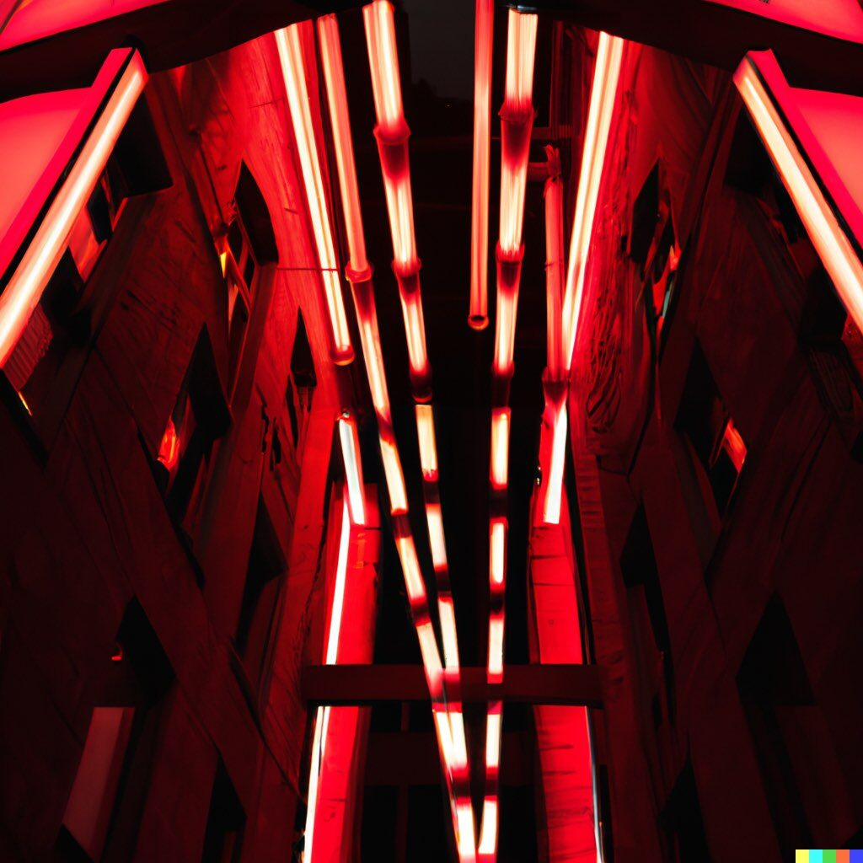Prompt #22. “Red fluorescent tubes suspended above a city alleyway, beautiful lighting installation inspired by Lumiere, night time photography, dramatic lighting”

Prompt: “A modern mansion that looks like it was built in the Middle Ages.”

Prompt: “Artists impression of award-winning rooftop garden design, white marble benches amidst wildflower meadow, NYC skyline in background, photograph at golden hour”

Prompt: “3d render of a supertall skyscraper in the style of traditional Philippine architecture”

Prompt: “3d render of a supertall skyscraper in the style of traditional Philippine architecture”

# 45+ Best Midjourney Prompts to Try Out

**Prompt #1:** Samurai looks at the enemy, stands after the battle, fear and horror on his face, tired and beaten, sand on his face mixed with sweat, an atmosphere of darkness and horror, hyper-realistic photo. Enhance the details, sharpness, and contrast in post-production to get a hyper-realistic effect.

**Prompt #2:** Samurai stands at sunset in japan and looks into the distance, in dynamics, highly detailed, packed with hidden details, style, high dynamic range, hyper realistic, dramatic light, realistic attention to detail, highly detailed, 8k, UHD

**Prompt #3:** japanese devil samurai standing majestically with kitana, highly detailed, intricate details, symmetrical, digital 3d, hard surface, real time, vfx, trending on artstation, ultra hd, hdr, cinematic, hyper realism, high detail, octane render, 8k

**Negative prompt used:** "Negative prompt: 3d, cartoon, anime, sketches, (worst quality:2), (low quality:2), (normal quality:2), lowres, normal quality, ((monochrome)), ((grayscale)), skin spots, acnes, skin blemishes, bad anatomy, girl, loli, young, large breasts, red eyes, muscular, over saturated, over saturated, over saturated, long neck, (watermark),signature, deformed, ugly, mutilated, disfigured, text, extra limbs, face cut, head cut, extra fingers, extra arms, poorly drawn face, mutation, bad proportions, cropped head, malformed limbs, (mutated hands), fused fingers, long neck, bad anatomy, Dull, barren, Unclear, smudge, muddy, incoherent , no face, no eyes, unfinished lines, small head, random lines, unrealistic hand shape, more than 2 arms, more than 2 legs, long handle"

**Prompt:** knolling, isotype of a modern sale of spare parts and accessories for beautiful african tribal vodoo shaman teenage girl , minimal design, vector, simple, flat, transparent background ,

**Prompt #1:** Detailed with notes, ink sketch of medieval preschool, slick design, clean lines, blueprint, perfect, awesome.

Contents

[What is Midjourney?](https://www.greataiprompts.com/imageprompt/midjourney-text-to-image-ai-prompts/#what-is-midjourney)[Best Midjourney Prompts](https://www.greataiprompts.com/imageprompt/midjourney-text-to-image-ai-prompts/#best-midjourney-prompts)[1. Battle-Worn Samurai: Artistic Surrealism](https://www.greataiprompts.com/imageprompt/midjourney-text-to-image-ai-prompts/#1-battleworn-samurai-artistic-surrealism)[2. Tribal Voodoo Accessories Sale](https://www.greataiprompts.com/imageprompt/midjourney-text-to-image-ai-prompts/#2-tribal-voodoo-accessories-sale)[3. Medieval Ink Sketches and Blueprint Prompts](https://www.greataiprompts.com/imageprompt/midjourney-text-to-image-ai-prompts/#3-medieval-ink-sketches-and-blueprint-prompts)[4. Realistic Portrait Photographs](https://www.greataiprompts.com/imageprompt/midjourney-text-to-image-ai-prompts/#4-realistic-portrait-photographs)[5. Anime Arts](https://www.greataiprompts.com/imageprompt/midjourney-text-to-image-ai-prompts/#5-anime-arts)[6. Concept AI Artworks](https://www.greataiprompts.com/imageprompt/midjourney-text-to-image-ai-prompts/#6-concept-ai-artworks)[7. Architecture Prompt (Lost City of Atlantis)](https://www.greataiprompts.com/imageprompt/midjourney-text-to-image-ai-prompts/#7-architecture-prompt-lost-city-of-atlantis)[8. Food Prompting](https://www.greataiprompts.com/imageprompt/midjourney-text-to-image-ai-prompts/#8-food-prompting)[Some Bonus Prompts to Experiment With](https://www.greataiprompts.com/imageprompt/midjourney-text-to-image-ai-prompts/#some-bonus-prompts-to-experiment-with)[Midjourney Prompts Syntax Tricks (Template + Words)](https://www.greataiprompts.com/imageprompt/midjourney-text-to-image-ai-prompts/#midjourney-prompts-syntax-tricks-template-words)[Midjourney Prompt Creation Template](https://www.greataiprompts.com/imageprompt/midjourney-text-to-image-ai-prompts/#midjourney-prompt-creation-template)[Objects or Themes You Can Add](https://www.greataiprompts.com/imageprompt/midjourney-text-to-image-ai-prompts/#objects-or-themes-you-can-add)[Styles To Use In Midjourney](https://www.greataiprompts.com/imageprompt/midjourney-text-to-image-ai-prompts/#styles-to-use-in-midjourney)[Artists to Add](https://www.greataiprompts.com/imageprompt/midjourney-text-to-image-ai-prompts/#artists-to-add)[More Words To Add In Your Prompts](https://www.greataiprompts.com/imageprompt/midjourney-text-to-image-ai-prompts/#more-words-to-add-in-your-prompts)[Best Midjourney Art Styles to Try in Your Prompts](https://www.greataiprompts.com/imageprompt/midjourney-text-to-image-ai-prompts/#best-midjourney-art-styles-to-try-in-your-prompts)[1. 3D Isometric Anime Style](https://www.greataiprompts.com/imageprompt/midjourney-text-to-image-ai-prompts/#1-3d-isometric-anime-style)[2. Jon Kudelka Style](https://www.greataiprompts.com/imageprompt/midjourney-text-to-image-ai-prompts/#2-jon-kudelka-style)[3. Analytic Drawing Style](https://www.greataiprompts.com/imageprompt/midjourney-text-to-image-ai-prompts/#3-analytic-drawing-style)[4. William Steig Style](https://www.greataiprompts.com/imageprompt/midjourney-text-to-image-ai-prompts/#4-william-steig-style)[5. Infographic Illustration Style](https://www.greataiprompts.com/imageprompt/midjourney-text-to-image-ai-prompts/#5-infographic-illustration-style)[6. Coloring Book Style](https://www.greataiprompts.com/imageprompt/midjourney-text-to-image-ai-prompts/#6-coloring-book-style)[7. Konstantin Razumov Style](https://www.greataiprompts.com/imageprompt/midjourney-text-to-image-ai-prompts/#7-konstantin-razumov-style)[8. Walt Handelsman Style](https://www.greataiprompts.com/imageprompt/midjourney-text-to-image-ai-prompts/#8-walt-handelsman-style)[9. Paper Cut Craft Illustration](https://www.greataiprompts.com/imageprompt/midjourney-text-to-image-ai-prompts/#9-paper-cut-craft-illustration)[10. Patchwork Collage](https://www.greataiprompts.com/imageprompt/midjourney-text-to-image-ai-prompts/#10-patchwork-collage)[The End!](https://www.greataiprompts.com/imageprompt/midjourney-text-to-image-ai-prompts/#the-end)

Looking for the best Midjourney prompts?

We have tried a lot of AI image generators like Stable Diffusion, Bing Image Creator, and DALL-E 3. And it’s no bummer that we also loved Midjourney too. But to make the most of it, you need the right prompts.

No worries – we’re here to help!

In this guide, we have shared the best Midjourney AI prompts to create unique AI images.

## What is Midjourney?

[Midjourney](https://www.midjourney.com/) is an AI image generator developed by an independent research lab.

Midjourney can change simple text prompts into beautiful images. While there are many tools like this today, Midjourney has become a top name among Stable Diffusion, Eluna AI, and DALL-E when the debate is about the best AI image generators.

[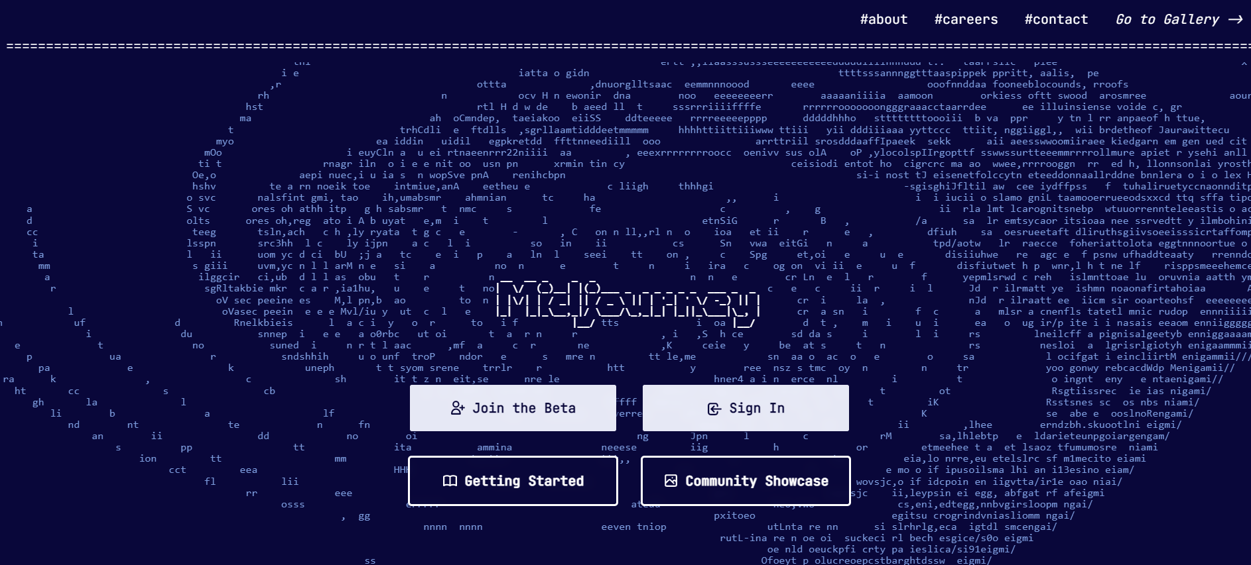](https://www.midjourney.com/)

How does Midjourney work?

It’s simple. With Midjourney, anyone can make great images using only text. All you need is the Discord chat app. However, unlike other tools, Midjourney is not free. Before generating AI images, you need to pay.

Still, people who are AI image designers love it, as the images are so good they can trick you into believing they are real. It’s because Midjourney uses a [diffusion model](https://encord.com/blog/diffusion-models/#:~:text=Diffusion%20models%20are%20a%20class%20of%20generative%20models%20that%20simulate,a%20sequence%20of%20invertible%20operations.).

But why isn’t it free?

Making these images takes a lot of computer power. It uses something called GPU a lot. And these GPUs have limited memory. This memory is needed to make the images clear.

So, using this high-level AI tool has a cost. Midjourney starts at $10 per month. This gives about 200 image creations. If you want more generations, you can choose a higher plan, which costs up to $120 monthly.

So, without further ado, let’s dive into our collection of Midjourney prompts and get you started on some truly fantastic artwork.

## Best Midjourney Prompts

We have compiled only the best and most loved Midjourney prompts from different sources like Discord, Reddit, Quora, and other prompt search engines.

#### ****Note****

These prompts are shared here to act as a template for your imagination. Do not try to copy and generate the images; make sure you tweak them and make something of your own on Midjourney.

Also, you can try our [Midjourney prompt generator](https://www.greataiprompts.com/midjourney-prompt-generator-and-builder/) to generate some awesome Midjourney prompts without typing every parameter manually.

So try these out, and let us know your favorite prompts in the comments.

### 1. Battle-Worn Samurai: Artistic Surrealism

Image Credits / Akasyan

Here’s a gripping depiction of a Samurai after an intense battle. The scene captures the deep emotions of exhaustion and terror.

**Prompt #1:** Samurai looks at the enemy, stands after the battle, fear and horror on his face, tired and beaten, sand on his face mixed with sweat, an atmosphere of darkness and horror, hyper-realistic photo. Enhance the details, sharpness, and contrast in post-production to get a hyper-realistic effect.Copy

Image Credits / Akasyan

**Prompt #2:** Samurai stands at sunset in japan and looks into the distance, in dynamics, highly detailed, packed with hidden details, style, high dynamic range, hyper realistic, dramatic light, realistic attention to detail, highly detailed, 8k, UHDCopy

Image credits / dsalvat1

**Prompt #3:** japanese devil samurai standing majestically with kitana, highly detailed, intricate details, symmetrical, digital 3d, hard surface, real time, vfx, trending on artstation, ultra hd, hdr, cinematic, hyper realism, high detail, octane render, 8k

**Negative prompt used:** "Negative prompt: 3d, cartoon, anime, sketches, (worst quality:2), (low quality:2), (normal quality:2), lowres, normal quality, ((monochrome)), ((grayscale)), skin spots, acnes, skin blemishes, bad anatomy, girl, loli, young, large breasts, red eyes, muscular, over saturated, over saturated, over saturated, long neck, (watermark),signature, deformed, ugly, mutilated, disfigured, text, extra limbs, face cut, head cut, extra fingers, extra arms, poorly drawn face, mutation, bad proportions, cropped head, malformed limbs, (mutated hands), fused fingers, long neck, bad anatomy, Dull, barren, Unclear, smudge, muddy, incoherent , no face, no eyes, unfinished lines, small head, random lines, unrealistic hand shape, more than 2 arms, more than 2 legs, long handle"Copy

### 2. Tribal Voodoo Accessories Sale

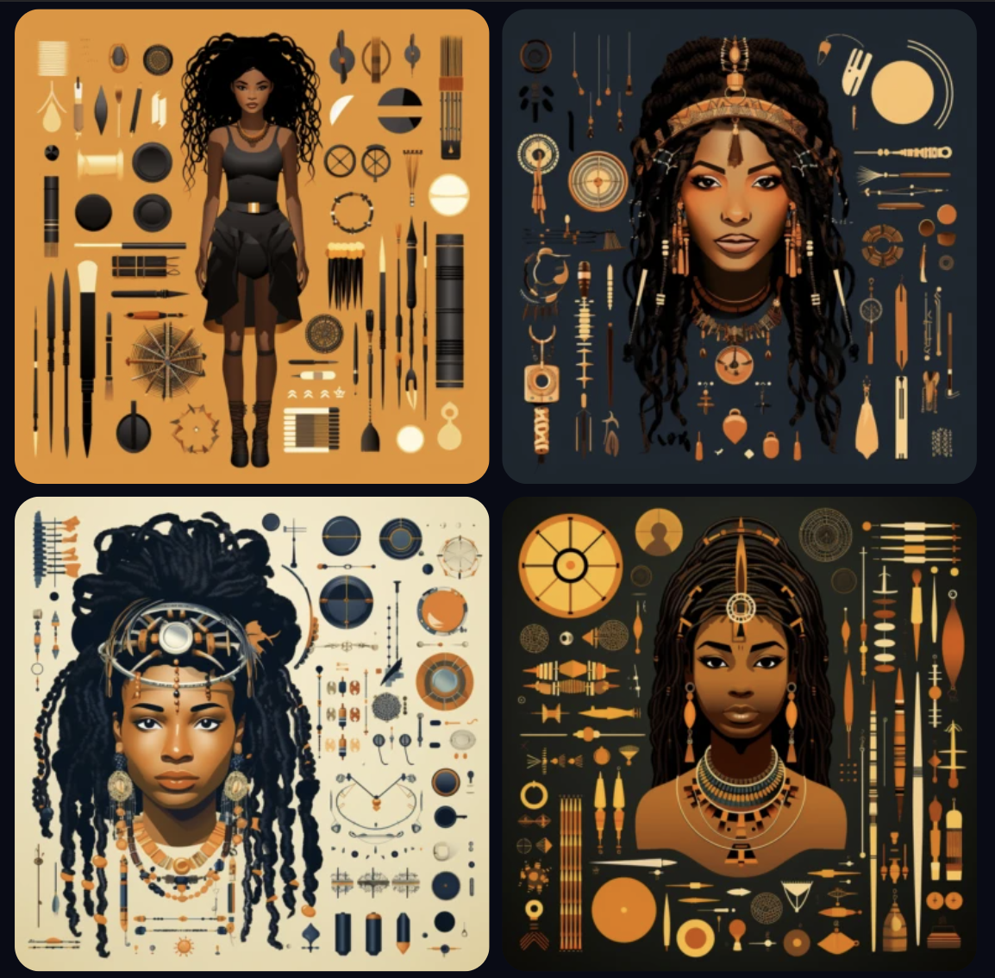Credits / Midjourney Showcase

This prompts a modern representation of an African tribal voodoo shaman teenage girl’s accessories. It’s fun as you can play with this prompt and create a different kind of vector art and even create other types of illustrations showcasing the elements.

**Prompt:** knolling, isotype of a modern sale of spare parts and accessories for beautiful african tribal vodoo shaman teenage girl , minimal design, vector, simple, flat, transparent background ,Copy

### 3. Medieval Ink Sketches and Blueprint Prompts

We love this prompt because of its mix of old and new. It uses the ancient medieval theme using clean and slick lines, creating an awesome blueprint. J

ust imagine creating designs for schools and playgrounds, toys, or storybooks with a vintage touch. Give it a try.

**Prompt #1:** Detailed with notes, ink sketch of medieval preschool, slick design, clean lines, blueprint, perfect, awesome.Copy

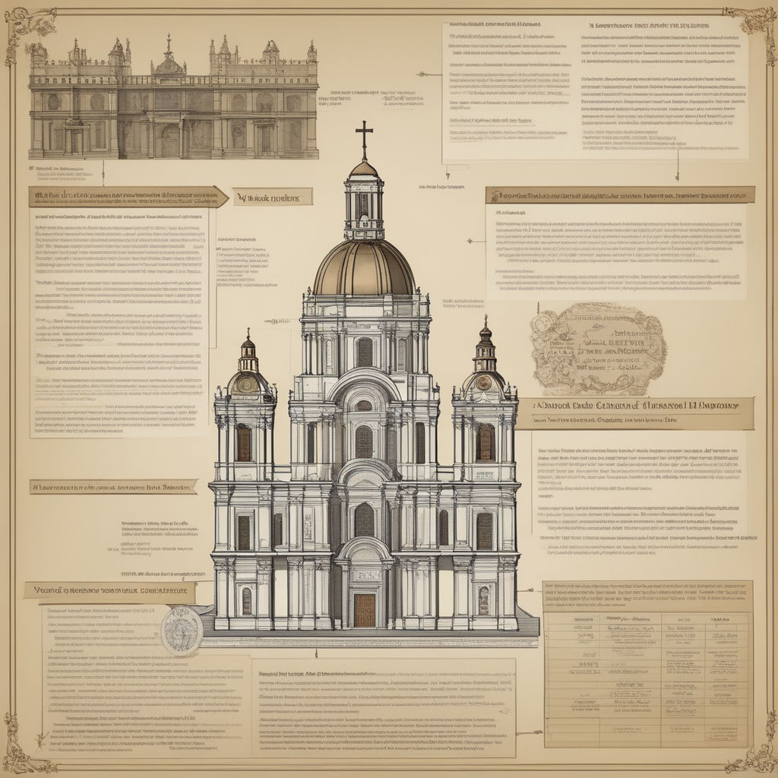Credits / Playground

**Prompt #2:** "create an image that narrates the newsroom: The Colonial Valuation 17th century, colonial Mexico: Valuation emerges, led by figures such as R. Sánchez Juárez and A. Fernández del Castillo, to establish tax bases and value properties. Although it did not require formal certification, the experts swore veracity before the church. This process demonstrated the importance of a reliable structure in the determination of wealth and taxation. (Torre Coto M., 2014), Miki Asai Macro photography, close-up, hyper detailed, trending on artstation, sharp focus, studio photo, intricate details, highly detailed, by greg rutkowski

**Prompt #3:** "Imagine a massive Roman palace depicted as a mind map. The mind map showcases the intricate layout and architectural details of the palace, emphasizing its grandeur and magnificence. The palace stands tall, exuding an aura of power and opulence, with imposing columns and elaborate decorations adorning its facade. Within this mind map, envision 30 numbers arranged in ascending order from 1 to 30. These numbers are strategically placed throughout the image, blending seamlessly with the organized structure of the palace. For instance, number 1 could be positioned at the entrance gate, while number 2 might be placed at the central courtyard. As you explore the mind map, you'll notice that the numbers are incorporated into various elements of the palace. They are prominently displayed, ensuring their visibility and making them appear large and prominent. The numbers are integrated into the architecture itself, etched into marble walls, engraved on statues, or elegantly displayed within vibrant murals. Each number represents a significant location within the palace, acting as a marker for key areas. For example, number 10 could signify the grand ballroom, while number 20 might represent the luxurious dining hall. The numbers are strategically positioned to guide you through the different sections of the palace, facilitating easy navigation and exploration. This image of a mind map depicting a Roman palace with 30 numbers arranged in ascending order within the organized structure creates a visually striking representation of your mid-journey. It allows you to immerse yourself in the splendor of the palace, while the prominent and visible numbers aid in connecting your thoughts and ideas to specific locations within the grand structure. Main Avatar"

Prompt #2: burning man desert woman stands in desert standing, in the style of light black and gold, dreamy portraits --ar 69:128 --s 750 --v 5.2

Prompt #3: a girl standing in a field with a scarf, in the style of dark and brooding designer, voluminous mass, photobash, serene faces, jagged edges, navy, natural beauty --ar 69:128 --s 750 --v 5.2

Prompt #4: “woman wearing a strapless black top + eye contact + full body pose arms crossed on her chest + blonde hair and dark-green eyes + candlelight and intimate setting + oil painting style + lots of detail + very detailed shadows”

Prompt #6: portrait photo of a asia old warrior chief, tribal panther make up, blue on red, side profile, looking away, serious eyes, 50mm portrait photography, hard rim lighting photography--beta --ar 2:3 --beta --upbeta

# Prompt #7: photograph close up portrait 62-year-old tough decorated general, CLEAN SHAVEN, serious, stoic cinematic 4k epic detailed 4k epic detailed photograph shot on kodak detailed bokeh cinematic hbo dark moody --ar 17:22 --beta –upbeta

# Prompt #1: young man riding a horse through the snow, hot, cute, --niji 5

Prompt #2: dragon ball z, in the style of dark brown and red, handsome, hyperrealistic fantasy, manticore, sharp focus, fairy academia, meticulous technique --ar 69:128 --s 750 --niji 5

Anime Comic Style Prompt #3: pages of various scenes from the comic book stumbled souls, in the style of precise, detailed architecture paintings, light black and brown, rustic charm, ink and color, 8k resolution, narrative paneling, vibrant urban scenes, photo, digital art, fantasy::, pages from a comic book showing images of a village, in the style of urban decay, atmospheric color washes, light black and brown, precisionist art, wood, 8k resolution, meticulously detailed, photo, digital art, fantasy:: --v 5. 2

### Prompt to try: magnificent detailed griffin wings, wings outstretched with gold tips on feathers, intricate ornate marble and bone interwoven and spiraling patterns, final fantasy style, griffin wearing translucent feathered dress, cinematic lighting, atmospheric, hyper detailed, photoreal, 8k, Unreal engine 5, stan Winston studio, 9:16

Another Prompt: 4K, anime, hyperrealism, digital art, realistic, Desert city, sunlight, gorgeous, highly detailed, high resolution, matte painting, masterpiece, vintage fantasy art, super detail, a masterpiece:, concept art, best quality, very cute appealing kawaii, looking at the viewer, macro, fantasy art, dynamic composition, dramatic lighting, epic realistic, award winning illustration, 32k, wild frame camera, ultra realistic, elegant, highly detailed, sharp focus, high, definition, insanely detailed, intricate, cinematic lighting, rim light, masterpiece, digital art, sci-fi art, 32k, ultra engine 5, octane render

Negative Prompt: "people, 2 heads, flag, duplicate, blurry, abstract, human, disfigured, deformed, cartoon, animated, figure, framed, 3d, cartoon, disfigured, bad art, poorly drawn, extra limbs, close up, weird colors, long neck, cropped image, out of frame, draft, deformed hands, twisted fingers, double image, malformed hands, multiple heads, extra limb, poorly drawn hands, missing limb, cut-off, grain, low-res, bad anatomy, poorly drawn face, mutation, mutated, floating limbs, disconnected limbs, out of focus, long body, disgusting, extra fingers, missing arms, mutated hands, cloned face, missing legs, black and white, blur haze, easy negative, worst quality, human, humans, animal, ears, teeth, fangs, fur, text, ware mark, signature, text, 2 heads, 2 faces, ugly, tiling, poorly drawn hands, poorly drawn, crossed eyes, poorly drawn face, out of frame, extra limbs, disfigured, deformed, toy, sculpture, body out of frame, blurry, bad anatomy, blurred, (watermark), grainy, signature, cut off, draft, duplicate, distortion of proportions, heterochromia, dots, bad quality, draft, malformed hands, blur, out of focus, mutilated, mutated, extra limb, missing limb, disconnected limbs, mangled, old, text, logo, wordmark, writing, heading, signature, text, logo, wordmark, writing, heading, signature, bear, west guy, western boy, the bang for the girl, blurry, bad anatomy, extra limbs, poorly drawn face, poorly drawn hands, missing fingers, bang, bang girl hair, flower, people in background, blurry, bad anatomy, extra limbs, poorly drawn face, poorly drawn hands, missing fingers, blurry, bad anatomy, extra limbs, poorly drawn face, poorly drawn hands, missing fingers"

Prompt: "Lost city of Atlantis, chaotic ocean, detailed, octane render, tall architectures, sharks + sealife, fish + coral, Unreal engine 5, 8k, --q 5 --s 7500 --ar 4:5."

Prompt: photorealistic hd high res ultra high quality front view morning modern house grey concrete tiles and finished concrete ground pakistani architechture style and first floor 450 sq ft, Flat roof, perfect composition, beautiful detailed intricate insanely detailed octane render trending on artstation, 8 k artistic photography, photorealistic concept art, soft natural volumetric cinematic perfect light, chiaroscuro, award - winning photograph, masterpiece, Mysterious

Negatives: Deformed, Blur, ugly, unreal, pool, low res

Prompt:"Blueberry ice cream, in a stylish modern glass, ice cubes, nuts, mint leaves, splashing milk cream, in a gradient purple background, fluid motion, dynamic movement, cinematic lighting, Mysterious"

Concept food Prompt: Set of autumn camping Food and Supplies: Plan hearty meals, snacks, and warm drinks to keep you fueled and hydrated. on white background. pastel style, ultra hd, realistic, vivid colors, highly detailed, UHD drawing, pen and ink, perfect composition, beautiful detailed intricate insanely detailed octane render trending on artstation, 8k artistic photography, photorealistic concept art, soft natural volumetric cinematic perfect light

| **o.** | **Prompts You Should Experiment with On your Own** |
| --- | --- |
| 1. | “beautiful pale cyberpunk female with heavy black eyeliner, blue eyes, shaved side haircut, hyper detail, cinematic lighting, magic neon, dark red city –ar 9:16 –testp –upbeta” |
| 2. | “earth reviving after human extinction, a new beginning, nature taking over buildings, animal kingdom, harmony, peace, earth balanced –version 3 –s 1250 –uplight –ar 4:3 –no text, blur” |
| 3. | “photo of a ultra realistic sailing ship, dramatic light, pale sunrise, cinematic lighting, battered, low angle, trending on artstation, 4k, hyper realistic, focused, extreme details, unreal engine 5, cinematic, masterpiece, art by studio ghibli, intricate artwork by john william turner” |
| 4. | “ethereal Bohemian Waxwing bird, Bombycilla garrulus :: intricate details, ornate, detailed illustration, octane render :: Johanna Rupprecht style, William Morris style :: trending on artstation –ar 9:16” |
| 5. | “Create an image of a futuristic city skyline at night, with a focus on advanced transportation systems and towering skyscrapers. Incorporate elements such as drones, flying cars, and high-speed trains.” |
| 6. | “Generate an image of a post-apocalyptic landscape, featuring a mix of natural and man-made elements. Include crumbling buildings, overgrown vegetation, and a sense of danger and abandonment.” |
| 7. | “Create a surrealist image of a dreamlike forest, featuring twisted trees, floating islands, and otherworldly creatures. Use vibrant colors and an ethereal atmosphere to evoke a sense of mystery and wonder.” |
| 8. | Generate an image of a cyberpunk-inspired metropolis, featuring neon lights, holographic advertisements, and a bustling, futuristic atmosphere. Incorporate elements such as augmented reality interfaces, advanced robotics, and cybernetic enhancements.” |
| 9. | “space suit with boots, futuristic, character design, cinematic lightning, epic fantasy, hyper realistic, detail 8k –ar 9:16” |
| 10. | “Create an image of a surreal underwater world, featuring strange sea creatures, coral reefs, and otherworldly landscapes. Use vibrant colors and an ethereal atmosphere to evoke a sense of mystery and wonder.” |
| 11. | “Generate an image of a post-apocalyptic city, featuring crumbling buildings, overgrown vegetation, and a sense of danger and abandonment. Incorporate elements such as advanced robotics, cybernetic enhancements, and advanced transportation systems.” |
| 12. | “Create an image of a futuristic city skyline at night, featuring advanced transportation systems, towering skyscrapers, and a sense of rapid technological advancement. Incorporate elements such as drones, flying cars, and high-speed trains.” |
| 13. | “Generate an image of a surreal otherworldly landscape, featuring twisted trees, floating islands, and otherworldly creatures. Use vibrant colors and an ethereal atmosphere to evoke a sense of mystery and wonder.” |
| 14. | “Create an image of a cyberpunk-inspired metropolis, featuring neon lights, holographic advertisements, and a bustling, futuristic atmosphere. Incorporate elements such as augmented reality interfaces, advanced robotics, and cybernetic enhancements.” |
| 15. | “Generate an image of a post-apocalyptic landscape, featuring a mix of natural and man-made elements. Include crumbling buildings, overgrown vegetation, and a sense of danger and abandonment. Incorporate elements such as advanced robotics, cybernetic enhancements, and advanced transportation systems.” |
| 16. | “a home built in a huge Soap bubble, windows, doors, porches, awnings, middle of SPACE, cyberpunk lights, Hyper Detail, 8K, HD, Octane Rendering, Unreal Engine, V-Ray, full hd — s5000 –uplight –q 3 –stop 80–w 0.5 –ar 1:3” |
| 17. | “aerial view of a giant fish tank shaped like a tower in the middle of new york city, 8k octane render, photorealistic –ar 9:20” |
| 18. | “Create a high resolution image of a futuristic city skyline at night, with a focus on advanced transportation systems and towering skyscrapers. Incorporate elements such as drones, flying cars, and high-speed trains. The image should be at least 3000×2000 pixels in size and include details such as reflections and lighting effects.” |
| 19. | “ice cream sundae, delicious, glistening, cherries, marshmallows, highly detailed, octane render,” |
| 20. | “ossuary cemetary segmented shelves overgrown, graveyard, vertical shelves, zdzisław beksiński, hr giger, mystical occult symbol in real life, high detail, green fog –ar 9:16 –iw 1” |
| 21. | “portrait photo of a asia old warrior chief, tribal panther make up, blue on red, side profile, looking away, serious eyes, 50mm portrait photography, hard rim lighting photography–beta –ar 2:3 –beta –upbeta” |
| 22. | “Rubber Duck Aliens visiting the Earth for the first time, hyper-realistic, cinematic, detailed –ar 16:9” |
| 23. | “Reunion of man, team, squad, cyberpunk, abstract, full hd render + 3d octane render +4k UHD + immense detail + dramatic lighting + well lit + black, purple, blue, pink, cerulean, teal, metallic colours, + fine details + octane render + 8k” |
| 24. | “ultra photoreal , photographic, concept art, cinematic lighting, cinematic composition, rule of thirds , mysterious, eerie, cinematic lighting, ultra-detailed, ultrarealistic, photorealism, 8k, octane render,” |
| 25. | “Generate an image in the style of Monet’s Water Lilies, featuring vibrant colors and a focus on the interplay of light and color. The image should be at least 4000×2500 pixels in size and include details such as reflections and ripples in the water to enhance the realism of the scene.” |
| 26. | “Create an AI-generated oil painting of a portrait, featuring a range of skin tones and realistic textures to convey a sense of humanity. The painting should be at least 3000×2000 pixels in size and include details such as brushstrokes and layering to mimic the techniques of traditional oil painting.” |
| 27. | “Generate an image in the style of Salvador Dali’s melting clocks, featuring surreal elements and a focus on the manipulation of time and space. The image should be at least 4000×2500 pixels in size and include details such as dynamic lighting and movement to enhance the surreal atmosphere.” |
| 28. | “Create an AI-generated mixed media painting that combines elements of photography, collage, and painting to create a unique and dynamic image. The painting should be at least 3000×2000 pixels in size and include a range of colors, textures, and techniques to create a sense of depth and complexity.” |
| 29. | “Generate an image in the style of Frida Kahlo’s self-portraits, featuring vibrant colors and a focus on self-expression and identity. The image should be at least 4000×2500 pixels in size and include details such as brushstrokes and symbols that evoke the style of the original artist.” |
| 30. | “wildly futuristic clothing with glowing and colorful decoration” |
| 31. | “charcuterie board with multicolored alien cheeses, with glowing mold and fungus” |
| 32. | “breathtaking detailed concept art painting art deco pattern – blue flowers with anxious piercing eyes and blend of flowers and birds, by hsiao – ron cheng and john james audubon, bizarre compositions, exquisite detail, extremely moody lighting, 8 k” |
| 33. | “woman wearing a strapless black top + eye contact + full body pose arms crossed on her chest + blonde hair and dark-green eyes + candlelight and intimate setting + oil painting style + lots of detail + very detailed shadows” |
| 34. | “[Link to an image of reference (you can find them in Google images -> copy + paste], 3d isometric [Element you want] on a [the base you want], cinema 4d, game asset, –v 4 -q 2” |
| 35. | “character design, void arcanist, mist, photorealistic, octane render, unreal engine, hyper detailed, volumetric lighting, hdr. –ar 9:16” |
| 36. | “a minimalist contemporary cafe with a large round zen window view of a starry nebula, interior environment design, contempoary furniture, candlelight, 8k, octane render, arch viz, modern, space opera, ray traced, medium format” |
| 37. | “ish zeus, (((artstation, concept art, colorful, psychedelic, smooth, sharp focus, artgerm, Tomasz Alen Kopera, Peter Mohrbacher, donato giancola, Joseph Christian Ley” |
| 38. | “twitter data center” |
| 39. | “photograph close up portrait 62-year-old tough decorated general, CLEAN SHAVEN, serious, stoic cinematic 4k epic detailed 4k epic detailed photograph shot on kodak detailed bokeh cinematic hbo dark moody –ar 17:22 –beta –upbeta” |
| 40. | “Swirls :: fog :: phantom + ghost + dog + glowing eyes + bright silver ::3 smoke + shine + sphere:: black paper + elements + dark grey + dark blue + neon + baroque + rococo + white + ink + tarot card with ornate border frame + sébastien mitton, viktor antonov, sergey kolesov, detailed, intricate ink illustration + magic + glow –ar 63:88” |
| 41. | “tyriel archangel, king shamn , avatar , swords , angel wings . 4k , unreal engine –wallpaper” |
| 43. | “Joe Biden sitting on a throne of classified documents laughing in a menacing demeanor.” |
| 44. | “cat swims in an aquarium” |
| 45. | ““real photo perfect modern bedroom, elegant bedding and furnishings, yellow and sea blues, deep colors, lamps, flowers in vases, interior design photography, volumetric lighting,”” |

## Midjourney Prompts Syntax Tricks (Template + Words)

You can experiment with the above list of Midjourney prompts and learn how to create your awesome prompts.

However, to help you further, use these parameters in your Midjourney prompts to create creative and mindblowing artwork.

### ****Midjourney Prompt Creation Template****

Here’s a simple template for beginners to use if you want to write a perfect Midjourney prompt every single time.

Check out the below prompt formula for Midjourney and try to write your own best prompts:

1. **Image Style**: [Choose: Photo/Artistic Rendering/Painting/Drawing/etc.]
   * **Example:**“Van Gogh style painting” or “Photo”
2. **Camera & Resolution Details**: [Camera Model], [Lens mm], [Camera Type (DSLR/SLR)]
   * **Example:**“Canon R5, 50 mm, DSLR”
3. **Subject**: [Specific description of main object/character/scene]
   * **Example:** “pack of 3 lions” or “medieval castle”
4. **Environment**: [Describe the setting or background]
   * **Example:** “streets of San Francisco” or “misty mountains”
5. **Lighting**: [Specify lighting conditions or time of day]
   * **Example:**“golden hour” or “soft morning light”
6. **Angle of View**: [Choose viewing perspective]
   * **Example:**“aerial view” or “close-up”
7. **Parameters**: [Technical adjustments]
   * **Example:** “–v 5 –ar 3:2 –s 750”
8. **Exclusions** (Optional): --no [Specify what shouldn't appear]
   * **Example:**“–no camera”

**Your Completed Prompt Should Look Like This**:

"**[Image Style]** with a **[Camera & Resolution Details]**, **[Subject]** in/on/at **[Environment]** during **[Lighting]**, **[Angle of View]** **[Parameters]** **[Exclusions]**"Copy

**Example Using The Template**:

"**Photo** with a **Canon R5, 50 mm, DSLR**, **pack of 3 lions walking** through the streets of San Francisco during **golden hour**, **aerial view** **--v 5** **--ar 3:2 --s 750** **--no camera**"